**OAK RIDGE**

**NATIONAL LABORATORY**

**MANAGED BY**

**MARTIN MARIETTA ENERGY SYSTEMS, INC. FOR THE UNITED STATES**

**DEPARTMENT OF ENERGY**

ORNL/CON-295

## Builder’s Foundation Handbook

John Carmody Jeffrey Christian Kenneth Labs



Part of the National Program for Building Thermal Envelope Systems and Materials

Prepared for the

U.S. Departmet of Energy Conservation and Renewable Energy

Office of Buildings and Community Systems Building Systems Division

This report has been reproduced directly from the best available copy.

Available to DOE and DOE contractors from the Office of Scientific and Technical Information, P.O. Box 62, Oak Ridge, TN 37831; prices available from (615) 576-8401, FTS 626-8401.

Available to the public from the National Technical Information Service,

U.S. Department of Commerce, 5285 Port Royal Rd., Springfield, VA 22161.

This report was prepared as an account of work sponsored by an agency of the United States Government. Neither the United States Government nor any agency thereof, nor any of their employees, makes any warranty, express or implied, or assumes any legal liability or responsibility for the accuracy, completeness, or usefulness of any information, apparatus, product, or process disclosed, or represents that its use would not infringe privately owned rights. Reference herein to any specific commercial product, process, or service by trade name, trademark, manufacturer, or otherwise, does not necessarily constitute or imply its endorsement, recommendation, or favoring by the United States Government or any agency thereof. The views and opinions of authors expressed herein do not necessarily state or reflect those of the United States Government or any agency thereof.

**Builder’s Foundation Handbook**

**John Carmody**

Underground Space Center University of Minnesota

**Jeffrey Christian**

Oak Ridge National Laboratory Oak Ridge, Tennessee

**Kenneth Labs**

Undercurrent Design Research New Haven, Connecticutt

##### Book Design and Illustrations: John Carmody Date of Publication: May, 1991

**Prepared for:**

**Oak Ridge National Laboratory Oak Ridge, Tennessee 37831**

**Operated by:**

**Martin Marietta Energy Systems, Inc. for the U. S. Department of Energy under Contract DE-AC05-84OR21400**

# List of Figures and Tables

##### Chapter 1 Figures

Figure 1-1: The impact of basement insulation is monitored on several modules at the foundation test facility at the University of Minnesota.

Figure 1-2: Benefits of Foundation Insulation and Other Design Improvements Figure 1-3: The impact of slab-on-grade foundation insulation is monitored in a test

facility at Oak Ridge National Laboratory. Figure 1-4: Decision-Making Process for Foundation Design Figure 1-5: Basic Foundation Types

Figure 1-6: Points of Radon Entry into Buildings

##### Chapter 2 Figures

Figure 2-1: Concrete Masonry Basement Wall with Exterior Insulation Figure 2-2: Components of Basement Structural System

Figure 2-3: Components of Basement Drainage and Waterproofing Systems Figure 2-4: Termite Control Techniques for Basements

Figure 2-5: Radon Control Techniques for Basements Figure 2-6: Soil Gas Collection and Discharge Techniques

Figure 2-7: System of Key Numbers in Construction Drawings that Refer to Notes on Following Pages

Figure 2-8: Concrete Basement Wall with Exterior Insulation Figure 2-9: Concrete Basement Wall with Exterior Insulation Figure 2-10: Masonry Basement Wall with Exterior Insulation Figure 2-11: Concrete Basement Wall with Interior Insulation Figure 2-12: Concrete Basement Wall with Ceiling Insulation Figure 2-13: Pressure-Preservative-Treated Wood Basement Wall

##### Chapter 3 Figures

Figure 3-1: Concrete Crawl Space Wall with Exterior Insulation Figure 3-2: Components of Crawl Space Structural System Figure 3-3: Crawl Space Drainage Techniques

Figure 3-4: Crawl Space Drainage Techniques

Figure 3-5: Termite Control Techniques for Crawl Spaces Figure 3-6: Radon Control Techniques for Crawl Spaces

Figure 3-7: System of Key Numbers in Construction Drawings that Refer to Notes on Following Pages

Figure 3-8: Vented Crawl Space Wall with Ceiling Insulation Figure 3-9: Unvented Crawl Space Wall with Exterior Insulation Figure 3-10: Unvented Crawl Space Wall with Interior Insulation Figure 3-11: Unvented Crawl Space Wall with Interior Insulation

##### Chapter 4 Figures

Figure 4-1: Slab-on-Grade Foundation with Exterior Insulation

Figure 4-2: Structural Components of Slab-on-Grade Foundation with Grade Beam Figure 4-3: Structural Components of Slab-on-Grade Foundation with Stem Wall and

Footing

Figure 4-4: Drainage Techniques for Slab-on-Grade Foundations Figure 4-5: Termite Control Techniques for Slab-on-Grade Foundations Figure 4-6: Radon Control Techniques for Slab-on-Grade Foundations Figure 4-7: Soil Gas Collection and Discharge Techniques

Figure 4-8: System of Key Numbers in Construction Drawings that Refer to Notes on Following Pages

Figure 4-9: Slab-on-Grade with Integral Grade Beam (Exterior Insulation) Figure 4-10: Slab-on-Grade with Brick Veneer (Exterior Insulation)

Figure 4-10: Slab-on-Grade with Brick Veneer (Exterior Insulation Figure 4-12: Slab-on-Grade with Masonry Wall (Exterior Insulation)) Figure 4-13: Slab-on-Grade with Concrete Wall (Insulation Under Slab) Figure 4-14: Slab-on-Grade with Masonry Wall (Insulation Under Slab) Figure 4-15: Slab-on-Grade with Masonry Wall (Interior Insulation) Figure 4-16: Slab-on-Grade with Brick Veneer (Insulation Under Slab)

##### Chapter 5 Figures

Figure 5-1: Steps in Worksheet to Determine Optimal Foundation Insulation Figure 5-2: Formulas Used as a Basis for Worksheet 1

Figure 5-3: Formulas Used as a Basis for Worksheet 3

##### Chapter 2 Tables

Table 2-1: Insulation Recommendations for Fully Conditioned Deep Basements Table 2-2: Insulation Recommendations for Unconditioned Deep Basements

Table 2-3: Fuel Price Levels Used to Develop Recommended Insulation Levels in Tables 2- 1 and 2-2

##### Chapter 3 Tables

Table 3-1: Insulation Recommendations for Crawl Spaces

Table 3-2: Fuel Price Levels Used to Develop Recommended Insulation Levels in Table 3-1

##### Chapter 4 Tables

Table 4-1: Insulation Recommendations for Slab-on-Grade Foundations

Table 4-2: Fuel Price Levels Used to Develop Recommended Insulation Levels in Table 4-1

##### Chapter 5 Tables

Table 5-1: Weather Data for Selected Cities (page 1 of 2)

Table 5-2: Insulation R-Values and Costs for Conditioned Basements (page 1 of 4) Table 5-2: Insulation R-Values and Costs for Slab-on-Grade Foundations (page 4 of 4) Table 5-3: Heating Load Factor Coefficients (HLFI and HLFS)

Table 5-4: Cooling Load Factor Coefficients (CLFI and CLFS)

Table 5-5: Initial Effective R-values for Uninsulated Foundation System and Adjacent Soil Table 5-6: Heating and Cooling Equipment Seasonal Efficiencies1

Table 5-7: Scalar Ratios for Various Economic Criteria

Table 5-8: Energy Cost Savings and Simple Paybacks for Conditioned Basements Table 5-8: Energy Cost Savings and Simple Paybacks for Conditioned Basements Table 5-10: Energy Cost Savings and Simple Paybacks for Crawl Space Foundations Table 5-11: Energy Cost Savings and Simple Paybacks for Slab-on-Grade Foundations

# Preface

This handbook is a product of the U.S. Department of Energy Building Envelope Systems and Materials (BTESM) Research Program centered at the Oak Ridge National Laboratory. The major objective of this research is to work with builders, contractors, and building owners to facilitate the reality of cost-effective energy efficient walls, roofs, and foundations on every building. This handbook is one of a dozen tools produced from the BTESM Program aimed at relevant design information in a usable form during the decision-making process.

The *Builder’s Foundation Handbook* contains a worksheet (Chapter 5) to help select insulation levels based on specific building construction, climate, HVAC equipment, insulation cost, and other economic considerations. This worksheet permits you to select the optimal insulation level for new and retrofit applications.

This handbook contains construction details representative of good practices for the design and installation of energy efficient basement, crawl space, and slab-on-grade foundations. In the preface to the *Building Foundation Design Handbook* published in 1988, I asked for comments on how to improve future editions. Most of the suggestions received have been incorporated into this version. For example, one suggestion was to add a detail showing how to insulate a slab-on-grade foundation supporting an above-grade wall with brick veneer. This detail appears as Figure 4-10.

The construction details are accompanied by critical design information useful for specifying structural integrity; thermal and vapor controls; subsurface drainage; waterproofing; and mold, mildew, odor, decay, termite, and radon control strategies. Another useful feature is a checklist which summarizes the major design considerations for each foundation type—basement (Chapter 2), crawl space (Chapter 3), and slab

(Chapter 4). These checklists have been found to be very useful during the design stage and could be very useful during construction inspection.

The first foundation handbook from the BTESM program—the *Building Foundation Design Handbook*—was released to the public in May 1988. Since that time several significant national codes have adopted foundation insulation levels based on research results from this program. In October 1988, the Council of American Building Officials Model Energy Code Committee accepted an upgrade to more energy efficient foundations. Several states have adopted the Model Energy Code into their building inspection programs including Iowa and Utah. The Department of Housing and Urban Development (HUD) Minimum Property Standard also looks as if it is going to adopt these foundation insulation recommendations.

Foundation insulation is gaining acceptance in the U.S. residential building industry. Moisture and indoor air quality problems caused by faulty foundation design and construction continue to grow in importance. The material contained in this handbook represents suggestions from a diverse group of knowledgeable foundation experts and will help guide the builder to foundation systems that are easily constructed and that have worked for others in the past, and will work for you in the future.

I welcome your response to this handbook. Please send me your comments and suggestions for improving future editions.

Jeffrey E. Christian

Oak Ridge National Laboratory

P.O. Box 2008 Building 3147 MS 6070

Oak Ridge, TN 37831-6070

*Builder’s Foundation Handbook Page vii*

*Page viii*

# Acknowledgments

This handbook, directed at builders, grew from a “brain storming” session including representatives from the research and building communities back in 1987. It was recognized that after development of a more comprehensive design manual, the *Building Foundation Design Handbook* (Labs, et al. 1988), it would be desirable to condense the pertinent information into a handbook for builders.

The authors are grateful to all those who participated in the development of the earlier *Building Foundation Design Handbook,* from which most of the material in this handbook is drawn. In particular we acknowledge the contributions of the following authors of the original book: Raymond Sterling, Lester Shen, Yu Joe Huang, and Danny Parker.

Funding support for this report came from Sam Taylor and John Goldsmith at the

U.S. Department of Energy. Sam Taylor also insisted on a high quality book with an inviting format to better convey the important messages contained in all this fine print.

The handbook was graciously reviewed and enhanced by a number of foundation experts. Several of the reviewers provided

lengthy lists of constructive suggestions: Don Leubs, National Association of Home Builders/ National Research Center; Mark Kelly, Building Science Engineering; Phil Hendrickson, Dow Chemical; Peter Billings, National Forest Products Association; J.D. Ned Nisson, Energy Design Update; Mark Feirer, Fine Homebuilding; Steven Bliss, Journal of Light Construction; Bob Wendt, Oak Ridge National Laboratory; Ron Graves, Oak Ridge National Laboratory; Martha Van Geem, Construction Technology Laboratories; Dave Murane, Environmental Protection Agency; Roy Davis and Pat Rynd, UC Industries, Inc.; Jon Mullarky and Jim Roseberg, National Ready Mix Contractor Association; Donald Fairman and William Freeborne, U.S. Department of Housing; Douglas Bowers, Geotech; Joe Lstiburek; John Daugherty, Owens-Corning Fiberglas; and Tom Greeley, BASF Corporation.

All of the drawings and the graphic design of the handbook were done by John Carmody of the Underground Space Center at the University of Minnesota. The authors appreciate the contribution of Pam Snopl who edited the final manuscript.

*Page ix*

*Builder’s Foundation Handbook*

*Page ix*

*Page x*

# Abstract

This handbook contains a worksheet for selecting insulation levels based on specific building construction, climate, HVAC equipment, insulation cost, and other economic considerations. The worksheet permits optimization of foundation insulation levels for new or retrofit applications. Construction details representing good practices for the design and installation of energy efficient basement, crawl space, and slab-on-grade foundations are the focal point of the handbook. The construction details are keyed to lists of critical design information useful for specifying structural integrity; thermal and vapor control; subsurface drainage; waterproofing; and mold, mildew, odor, decay, termite, and radon control strategies. Another useful feature are checklist chapter summaries covering major design

considerations for each foundation type-- basement, crawl space, and slab-on-grade. These checklist summaries are useful during design and construction inspection. The information in this handbook is drawn heavily from the first foundation handbook from the DOE/ ORNL Building Envelope Systems and

Materials Program, the *Building Foundation Design Handbook* (Labs et al., 1988), which is an extensive technical reference manual. This book presents “what to do in foundation design” in an inviting, concise format. This handbook is intended to serve the needs of active home builders; however, the information is pertinent to anyone involved in foundation design and construction decisions including homeowners, architects, and engineers.

*Builder’s Foundation Handbook Page xi*

## CHAPTER 1

**Introduction to Foundation Design**

The foundation of a house is a somewhat invisible and sometimes ignored component of the building. It is increasingly evident, however, that attention to good foundation design and construction has significant benefits to the homeowner and the builder, and can avoid some serious future problems. Good foundation design and construction practice means not only insulating to save energy, but also providing effective structural design as well as moisture, termite,

and radon control techniques where appropriate.

The purpose of this handbook is to provide information that will enable designers, builders, and homeowners to understand foundation design problems and solutions. This chapter provides the general background and introduction to foundation design issues. Section 1.1 explains the practical and economic advantages of good foundation design. The organization and

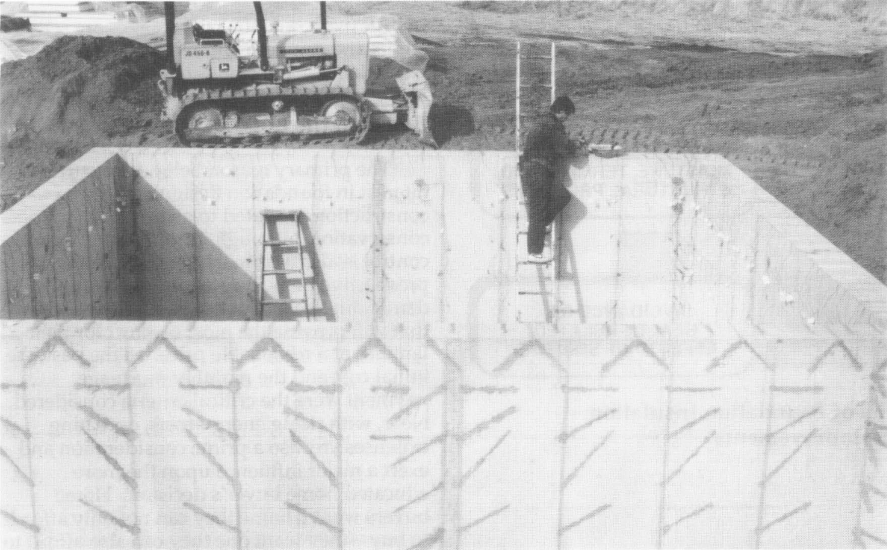

*Figure 1-1: The impact of basement insulation is monitored on several modules at the foundation test facility at the University of Minnesota.*

*Builder’s Foundation Handbook Page 1*

scope of this handbook is described in section

1.2. Before proceeding with solving design and problems, there must be a basic decision about the type of foundation to be used— basement, crawl space, or slab-on-grade. Section 1.3 discusses the considerations that affect choosing a foundation type. While many aspects of foundation design and construction are known to some extent, there

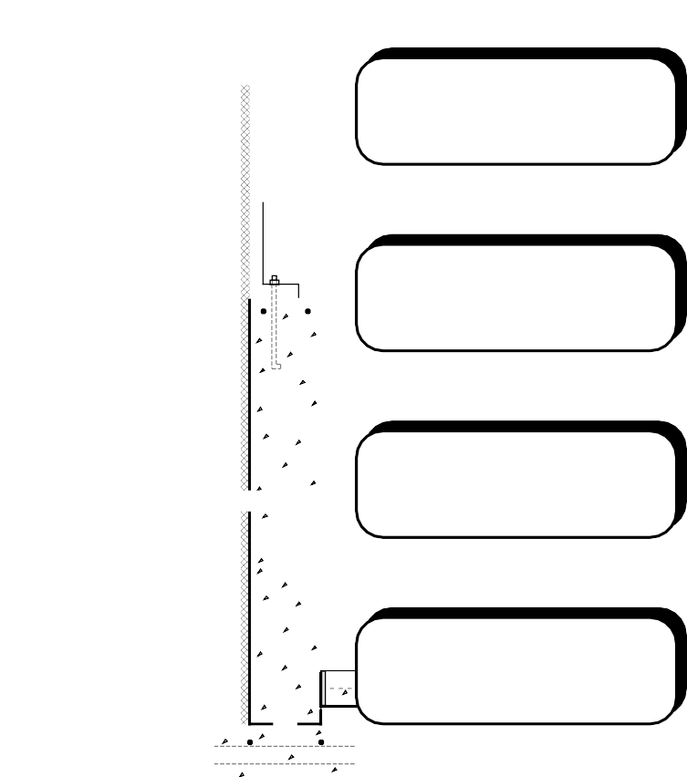

**CREATION OF MORE COMFORTABLE**

**ABOVE-GRADE SPACES**

**REDUCTION IN HOMEOWNER'S UTILITY BILLS**

**CREATION OF MORE USABLE, COMFORTABLE BELOW-GRADE SPACES**

**AVOIDANCE OF COSTLY MOISTURE, TERMITE, AND STRUCTURAL PROBLEMS**

**AVOIDANCE OF HEALTH-RELATED EFFECTS OF SOIL GAS**

##### Figure 1-2: Benefits of Foundation Insulation and Other Design Improvements

is one major concern that is relatively new— controlling radon. Because radon represents a potentially major health hazard, and knowledge about techniques to control it are just emerging, a special introduction to radon appears in section 1.4. This chapter is intended to set the stage for the more detailed information found in chapters 2 through 5.

* 1. **Benefits of Effective Foundation Design**

The practical and economic advantages of following the recommended practices in this handbook are:

* Homeowners' utility bills are reduced.
* Potentially costly future moisture, termite, and even structural problems can be avoided.
* Potentially serious health-related effects of soil gas can be avoided.
* More comfortable above-grade space is created.
* For houses with basements, truly comfortable conditions in below-grade space are created.

All these potential advantages are selling points and can help builders avoid costly callbacks.

##### The Benefits of Foundation Insulation

The primary reason behind the current interest in foundation design and construction is related to energy conservation, although in some areas radon control is also a primary concern. Today's prospective home buyers are increasingly demanding healthy, energy-efficient homes that will provide the most comfort for their families at a reasonable price. In the past, the initial cost and the monthly mortgage payment were the critical criteria considered. Now, with rising energy costs, operating expenses are also a prime consideration and exert a major influence upon the more educated home buyer’s decision. Home buyers want a home they can not only afford to buy—they want one they can also afford to live in.

Home builders and code officials have

*Page 2 Chapter 1—Introduction to Foundation Design*

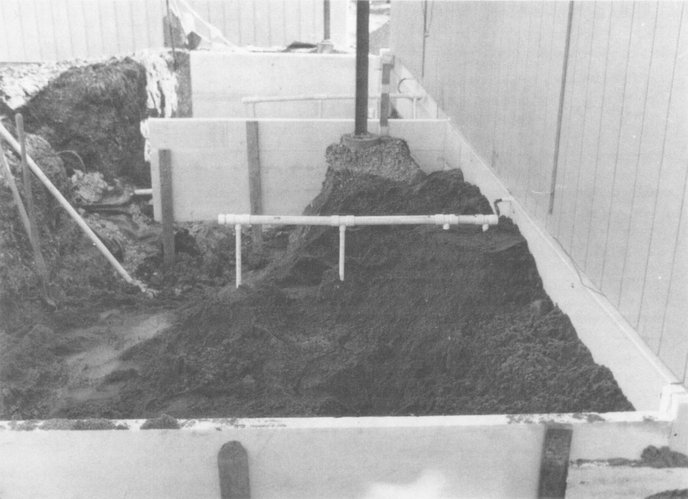

*Figure 1-3: The impact of slab-on-grade foundation insulation is monitored in a test facility at Oak Ridge National Laboratory.*

initially responded to these desires by providing more thermal insulation in the above-grade portions of the home. Attention to the foundation has lagged for the most part, with most effort focused primarily on a foundation's structural adequacy. Lately however, the general awareness of health- oriented, energy-efficient foundation construction practices has increased in the United States. In 1989-90 several national building energy codes and standards were revised to recommend foundation insulation in moderate to cold U.S. climates (those with over 2500 heating degree days). Uninsulated foundations no longer represent 10 to

15 percent of a poorly insulated building’s total heat loss; instead, an uninsulated, conditioned basement may represent up to 50 percent of the heat loss in a tightly sealed house that is well insulated above grade.

In order to develop a better understanding of the impact of foundation insulation and provide information to the building industry and the public, several research activities are proceeding. Two notable projects are the foundation test

facilities located at the University of Minnesota (Figure 1-1), and at Oak Ridge National Laboratory (Figure 1-3).

##### Other Foundation Design Issues

While saving energy may be the primary reason for understanding good foundation design practices, there are other related benefits. For example, insulating any type of foundation is likely to result in warmer floors during winter in above-grade spaces, thus improving comfort as well as reducing energy use. Insulating basement foundations creates more comfortable conditions in

below-grade space as well, making it more usable for a variety of purposes at a relatively low cost. Raising basement temperatures by using insulation can also reduce condensation, thus minimizing problems with mold and mildew.

In addition to energy conservation and thermal comfort, good foundation design must be structurally sound, prevent water and moisture problems, and control termites and radon where appropriate. The

*Builder’s Foundation Handbook Page 3*

importance of these issues increases with an energy-efficient design because there are some potential problems caused by incorrect insulating practices. Under certain circumstances the structural integrity of a foundation can be negatively affected by insulation when water control is not adequate. Without properly installing vapor barriers and adequate air sealing, moisture can degrade foundation insulation and other moisture problems can actually be created. Improperly installed foundation insulation may also provide entry paths for termites.

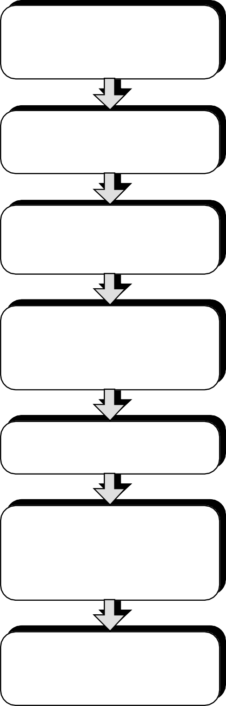

**DETERMINE FOUNDATION TYPE:**

* **BASEMENT**
* **CRAWL SPACE**
* **SLAB-ON-GRADE**

**DETERMINE USE OF BASEMENT:**

* **HEATED / COOLED**
* **UNCONDITIONED**

**DETERMINE CONSTRUCTION SYSTEM:**

* **CONCRETE**
* **MASONRY**
* **WOOD**

**DETERMINE INSULATION PLACEMENT:**

* **INTERIOR / EXTERIOR**
* **VERTICAL / HORIZONTAL**
* **WITHIN STRUCTURE (WOOD JOISTS OR STUDS)**

**DETERMINE AMOUNT OF**

**INSULATION**

**DEVELOP CONSTRUCTION DETAILS:**

* **INSULATION / THERMAL**
* **STRUCTURAL**
* **DRAINAGE AND WATERPROOFING**
* **TERMITE CONTROL**
* **RADON CONTROL**

**FINALIZE CONSTRUCTION**

**DOCUMENTS AND ESTABLISH QUALITY CONTROL INSPECTION PROCEDURES**

Insulating and sealing a foundation to save energy results in a tighter building with less infiltration. If radon is present, it can accumulate and reach higher levels in the building than if greater outside air exchange was occurring. All of these potential side effects can be avoided if recommended practices are followed.

### Organization and Scope of the Handbook

Residential foundations can be constructed which reduce energy consumption without creating health, moisture, radon, structural, or other foundation-related problems. The two basic purposes of this handbook are (1) to provide simplified methods for estimating the site- specific energy savings and cost-effectiveness of foundation insulation measures, and (2) to provide information and construction details concerning thermal protection, subdrainage, waterproofing, structural requirements, radon control, and termite damage prevention.

##### Figure 1-4: Decision-Making Process for Foundation Design

**Handbook Organization**

The book is organized in a manner that reflects the decision-making process used by a designer, builder, or homeowner dealing with foundation design questions (see Figure 1-4). First, one must determine the foundation type and construction to be used. Then, if it is a basement foundation, it must be decided whether the below grade space be heated and / or cooled. These decisions are determined by regional, local, and site- specific factors as well as individual or market preference. Considerations related to choosing a foundation type are discussed

later in chapter 1. The first chapter also includes introductory information on some general concerns that pertain to all foundation types.

After selecting a foundation type, proceed to the corresponding chapter: chapter 2 for basements, chapter 3 for crawl spaces, and chapter 4 for slab-on-grade foundations. Each of these chapters is organized into four parts. The first section of each chapter helps you select a cost-effective insulation placement and amount for a particular climate. The second section summarizes general principles of structural design, drainage and waterproofing, as well as radon and termite control techniques. This is followed by a series of alternative construction details illustrating the integration of the major concerns involved in foundation design. These construction details can be adapted to fit a unique site or building condition. Within each construction drawing are labels that contain numbers within boxes that refer to notes listed at the end of this section. Finally, the last section in chapters 2, 3, and 4 is a checklist to be used during design and construction.

Chapter 5 provides an alternative method for determining the cost- effectiveness of foundation insulation. In the first section of chapters 2, 3, and 4, insulation levels are recommended for each foundation type using a 30-year minimum life cycle cost analysis for several climatic regions in the United States. These are based on average construction costs and representative energy prices for natural gas and electricity. While these tables of recommendations are easy to use and provide good general guidelines, they cannot easily be adapted to reflect other costs and conditions. Therefore, if the assumptions underlying the recommended insulation levels in chapters 2, 3, and 4 do not correspond to local conditions, it is strongly recommended that the user fill out the worksheet provided in chapter 5. This worksheet helps select the optimal level of foundation insulation for site-specific new or retrofit construction. Local energy prices and construction costs can be used in the calculation, and economic decision criteria can be chosen such as 20-year minimum life cycle cost (suggested for retrofit) or 30-year minimum life cycle cost (suggested for new construction).

##### Scope of the Handbook

The information presented in this handbook pertains mostly to new residential construction and small commercial buildings. The handbook covers all three basic foundation types — basement, crawl space, and slab-on-grade. Conventional foundation systems of cast-in-place concrete or concrete block masonry are emphasized, although pressure-preservative-treated wood foundations are also addressed.

The intention of this book is to provide the tools to help people make decisions about foundation design. Often information exists related to a particular building material or product, but this book is one of the few resources that attempts to address the overall integration of a number of systems. While this book does not provide exact construction documents, specifications, and procedures, it provides the basic framework and fundamental information needed to create these documents.

##### Relation to the Previous Handbook

The information in this handbook is drawn mainly from the *Building Foundation Design Handbook* (Labs et al., 1988), a more extensive technical reference manual on foundation design. The original handbook was intended for architects and engineers, while this handbook is intended to serve builders. The first book explained not only what to do in foundation design but also much of the technical rationale behind the recommendations. This book presents what to do in foundation design in a more concise format, and includes a few additions and improvements to the original handbook.

While the intended audience for this book is clearly home builders, the information is pertinent to anyone involved in foundation design and construction decisions including homeowners as well as architects and engineers looking for information in a more concise and updated form.

While this handbook does not include the technical reference information of the original book, notable additions to this version are: (1) the worksheet in chapter 5 which permits energy use calculations based on individual parameters, (2) simplified tables of recommended insulation levels in chapters 2, 3, and 4, (3) distinct insulation recommendations for several subcategories of insulation placement (i.e., interior, exterior,

ceiling, and within wall insulation for basements), (4) construction practice notes linked to the drawings, and (5) drawings that have been revised or replaced. In spite of these improvements, the original *Building Foundation Design Handbook* represents a valuable resource for detailed technical information not found in this book.

### Foundation Type and Construction System

The three basic types of foundations— full basement, crawl space, and slab-on- grade—are shown in Figure 1-5. Of course, actual houses may include combinations of these types. Information on a fourth type of foundation—the shallow or half-bermed basement—can be found in the *Building Foundation Design Handbook* (Labs et al. 1988).

There are several construction systems from which to choose for each foundation type. The most common systems, cast-in- place concrete and concrete block foundation walls, can be used for all four basic foundation types. Other systems include pressure-preservative-treated wood foundations, precast concrete foundation walls, masonry or concrete piers, cast-in- place concrete sandwich panels, and various masonry systems. A slab-on-grade construction with an integral concrete grade beam at the slab edge is common in climates with a shallow frost depth. In colder climates, deeper cast-in-place concrete walls and concrete block walls are more common, although a shallower footing can sometimes be used depending on soil type, groundwater conditions, and insulation placement.

Most of the foundation types and construction systems described above can be designed to meet necessary structural, thermal, radon, termite and moisture or water control requirements. Factors affecting the choice of foundation type and construction system include site conditions, overall building design, the climate, and local market preferences as well as construction costs. These factors are discussed below.

##### Site Conditions

The topography, water table location, presence of radon, soil type, and depth of bedrock can all affect the choice of a

foundation type. Any foundation type can be used on a flat site; however, a sloping site often necessitates the use of a walkout basement or crawl space. On steeper slopes, a walkout basement combines a basement foundation wall on the uphill side, a slab-on- grade foundation on the downhill side, and partially bermed foundation walls on the remaining two sides.

A water table depth within 8 feet of the surface will likely make a basement foundation undesirable. Lowering the water table with drainage and pumping usually cannot be justified, and waterproofing may not be feasible or may be too costly. A water table near the surface generally restricts the design to a slab-on-grade or crawl space foundation.

The presence of expansive clay soils on a site requires special techniques to avoid foundation movement and significant structural damage. Often, buildings placed on sites with expansive clay require pile foundations extending down to stable soil strata or bedrock. Similarly, sites with bedrock near the surface require special foundation techniques. Expensive bedrock excavation is not required to reach frost depth nor is it economically justifiable to create basement space. In these unusual conditions of expansive clay soils or bedrock near the surface, special variations of the typical foundation types may be appropriate.

##### Overall Building Design

The foundation type and construction system are chosen in part because of appearance factors. Although it is not usually a major aesthetic element, the foundation at the base of a building can be raised above the ground plane, so the foundation wall materials can affect the overall appearance. A building with a slab- on-grade foundation has little visible foundation; however, the foundation wall of a crawl space or basement can vary considerably from almost no exposure to full exposure above grade.

##### Climate

The preference of foundation type varies with climatic region, although examples of most types can generally be found in any given region. One of the principal factors behind foundation preference is the impact of frost depth on foundation design. The

impact of frost depth basically arises from the need to place foundations at greater depths in colder climates. For example, a footing in Minnesota must be at least 42 inches below the surface, while in states along the Gulf Coast, footings need not extend below the surface at all in order to avoid structural damage from frost heave. Because a foundation wall extending to a substantial depth is required in northern climates, the incremental cost of creating basement space is much less, since it is necessary to build approximately half the basement wall anyway. In a southern climate the incremental first cost of creating a basement is greater when compared with a slab-on- grade with no significant required footing depth.

This historic perception that foundations must extend below the natural frost depth is not entirely accurate. Buildings with very shallow foundations can be used in cold climates if they are insulated properly.

##### Local Market Preferences and Construction Costs

The foundation type and construction system are also chosen based on cost and market factors that vary regionally or even locally. Virtually any foundation type and construction system can be built in any location in the United States. The relative costs, however, are likely to differ. These costs reflect local material and labor costs as well as the availability of certain materials and the preferences of local contractors. For example, in certain regions there are many contractors specializing in cast-in-place concrete foundation walls. Because they have the concrete forms and the required experience with this system and because bidding is very competitive, this system may be more cost-effective compared with other alternatives. In other regions, the availability of concrete blocks is greater and there are many contractors specializing in masonry foundation walls. In these areas, a cast-in- place concrete system may be less competitive economically because fewer contractors are available.

More subjective factors that influence a designer’s choice of foundation type and construction system are the expectations and preferences of individual clients and the home-buying public. These market influences are based not only on cost but also on the area’s tradition. If people in a certain

region expect basements, then builders generally provide them. Of course, analyzing the cost-effectiveness of providing a basement requires a somewhat subjective judgment concerning the value of basement space. These more subjective market factors and regional preferences tend to increase the availability of materials and contractors for the preferred systems, which in turn makes these systems more cost-effective choices.

###### A: DEEP BASEMENT

**B: CRAWL SPACE**



**C: SLAB-ON-GRADE**

**Figure 1-5: Basic Foundation Types**

* 1. **Radon Mitigation Techniques**

In this introductory chapter radon is addressed because it is a relatively new concern and one in which techniques to deal with it are just emerging.

Radon is a colorless, odorless, tasteless gas found in soils and underground water. An element with an atomic weight of 222, radon is produced in the natural decay of radium, and exists at varying levels throughout the United States. Radon is emitted from the ground to the outdoor air, where it is diluted to an insignificant level by the atmosphere. Because radon is a gas, it can travel through the soil and into a building through cracks, joints, and other openings in the foundation floor and wall.

Earth-based building materials such as cast concrete, concrete masonry, brick, and adobe ordinarily are not significant sources of

indoor radon. Radon from well water sometimes contributes in a minor way to radon levels in indoor air. In a few cases, radon from well water has contributed significantly to elevated radon levels.

##### Health Risk of Radon Exposure

Radon is potentially harmful only if it is in the lungs when it decays into other isotopes (called *radon progeny* or *radon daughters*), and when these further decay.

The decay process releases small amounts of ionizing radiation; this radiation is held responsible for the above-normal incidence of lung cancer found among miners. Most of what is known about the risk of radon exposure is based on statistical analysis of lung cancers in humans (specifically, underground miners) associated with exposure to radon. This information is well documented internationally, although much less is known about the risk of long-term

**CRACKS IN WALLS**



**GAPS IN SUSPENDED FLOORS**

**GAPS AROUND**

**SERVICE PIPES CAVITIES IN MASONRY WALLS**

**CONSTRUCTION JOINT AT SLAB EDGE**

**CRACKS IN FLOOR SLABS**

**CRACKS IN BELOW- GRADE WALLS**

##### Figure 1-6: Points of Radon Entry into Buildings

*Page 8 Chapter 1—Introduction to Foundation Design*

exposure to low concentrations of radon in buildings.

The lung cancer hazard due to radon is a function of the number of radioactive decay events that occur in the lungs. This is related to both intensity and duration of exposure to radon gas and decay products plus the equilibrium ratio. Exposure to a low level of radon over a period of many years in one building can present the same health hazard as exposure to a higher level of radon for a shorter period of time in another building.

The sum of all exposures over the course of one's life determines the overall risk to that individual.

##### Strategies to Control Radon

As a national policy, the public has been urged by the Environmental Protection Agency to consider 4 pCi / L (from long-term radon tests) as an “action level” for both new and existing buildings (EPA 1987). The ASHRAE Standard 62-1989, *Ventilation for Acceptable Indoor Air Quality*, has also recognized this value as a guideline (ASHRAE 1989).

In order to address the radon problem, it is necessary to find out to what degree it is present on the site. Then, depending on the level of concern, various techniques to control radon levels can be applied.

Generally there are three approaches: (1) the barrier approach, (2) soil gas interception, and (3) indoor air management. The barrier approach refers to a set of techniques for constructing a tight building foundation in order to prevent soil gas from entering. Since the barrier approach differs for each foundation type, these techniques are described in chapters 2, 3, and 4 as they apply to basements, crawl spaces, and slab- on-grade foundations. Intercepting soil gas refers to using vent pipes and fans to draw soil gas from a gravel layer beneath the foundation floor slab. Since this approach can be utilized for basements and slab-on- grade foundations, it is described in detail in chapters 2 and 4. The third general approach—managing indoor air—applies to all foundation types and is described below.

##### Managing Indoor Air

Air management techniques may be used to minimize the suction applied to the surrounding soil gas by the building. To control the pressure differential across the

envelope, it is desirable to make the entire building envelope airtight and control the amount of incoming fresh air, exhausted inside air, and supply air for combustion devices. A passive house with no mechanical fans operating at any given condition has a neutral pressure plane where no pressure differential exists across the building envelope. Envelope cracks above this plane exfiltrate and openings below infiltrate.

The principles applied to minimize pressure differences across the building foundation envelope are essentially the same as those recommended for moisture vapor control and energy-efficient design. These include the following:

1. Reduce air infiltration from the unconditioned spaces (crawl spaces, attics, and unconditioned basements) into the occupied space by sealing openings and cracks between the two, including flues, vent stacks, attic hatchways, plumbing, wiring, and duct openings.
2. Consider locating the attic access outside conditioned space (for example, an attached garage).
3. Seal all openings in top and bottom plates of frame construction, including interior partitions.
4. Provide separate outdoor air intakes for combustion equipment.
5. Install an air barrier in all above-grade exterior walls.
6. Adjust ventilation systems to help neutralize imbalances between indoor and outdoor air pressures. Keeping a house under continuous slight positive pressure is a difficult technique to accomplish. At this time whole house, basement, or crawl space pressurization does not appear to be a viable solution to radon control.
7. Do not locate return air ducts in a crawl space or beneath a slab. Placing the HVAC ducting inside the conditioned space will save energy as well.
8. Do not locate supply ducts below concrete slabs on or below grade.
9. Seal all return ductwork located in crawl spaces.
10. Balance the HVAC ducts. System imbalance can lead to pressurization in some zones and depressurization in others.

*Builder’s Foundation Handbook Page 9*

## CHAPTER 2

**Basement Construction**

This chapter summarizes suggested practices related to basements. Section 2.1 presents recommended optimal levels of insulation. Recommendations are given for two distinct basement conditions: (1) a fully conditioned (heated and cooled) deep basement, and (2) an unconditioned deep basement.

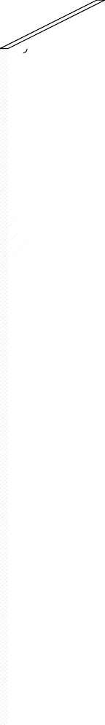

Section 2.2 contains a brief summary of basement design practices and covers structural design, location of insulation, drainage and waterproofing, termite and wood decay control, and radon control.

Section 2.3 includes a series of alternative construction details with accompanying notes indicating specific practices. Section 2.4 is a checklist to be used during the design, construction, and site inspection of a basement.

### Basement Insulation Placement and Thickness

###### Figure 2-1: Concrete Masonry Basement Wall with Exterior Insulation

The term deep basement refers to a 7- to 10-foot basement wall with no more than the upper 25 percent exposed above grade. Fully conditioned means that the basement is heated and cooled to set thermostat levels similar to typical above-grade spaces: at least 70OF during the heating season, and no higher than 78OF during the cooling season.

The unconditioned deep basement is identical to the conditioned deep basement described previously except that the space is not directly heated or cooled to maintain a temperature in the 70OF to 78OF range.

Instead, it is assumed that the basement temperature fluctuates during the year based

*Page 10 Chapter 2—Basement Construction*

on heat transfer between the basement and various other heat sources and sinks including (1) the above-grade space, (2) the surrounding soil, and (3) the furnace and ducts within the basement. Generally, the temperature of the unconditioned space ranges between 55OF and 70OF most of the year in most climates.

**Insulation Configurations**

Tables 2-1 and 2-2 include illustrations and descriptions of a variety of basement insulation configurations. Two basic construction systems are shown—a concrete (or masonry) basement wall and a pressure- preservative-treated wood basement wall.

For conditioned basements, shown in Table 2-1, there are three general approaches to insulating the concrete / masonry wall: (1) on the exterior covering the upper half of the wall, (2) on the exterior covering the entire wall, and (3) on the interior covering the entire wall. With pressure-preservative- treated wood construction, mineral wool batt insulation is placed in the cavities between the wood studs.

Table 2-2, which addresses unconditioned basements, includes the same set of configurations used in Table 2-1 as well as three additional cases where insulation is placed between the floor joists in the ceiling above the unconditioned basement. This approach thermally separates the basement from the above-grade space, resulting in lower basement temperatures in winter and usually necessitating insulation of exposed ducts and pipes in the basement. Basement ceiling insulation can be applied with either construction system — concrete / masonry or wood basement walls — but is most commonly used with concrete / masonry foundations.

##### Recommended Insulation Levels

While increasing the amount of basement insulation produces greater energy savings, the cost of installation must be compared to these savings. Such a comparison can be done in several ways; however, a life cycle cost analysis presented in worksheet form in chapter 5 is recommended. It takes into account a number of economic variables including installation costs, mortgage rates, HVAC efficiencies, and fuel escalation rates. In order to identify the most economical amount of insulation for the basement

configurations shown in Tables 2-1 and 2-2, the case with the lowest 30-year life cycle cost was determined for five U.S. cities at three different fuel cost levels. See the *Building Foundation Design Handbook* (Labs et al. 1988) to find recommendations for a greater number of cities and for a detailed explanation of the methodology. The economic methodology used to determine the insulation levels in Tables 2-1 and 2-2 is consistent with ASHRAE standard 90.2P.

The simple payback averages 13 years for all

U.S. climate zones, and never exceeds 18 years for any of the recommended levels.

Economically optimal configurations are shown by the darkened circles in Tables 2-1 and 2-2 in the following categories:

1. concrete / masonry wall with exterior insulation, (2) concrete / masonry wall with interior insulation without including the cost for interior finish material, (3) concrete / masonry wall with interior insulation which includes the cost for sheetrock, (4) pressure- preservative-treated wood wall insulation, and (5) ceiling insulation (shown only in Table 2-2). Configurations are recommended for a range of climates and fuel prices in each of these categories, but the different categories of cases are not directly compared with each other. In other words, there is an optimal amount of exterior insulation recommended for a given climate and fuel price, and there is a different optimal amount of insulation for interior insulation with sheetrock. Where there is no darkened circle in a particular category, insulation is not economically justified under the assumptions used.

##### Fully Conditioned Basements

For fully conditioned basements with concrete / masonry walls, exterior insulation is justified at three fuel price levels (shown in Table 2-3) in all climate zones except the warmest one, which includes cities such as Los Angeles and Miami. In most locations R- 10 insulation or greater covering the entire wall on the exterior is justified with a fully conditioned basement. For interior insulation even higher levels of insulation are generally recommended ranging from R-11 to R-19 in most cases. Whether or not sheetrock is included in the cost of installation appears to have relatively little impact on the recommendations. For pressure-preservative-treated wood walls, R- 19 insulation is justified in almost all

**Table 2-1: Insulation Recommendations for Fully Conditioned Deep Basements**

**A: Concrete or Masonry Foundation Walls with Exterior Insulation**



**CONFIGURATION**

**DESCRIPTION**

NO INSULATION 4 FT: R-5 RIGID

4 FT: R-10 RIGID

8 FT: R-5 RIGID

8 FT: R-10 RIGID

8 FT: R-15 RIGID

8 FT: R-20 RIGID

**RECOMMENDED CONFIGURATIONS AT THREE FUEL PRICE LEVELS**

**0-2000 HDD 2-4000 HDD 4-6000 HDD 6-8000 HDD 8-10000 HDD (LOS ANG) (FT WORTH) (KAN CITY) (CHICAGO) (MPLS)**

**L M H L M H L M H L M H L M H**

**EXTERIOR: HALF WALL**

**EXTERIOR: FULL WALL**

**B: Concrete or Masonry Foundation Walls with Interior Insulation (Costs do not include interior finish material)**

|  |  |  |  |  |  |  |  |
| --- | --- | --- | --- | --- | --- | --- | --- |
| **INTERIOR: FULL WALL** | | NO INSULATION 8 FT: R-6 RIGID  8 FT: R-8 RIGID  8 FT: R-11 BATT  8 FT: R-19 BATT |  |  |  |  |  |
|  |  |
|  |
|  | |

**C: Concrete or Masonry Foundation Walls with Interior Insulation (Costs include sheetrock on interior wall)**

|  |  |  |  |  |  |  |  |
| --- | --- | --- | --- | --- | --- | --- | --- |
| **INTERIOR: FULL WALL** | | NO INSULATION 8 FT: R-6 RIGID  8 FT: R-8 RIGID  8 FT: R-11 BATT  8 FT: R-19 BATT |  |  |  |  |  |
|  |  |
|  |
|  | |

**D: Pressure-Treated Wood Foundation Walls**

|  |  |  |  |  |  |  |
| --- | --- | --- | --- | --- | --- | --- |
| **WOOD: FULL WALL** | NO INSULATION 8 FT: R-11 BATT  8 FT: R-19 BATT  8 FT: R-30 BATT |  |  |  |  |  |

* 1. L, H, and M refer to the low, medium, and high fuel cost levels indicated in Table 2-3.
  2. The darkened circle represents the recommended level of insulation in each column for each of the four basic insulation configurations.
  3. These recommendations are based on assumptions that are summarized at the end of section 2.1 and further explained in chapter 5.

#### Table 2-2: Insulation Recommendations for Unconditioned Deep Basements

**A: Concrete or Masonry Foundation Walls with Exterior Insulation**



**CONFIGURATION**

**DESCRIPTION**

NO INSULATION 4 FT: R-5 RIGID

4 FT: R-10 RIGID

8 FT: R-5 RIGID

8 FT: R-10 RIGID

8 FT: R-15 RIGID

8 FT: R-20 RIGID

**RECOMMENDED CONFIGURATIONS AT THREE FUEL PRICE LEVELS**

**0-2000 HDD 2-4000 HDD 4-6000 HDD 6-8000 HDD 8-10000 HDD (LOS ANG) (FT WORTH) (KAN CITY) (CHICAGO) (MPLS)**

**L M H L M H L M H L M H L M H**

**EXTERIOR: HALF WALL**

**EXTERIOR: FULL WALL**

**B: Concrete or Masonry Foundation Walls with Interior Insulation (Costs do not include interior finish material)**

|  |  |  |  |  |  |  |  |
| --- | --- | --- | --- | --- | --- | --- | --- |
| **INTERIOR: FULL WALL** | | NO INSULATION 8 FT: R-6 RIGID  8 FT: R-8 RIGID  8 FT: R-11 BATT  8 FT: R-19 BATT |  |  |  |  |  |
|  |  |
|  |
|  | |

              

**C: Concrete or Masonry Foundation Walls with Interior Insulation (Costs include sheetrock on interior wall)**

|  |  |  |  |  |  |  |  |
| --- | --- | --- | --- | --- | --- | --- | --- |
| **INTERIOR: FULL WALL** | | NO INSULATION 8 FT: R-6 RIGID  8 FT: R-8 RIGID  8 FT: R-11 BATT  8 FT: R-19 BATT |  |  |  |  |  |
|  |  |
|  |
|  | |

              

**D: Pressure-Treated Wood Foundation Walls**

|  |  |  |  |  |  |  |
| --- | --- | --- | --- | --- | --- | --- |
| **WOOD: FULL WALL** | NO INSULATION 8 FT: R-11 BATT  8 FT: R-19 BATT  8 FT: R-30 BATT |  |  |  |  |  |

**E: Concrete or Masonry Foundation Walls with Ceiling Insulation**





NO INSULATION R-11 BATT

R-19 BATT R-30 BATT

**CEILING**

1. L, H, and M refer to the low, medium, and high fuel cost levels indicated in Table 2-3.
2. The darkened circle represents the recommended level of insulation in each column for each of the four basic insulation configurations.
3. These recommendations are based on assumptions that are summarized at the end of section 2.1 and further explained in chapter 5.

*Builder’s Foundation Handbook Page 13*

##### Table 2-3: Fuel Price Levels Used to Develop Recommended Insulation Levels in Tables 2-1 and 2-2

|  |  |  |  |  |
| --- | --- | --- | --- | --- |
| **SEASON** | **FUEL TYPE** | **LOW PRICE LEVEL ($)** | **MEDIUM PRICE LEVEL ($)** | **HIGH PRICE LEVEL ($)** |
| **HEATING** | NATURAL GAS FUEL OIL PROPANE | .374 / THERM  .527 / GALLON  .344 / GALLON | .561 / THERM  .791 / GALLON  .516 / GALLON | .842 / THERM  1.187 / GALLON  .775 / GALLON |
| **COOLING** | ELECTRICITY | .051 / KWH | .076 / KWH | .114 / KWH |

locations at all fuel price levels. This is due to the low initial cost of installing insulation within the available stud cavity of the wood foundation.

##### Unconditioned Basements

Compared with recommended insulation levels for fully conditioned basements, lower levels are economically justified in unconditioned basements in most locations due to generally lower basement temperatures. For concrete / masonry walls with exterior insulation, R-5 insulation on the upper wall is justified only in the colder climates at low (L) and medium (M) fuel prices. At the high fuel price level (H), R-5 insulation on the upper wall is justified in moderate climates, while R-10 insulation on the entire wall is recommended in the coldest cities. For interior insulation without sheetrock, R-11 is recommended in moderate to cold climates at all fuel price levels.

Including the cost of sheetrock, however, reduces the number of cases where interior insulation is economically justified. For basements with pressure-preservative- treated wood walls, R-11 to R-19 insulation is justified in moderate to cold climates. When ceiling insulation is placed over an unconditioned basement, R-30 insulation is justified in colder cities and some insulation is justified in most cities.

##### Comparison of Insulation Systems

Generally, insulating pressure- preservative-treated wood walls is more cost- effective than insulating concrete / masonry walls to an equivalent level. This is because the cavity exists between studs in a wood wall system and the incremental cost of installing batt insulation in these cavities is

relatively low. Thus, a higher R-value is economically justified for wood wall systems.

On concrete / masonry basement walls, interior insulation is generally more cost- effective than an equivalent amount of exterior insulation. This is because the labor and material costs for rigid insulation with protective covering required for an exterior installation typically exceed the cost of interior insulation. Even though the cost of studs and sheetrock may be included in an interior installation, the incremental cost of batt installation is relatively little. If rigid insulation is used in an interior application, the installation cost is less than placing it on the exterior. Because it does not have to withstand exposure to water and soil pressure below grade as it does on the exterior, a less expensive material can be used. Costs are further reduced since interior insulation does not require a protective flashing or coating to prevent degradation from ultraviolet light as well as mechanical deterioration.

Insulating the ceiling of an unconditioned basement is generally more cost-effective than insulating the walls of an unconditioned basement to an equivalent level. This is because placing batt insulation into the existing spaces between floor joists represents a much smaller incremental cost than placing insulation on the walls. Thus higher levels of ceiling insulation can be economically justified when compared to wall insulation.

In spite of the apparent energy efficiency of wood versus concrete / masonry basement walls, this is only one of many cost and performance issues to be considered.

Likewise, on a concrete / masonry foundation wall, the economic benefit of interior versus exterior insulation may be offset by other practical, performance, and aesthetic

*Page 14 Chapter 2—Basement Construction*

considerations discussed elsewhere in this book. Although ceiling insulation in an unconditioned basement appears more cost- effective than wall insulation, this approach may be undesirable in colder climates since pipes and ducts may be exposed to freezing temperatures and the space will be unusable for many purposes. In all cases the choice of foundation type and insulation system must be based on many factors in addition to energy cost-effectiveness.

##### Assumptions

These general recommendations are based on a set of underlying assumptions. Fuel price assumptions used in this analysis are shown in Table 2-3. The total heating system efficiency is 68 percent and the cooling system SEER is 9.2 with 10 percent duct losses. Energy price inflation and mortgage conditions are selected to allow maximum simple payback of 18 years with average paybacks of about 13 years.

The total installed costs for all insulation systems considered in this analysis are shown in Table 5-2 in chapter 5. Installation costs used in this analysis are based on average U.S. costs in 1987. For the exterior cases, costs include labor and materials for extruded polystyrene insulation and the required protective covering and flashing above grade. For the interior cases, costs include labor and materials for expanded polystyrene (R-6 and R-8) and wood framing with fiberglass batts (R-11 and R-19). The installed costs and R-values for all interior

cases are shown with and without interior finish material. All costs include a 30 percent builder markup and a 30 percent subcontractor markup for overhead and profit.

With pressure-preservative-treated wood construction, batt insulation is placed in the cavities between the wood studs. Costs used in the analysis reflect only the additional cost of installing the insulation, not the interior finish which might be used with or without insulation. A higher cost increment is used when R-30 insulation is placed in a wood wall reflecting the additional depth required in the studs.

If the general assumptions used in this analysis are satisfactory for the specific project, the reader can determine the approximate recommended insulation level for a location by finding the heating degree days from Table 5-1 in chapter 5 and selecting the appropriate climate zone and fuel price level shown in Tables 2-1 and 2-2. If not, project-specific optimal insulation levels can be determined using actual estimated construction costs with the worksheet provided in chapter 5. The worksheet enables the user to select economic criteria other than allowing maximum simple paybacks of 18 years. In addition the user can incorporate local energy prices, actual

insulation costs, HVAC efficiencies, mortgage conditions, and fuel escalation rates. Cost- effectiveness can vary considerably, depending on the construction details and cost assumptions.

### Recommended Design and Construction Details

#### STRUCTURAL DESIGN

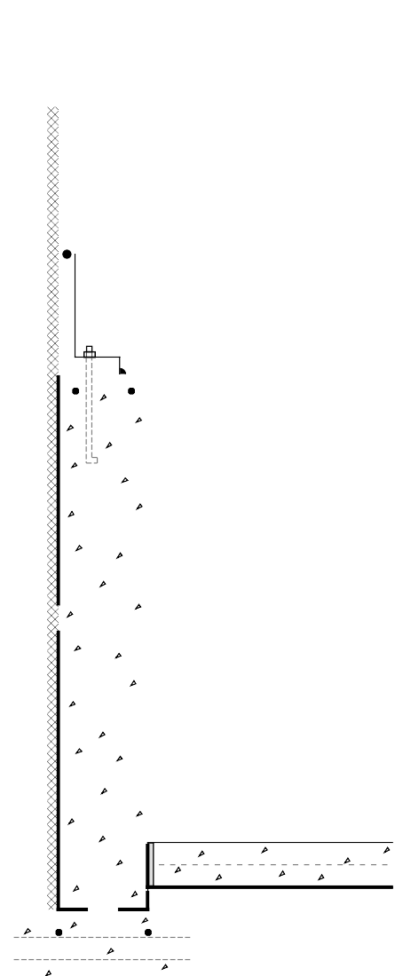

**ANCHOR BOLT CONNECTS FOUNDATION WALL TO SUPERSTRUCTURE AND RESISTS WIND UPLIFT**

**WALL RESISTS VERTICAL LOAD FROM ABOVE-GRADE STRUCTURE**

**WALL RESISTS LATERAL LOAD FROM SOIL**

**SPREAD FOOTING DISTRIBUTES VERTICAL LOAD TO GROUND**

**SLAB SUPPORTS FLOOR LOAD FROM BASEMENT**

##### Figure 2-2: Components of Basement Structural System

The major structural components of a basement are the wall, the footing, and the floor (see Figure 2-2). Basement walls are typically constructed of cast-in-place concrete, concrete masonry units, or pressure-preservative-treated wood.

Basement walls must be designed to resist lateral loads from the soil and vertical loads from the structure above. The lateral loads on the wall depend on the height of the fill, the soil type, soil moisture content, and whether the building is located in an area of low or high seismic activity. Some simple guidelines for wall thickness, concrete strength, and reinforcing are given in the construction details that follow. Where simple limits are exceeded, a structural engineer should be consulted.

Concrete spread footings provide support beneath basement concrete and masonry walls and columns. Footings must be designed with adequate size to distribute the load to the soil. Unless founded on bedrock or proven non-frost-susceptible soils, footings must be placed beneath the maximum frost penetration depth or be insulated to prevent frost penetration. A compacted gravel bed serves as the footing under a wood foundation wall when designed in accordance with the National Forest Products Association’s wood foundations design specifications (NFPA 1987).

Concrete slab-on-grade floors are generally designed to have sufficient strength to support floor loads without reinforcing when poured on undisturbed or compacted soil. The use of welded wire fabric and concrete with a low water / cement ratio can reduce shrinkage cracking, which is an important concern for appearance and for reducing potential radon infiltration.

Where expansive soils are present or in areas of high seismic activity, special foundation construction techniques may be necessary. In these cases, consultation with local building officials and a structural engineer is recommended.

#### DRAINAGE AND WATERPROOFING

Keeping water out of basements is a major concern in many regions. The source of water is primarily from rainfall, snow melt, and sometimes irrigation on the surface. In some cases, the groundwater table is near or above the basement floor level at times during the year. There are three basic lines of defense against water problems in basements: (1) surface drainage, (2) subsurface drainage, and (3) dampproofing or waterproofing on the wall surface (see Figure 2-3).

The goal of surface drainage is to keep water from surface sources away from the foundation by sloping the ground surface and using gutters and downspouts for roof drainage. The goal of subsurface drainage is to intercept, collect, and carry away any water in the ground surrounding the basement. Components of a subsurface system can include porous backfill, drainage mat materials or insulated drainage boards, and perforated drainpipes in a gravel bed along the footing or beneath the slab that drain to a sump or to daylight. Local conditions will determine which of these subsurface drainage system components, if any, are recommended for a particular site.

The final line of defense— waterproofing—is intended to keep out water that finds its way to the wall of the structure. First, it is important to distinguish between the need for dampproofing versus waterproofing. In most cases a dampproof coating covered by a 4-mil layer of polyethylene is recommended to reduce vapor and capillary draw transmission from the soil through the basement wall. A dampproof coating, however, is not effective in preventing water from entering through the wall. Waterproofing is recommended (1) on sites with anticipated water problems or poor drainage, (2) when finished basement space is planned, or (3) on any foundation built where intermittent hydrostatic pressure occurs against the basement wall due to rainfall, irrigation, or snow melt. On sites where the basement floor could be below the water table, a crawl space or slab-on-grade foundation is recommended.

##### Figure 2-3: Components of Basement Drainage and Waterproofing Systems

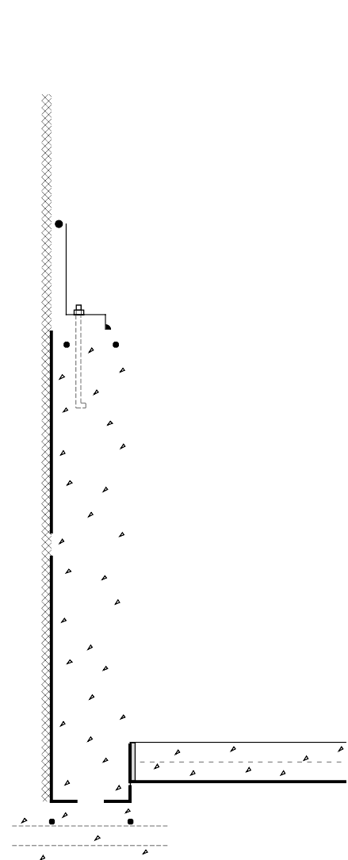

1. **SURFACE DRAINAGE SYSTEM COMPONENTS**
   * **SLOPE GROUND AWAY**
   * **IMPERMEABLE TOPSOIL**
   * **GUTTERS AND DOWNSPOUTS**
2. **SUBSURFACE DRAINAGE SYSTEM COMPONENTS**
   * **POROUS BACKFILL OR DRAINAGE MAT**
   * **DRAIN PIPES IN GRAVEL BED ALONG FOOTING**
   * **GRAVEL LAYER UNDER FLOOR SLAB**
   * **PIPES DRAIN TO A SUMP OR DAYLIGHT**
3. **DAMPPROOFING OR WATERPROOFING SYSTEM COMPONENTS**
   * **MATERIAL APPLIED DIRECTLY TO WALL EXTERIOR**
   * **PROTECTION BOARD OFTEN REQUIRED**

#### LOCATION OF INSULATION

A key question in foundation design is whether to place insulation inside or outside the basement wall. In terms of energy use, there is not a significant difference between the same amount of full wall insulation applied to the exterior versus the interior of a concrete or masonry wall. However, the installation costs, ease of application, appearance, and various technical concerns can be quite different. Individual design considerations as well as local costs and practices determine the best approach for each project.

Rigid insulation placed on the exterior surface of a concrete or masonry basement wall has some advantages over interior placement in that it (1) can provide continuous insulation with no thermal bridges, (2) protects and maintains the waterproofing and structural wall at moderate temperatures, (3) minimizes moisture condensation problems, and (4) does not reduce interior basement floor area. Exterior insulation at the rim joist leaves joists and sill plates open to inspection from the interior for termites and decay. On the other hand, exterior insulation on the wall can provide a path for termites if not treated adequately and can prevent inspection of the wall from the exterior.

Interior insulation is an effective alternative to exterior insulation. Interior insulation placement is generally less expensive than exterior placement if the cost of the interior finish materials is not included. However, this does not leave the wall with a finished, durable surface. Energy savings may be reduced with some systems and details due to thermal bridges. For example, partial interior wall insulation is not recommended because of the possible circumventing of the insulation through the wall construction. Insulation can be placed on the inside of the rim joist but with greater risk of condensation problems and less access to wood joists and sills for termite inspection from the interior.

Insulation placement in the basement ceiling of an unconditioned basement is another acceptable alternative. This approach is relatively low in cost and provides significant energy savings.

However, ceiling insulation should be used with caution in colder climates where pipes may freeze and structural damage may result from lowering the frost depth.

With a wood foundation system, insulation is placed in the stud cavities similarly to insulation in an above-grade wood frame wall. A 2-inch air space should be provided between the end of the insulation and the bottom plate of the foundation wall. This approach has a relatively low cost and provides sufficient space for considerable insulation thickness.

In addition to more conventional interior or exterior placement covered in this handbook, there are several systems that incorporate insulation into the construction of the concrete or masonry walls. These include (1) rigid foam plastic insulation cast within a concrete wall, (2) polystyrene beads or granular insulation materials poured into the cavities of conventional masonry walls,

1. systems of concrete blocks with insulating foam inserts, (4) formed, interlocking rigid foam units that serve as a permanent, insulating form for cast-in-place concrete, and (5) masonry blocks made with polystyrene beads instead of aggregate in the concrete mixture, resulting in significantly higher R-values. However, the effectiveness of systems that insulate only a portion of the wall area should be evaluated closely because thermal bridges through the insulation can impact the total performance significantly.

#### TERMITE AND WOOD DECAY CONTROL TECHNIQUES

Techniques for controlling the entry of termites through residential foundations are advisable in much of the United States (see Figure 2-4). The following recommendations apply where termites are a potential problem. Consult with local building officials and codes for further details.

* 1. Minimize soil moisture around the basement by using gutters, downspouts, and runouts to remove roof water, and by installing a complete subdrainage system around the foundation.
  2. Remove all roots, stumps, and scrap wood from the site before, during, and after construction, including wood stakes and formwork from the foundation area.
  3. Treat soil with termiticide on all sites vulnerable to termites.
  4. Place a bond beam or course of cap blocks on top of all concrete masonry foundation walls to ensure that no open cores

are left exposed. Alternatively, fill all cores on the top course with mortar, and reinforce the mortar joint beneath the top course.

* 1. Place the sill plate at least 8 inches above grade; it should be pressure- preservative treated to resist decay. The sill plate should be visible for inspection from the interior. Since termite shields are often damaged or not installed carefully enough, they are considered optional and should not be regarded as sufficient defense by themselves.

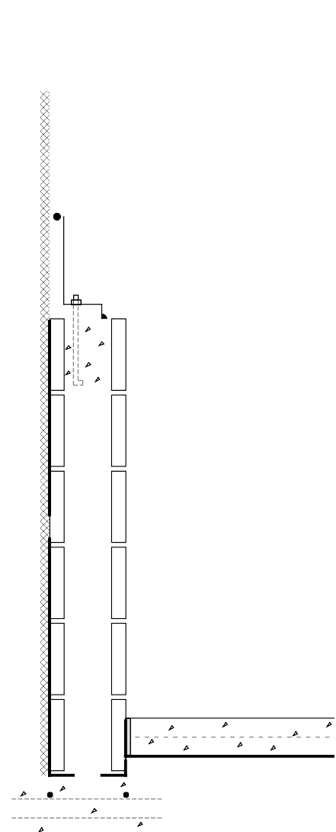

**PRESSURE-PRESERVATIVE TREATED SILL PLATE**

**8-IN. MIN. ABOVE GRADE**

**WOOD SIDING 6-IN. MIN. ABOVE GRADE**

**BOND BEAM, CAP BLOCK, OR FILLED UPPER COURSE OF MASONRY WALL**

**TREAT SOIL FOR TERMITES**

**WOOD POSTS SHOULD BE TREATED OR PLACED ON A 1-IN. PEDESTAL**

**PLACE FLASHING OVER HOLLOW METAL POSTS**

**REMOVE ROOTS, TRUNKS, AND SCRAP WOOD FROM FOUNDATION AREA**

**MINIMIZE SOIL MOISTURE**

* **USE GUTTERS AND DOWNSPOUTS**
* **INSTALL SUBSURFACE DRAINAGE SYSTEM**

**FILL JOINT WITH CAULKING**

* 1. Be sure that exterior wood siding and trim is at least 6 inches above grade.
  2. Construct porches and exterior slabs so that they slope away from the foundation wall, and are at least 2 inches below exterior siding. In addition, porches and exterior slabs should be separated from all wood members by a 2-inch gap visible for inspection or by a continuous metal flashing soldered at all seams.
  3. Fill the joint between the slab floor and foundation wall with urethane caulk or coal tar pitch to form a termite barrier.
  4. Use pressure-preservative-treated wood posts on the basement floor slab, or place posts on flashing or a concrete pedestal raised 1 inch above the floor.
  5. Flash hollow steel columns at the top to stop termites. Solid steel bearing plates can also serve as a termite shield at the top of a wood post or hollow steel column.

Plastic foam and mineral wool insulation materials have no food value to termites, but they can provide protective cover and easy tunnelling. Insulation installations can be detailed for ease of inspection, although often by sacrificing thermal efficiency. In principle, termite shields offer protection, but should not be relied upon as a barrier.

These concerns over insulation and the unreliability of termite shields have led to the conclusion that soil treatment is the most effective technique to control termites with an insulated foundation. However, the restrictions on widely used termiticides may make this option either unavailable or cause the substitution of products that are more expensive and possibly less effective. This situation should encourage insulation techniques that enhance visual inspection and provide effective barriers to termites.

##### Figure 2-4: Termite Control Techniques for Basements

**RADON CONTROL TECHNIQUES**

Construction techniques for minimizing radon infiltration into the basement are appropriate where there is a reasonable probability that radon may be present (see Figure 2-5). To determine this, contact the state health department or environmental protection office. General approaches to minimizing radon include (1) sealing joints, cracks, and penetrations in the foundation, and (2) evacuating soil gas surrounding the basement.

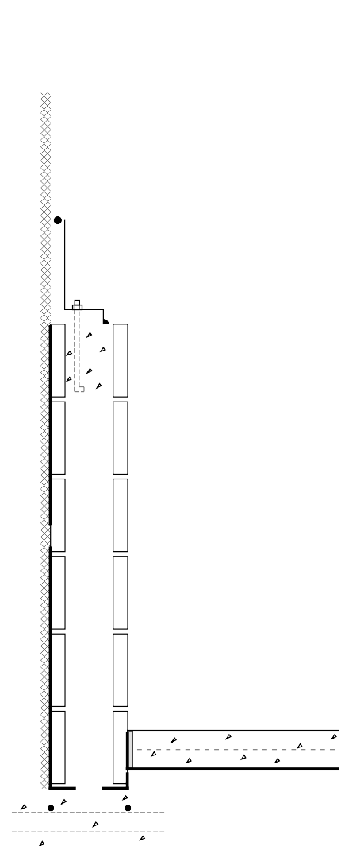

##### Sealing the Basement Floor

**PARGE MASONRY WALL INSTALL DRAINAGE**

**BOARD TO PROVIDE**

**ESCAPE FOR SOIL GAS**

**DAMPPROOFING OR WATERPROOFING**

**SOLID BLOCK OR FILL LOWER COURSE SOLID**

**REINFORCE WALLS AND FOOTING TO MINIMIZE CRACKING**

**BOND BEAM, CAP BLOCK, OR FILLED UPPER COURSE OF MASONRY WALL**

**SEAL AROUND ALL DOORS, DUCTS OR PIPES IN WALLS, FLOORS, OR LEADING TO ADJACENT CRAWL SPACES**

**USE SOLID DRAINPIPES IN FLOOR WITH MECHANICAL TRAPS**

**POLYURETHANE CAULKING IN JOINT**

**REINFORCE SLAB AND USE CONCRETE WITH LOW WATER/CEMENT RATIO TO REDUCE CRACKING**

1. **MIL POLY LAYER UNDER SLAB SEALED TO WALL**
   1. Use solid pipes for floor discharge drains to daylight, or mechanical traps that discharge to subsurface drains.
   2. Use a 6-mil (minimum) polyethylene film beneath the slab on top of the gravel drainage bed. This film serves as a radon and moisture retarder and also prevents concrete from infiltrating the aggregate base under the slab as it is cast. Slit an “x” in the polyethylene membrane to receive penetrations. Turn up the tabs and tape them. Care should be taken to avoid unintentionally puncturing the barrier; consider using rounded riverbed gravel if possible. The riverbed gravel allows for freer movement of the soil gas and also offers no sharp edges to penetrate the polyethylene. The edges of the film should be lapped at least 12 inches. The polyethylene should extend over the top of the footing, or be sealed to the foundation wall. A 2-inch-thick sand layer on top of the polyethylene improves concrete curing and offers some protection from puncture of the polyethylene during the concrete pouring operation.
   3. Tool the joint between the wall and slab floor and seal with polyurethane caulk, which adheres well to concrete and is long- lasting.
   4. Avoid perimeter gutters around the slab that provide a direct opening to the soil

##### Figure 2-5: Radon Control Techniques for Basements

beneath the slab.

* 1. Minimize shrinkage cracking by keeping the water content of the concrete as low as possible. If necessary, use plasticizers, not water, to increase workability.
  2. Reinforce the slab with wire mesh or fibers to reduce shrinkage cracking, especially near the inside corner of “L” shaped slabs.

*Page 20 Chapter 2—Basement Construction*

* 1. Where used, finish control joints with a 1 / 2-inch depression and fully fill this recess with polyurethane or similar caulk.
  2. Minimize the number of pours to avoid cold joints. Begin curing the concrete immediately after the pour, according to recommendations of the American Concrete Institute (1980; 1983). At least three days are required at 70OF, and longer at lower temperatures. Use an impervious cover sheet or wetted burlap to facilitate curing. The National Ready Mix Concrete Association suggests a pigmented curing compound should also be used.
  3. Form a gap of at least 1 / 2-inch width around all plumbing and utility lead-ins through the slab to a depth of at least 1 / 2 inch. Fill with polyurethane or similar caulking.
  4. Do not install sumps within basements in radon-prone areas unless absolutely necessary. Where used, cover the sump pit with a sealed lid and vent to the outdoors. Use submersible pumps.
  5. Install mechanical traps at all necessary floor drains discharging through the gravel beneath the slab.
  6. Place HVAC condensate drains so that they drain to daylight outside of the building envelope. Condensate drains that connect to dry wells or other soil may become direct paths for soil gas, and can be a major entry point for radon.
  7. Seal openings around water closets, tub traps, and other plumbing fixtures (consider nonshrinkable grout).

##### Sealing the Basement Walls

1. Reinforce walls and footings to minimize shrinkage cracking and cracking due to uneven settlement.
2. To retard movement of radon through hollow core masonry walls, the top and bottom courses of hollow masonry walls should be solid block, or filled solid. If the top side of the bottom course is below the level of the slab, the course of block at the intersection of the bottom of the slab should be filled. Where a brick veneer or other masonry ledge is installed, the course immediately below that ledge should also be solid block.
3. Parge and seal the exterior face of below-grade concrete masonry walls in contact with the soil. Install drainage boards to provide an airway for soil gas to reach the surface outside the wall rather than being drawn through the wall.
4. Install a continuous dampproofing or waterproofing membrane on the exterior of the wall. Six-mil polyethylene placed on the exterior of the basement wall surface will retard radon entry through wall cracks.
5. Seal around plumbing and other utility and service penetrations through the wall with polyurethane or similar caulking. Both the exterior and the interior of concrete masonry walls should be sealed at penetrations.
6. Install airtight seals on doors and other openings between a basement and adjoining crawl space.
7. Seal around ducts, plumbing, and other service connections between a basement and a crawl space.

##### Intercepting Soil Gas

At this time the best strategy for mitigating radon hazard seems to be to reduce stack effects by building a tight foundation in combination with a generally tight above-grade structure, and to make sure a radon collection system and, at the very least, provisions for a discharge system are an integral part of the initial construction.

This acts as an insurance policy at modest cost. Once the house is built, if radon levels are excessive, a passive discharge system can be connected and if further mitigation effort is needed, the system can be activated by installing an in-line duct fan (see Figure 2-6).

Subslab depressurization has proven to be an effective technique for reducing radon concentrations to acceptable levels, even in homes with extremely high concentrations (Dudney 1988). This technique lowers the pressure around the foundation envelope, causing the soil gas to be routed into a collection system, avoiding the inside spaces and discharging to the outdoors. This system could be installed in two phases. The first phase is the collection system located on the soil side of the foundation, which should be installed during construction. The collection system, which may consist of nothing more than 4 inches of gravel beneath the slab floor, can be installed at little or no additional cost

**ROOF VENT FOR**



**SOIL GAS DISCHARGE**

**DISCHARGE FAN LOCATED IN ATTIC**

**RISER PIPES FROM SUMP AND AREA UNDER SLAB**

**STANDPIPES CAN BE CAPPED FOR FUTURE USE**

**REINFORCED FOOTING OVER PIPE TRENCH**

**CONCRETE SLAB OVER POLY VAPOR BARRIER**

**SEALED SUMP PIT COVER**

**SUCTION TAP CAST IN SLAB**

**NEAR SUMP**

**MONOLITHIC CONCRETE OR SOLID PLASTIC SUMP WITH PUMP**

**PERIMETER DRAINPIPE AT FOOTING DRAINS TO SUMP**

##### Figure 2-6: Soil Gas Collection and Discharge Techniques

in new construction. The second phase is the discharge system, which could be installed later if necessary.

A foundation with good subsurface drainage already has a collection system. The underslab gravel drainage layer can be used to collect soil gas. It should be at least 4 inches thick, and of clean aggregate no less than 1 / 2 inch in diameter. Weep holes provided through the footing or gravel bed extending beyond the foundation wall will

help assure good air communication between the foundation perimeter soil and the underside of the slab. The gravel should be covered with a 6-mil polyethylene radon and moisture retarder, which in turn could be covered with a 2-inch sand bed.

A 3- or 4-inch diameter PVC 12-inch section of pipe should be inserted vertically into the subslab aggregate and capped at the top. Stack pipes could also be installed horizontally through below-grade walls to the area beneath adjoining slabs. A single standpipe is adequate for typical house-size floors with a clean, coarse gravel layer. If necessary, the standpipe can be uncapped and connected to a vent pipe. The standpipe can also be added by drilling a 4-inch hole through the finished slab. The standpipe should be positioned for easy routing to the roof through plumbing chases, interior walls, or closets. Note, however, that it is normally less costly to complete the vent stack routing through the roof during construction than to install or complete the vent stack after the building is finished. Connecting the vent pipe initially without the fan provides a passive depressurization system which may be adequate in some cases and could be designed for easy modification to an active system if necessary.

A subslab depressurization system requires the floor slab to be nearly airtight so that collection efforts are not short-circuited by drawing excessive room air down through the slab and into the system. Cracks, slab penetrations, and control joints must be sealed. Sump hole covers should be designed and installed to be airtight. Floor drains that discharge to the gravel beneath the slab should be avoided, but when used, should be fitted with a mechanical trap capable of providing an airtight seal.

Another potential short circuit can occur if the subdrainage system has a gravity discharge to an underground outfall. This discharge line may need to be provided with a mechanical seal. The subsurface drainage

discharge line, if not run into a sealed sump, should be constructed with a solid-glued drainpipe that runs to daylight. The standpipe should be located on the opposite side from this drainage discharge.

It is desirable to avoid dependence on a continuously operating fan. Ideally, a passive depressurization system should be installed, radon levels tested and, if necessary, the system activated by adding a fan. Active systems use quiet, in-line duct fans to draw gas from the soil. The fan should be located in an accessible section of the stack so that any leaks from the positive pressure side of the fan are not in the living space. The fan should be oriented to prevent accumulation of condensed water in the fan housing. The stack should be routed up through the building and extend 2 to 4 feet above the roof. It can also be carried out through the band joist and up along the outside of wall, to a point at or above the eave line. The exhaust should be located away from doors and windows to avoid re- entry of the soil gas into the above-grade space.

A fan capable of maintaining 0.2 inch of water suction under installation conditions is adequate for serving subslab collection systems for most houses (Labs 1988). This is often achieved with a 0.03 hp (25W), 160 cfm centrifugal fan (maximum capacity) capable of drawing up to 1 inch of water before stalling. Under field conditions of 0.2 inch of water, such a fan operates at about 80 cfm.

It is possible to test the suction of the subslab system by drilling a small (1 / 4-inch) hole in an area of the slab remote from the collector pipe or suction point, and measuring the suction through the hole. A suction of 5 Pascals is considered satisfactory. The hole must be sealed after the test.

Active subslab depressurization does raise some long-term concerns which at this time are not fully understood. If the radon barrier techniques are not fully utilized along with the subslab depressurization, considerable indoor air could be discharged, resulting in a larger than expected energy penalty. System durability is of concern, particularly motor-driven components. This system is susceptible to owner interference.

### Basement Construction Details

In this section several typical basement wall sections are illustrated and described. Figures 2-8 through 2-10 show configurations with insulation on the exterior surface of basement walls. A typical interior placement configuration is shown in Figure 2-11. Figure 2-12 illustrates ceiling insulation over an unconditioned basement. A typical wood foundation wall section is shown in Figure 2-

13. Included in this group of details are variations in construction systems, use of insulation under the slab, and approaches to insulating rim joists. Numbers that occur within boxes in each drawing refer to the

notes on pages 31 and 32 that follow the drawings (see Figure 2-7).

The challenge is to develop integrated solutions that address all key considerations without unnecessarily complicating construction or increasing the cost. There is no one set of perfect solutions; recommended practices or details often represent compromises and trade-offs. For example, in some regions termite control may be considered more critical than thermal considerations, while the reverse is true elsewhere. No particular approach, such as interior versus exterior insulation, is considered superior in all cases. The purpose of this section is to show and describe a variety of reasonable alternatives. Individual circumstances will dictate final design choices.

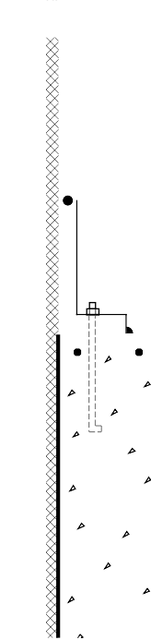

**RIM JOIST**

**PROTECTION BOARD OR COATING EXTENDS 6 IN. BELOW GRADE 1**

**GROUND SLOPES AWAY FROM WALL AT 5% (6" IN 10 FT) 2**

**7-IN. MIN.**

**8-IN. MIN.**

###### Figure 2-7: System of Key Numbers in Construction Drawings

EXAMPLE OF NOTES CORRESPONDING TO CONSTRUCTION DRAWING:

1. **Insulation protection:** Exterior insulation materials should not be exposed above grade. They should be covered by a protective material — such as exterior grade plastic, fiberglass, galvanized metal or aluminum flashing, a cementitious coating, or a rigid protection board — extending at least 6 inches below grade.
2. **Surface drainage:** The ground surface should slope downward at least 5 percent (6 inches) over the first 10 feet surrounding the basement wall to direct surface runoff away from the building. Downspouts and gutters should be used to collect roof drainage and direct it away from the foundation walls.

**that Refer to Notes on Following Pages**

**EXTERIOR SIDING**

**RIGID INSULATION SHEATHING**

**RIM JOIST**

**BATT INSULATION VAPOR RETARDER**

**GYPSUM BOARD SUBFLOOR**

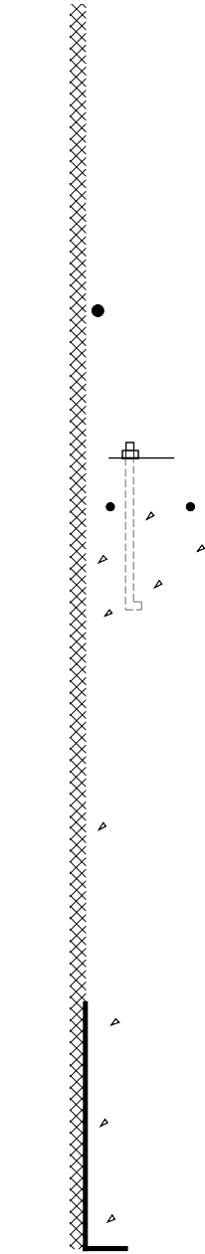

**SEALANT, CAULKING**

**OR GASKET (OPTIONAL) 10**

**PRESSURE-TREATED SILL PLATE 11**

**PROTECTION BOARD OR COATING EXTENDS 6 IN. BELOW GRADE 1**

**GROUND SLOPES AWAY FROM WALL AT 5% (6" IN 10 FT) 2**

**8-IN. MIN.**

**7-IN. MIN.**

**REINFORCING (OPTIONAL) 12**

**1/2-IN. ANCHOR BOLTS AT 6 FT. O. C. MAX. 13**

*Figure 2-8 illustrates a concrete foundation wall with exterior insulation. The rigid insulation also serves as sheathing over the 2 x 4 wood frame wall above grade. This approach can be used for rigid insulation that is 1.5 inches thick or less.*

**LOW PERMEABILITY SOIL (OPTIONAL) 3**

**DRAINAGE MAT, INSULATING DRAINAGE BOARD, OR GRANULAR BACKFILL (OPTIONAL) 4**

**RIGID INSULATION 5**

**DAMPPROOFING OR WATERPROOFING 6**

**FILTER FABRIC ABOVE GRAVEL (OPTIONAL ON SIDES AND BELOW) 7**

**COARSE GRAVEL**

**CONCRETE FOUNDATION WALL 14**

**ISOLATION JOINT 15**

**4-IN. CONCRETE SLAB WITH OPTIONAL**

**W. W. MESH 16**

**VAPOR RETARDER 17**

**4-IN. PERFORATED DRAIN PIPE WITH HOLES FACING DOWN (OPTIONAL) 8**

**CONCRETE FOOTING 9**

**4-IN. GRAVEL DRAINAGE LAYER (OPTIONAL) 18**

**THROUGH WALL MOISTURE BARRIER / KEYWAY (OPTIONAL) 19**

**2-IN. DIAMETER WEEP HOLES**

**AT 8 FT. O. C. MAX. (OPTIONAL) 20 REINFORCING (OPTIONAL) 21**

**Figure 2-8: Concrete Basement Wall with Exterior Insulation**

*Builder’s Foundation Handbook Page 25*

**EXTERIOR SIDING SHEATHING**

**2 x 6 FRAME WALL OVERHANGS RIM JOIST UP TO 2 IN.**

**BATT INSULATION VAPOR RETARDER GYPSUM BOARD SUBFLOOR**

**RIGID INSULATION RIM JOIST**

**SEALANT, CAULKING**

**OR GASKET (OPTIONAL) 10**

**5**

**PRESSURE-TREATED SILL PLATE 11**

*Figure 2-9 illustrates a concrete foundation wall with exterior insulation. This differs from Figure 2-8 in that the above grade wood frame wall is constructed of 2 x 6's which overhang the foundation wall. The overhang can be up to 2 inches but additional rigid insulation can be added that extends over the entire wall*

**PROTECTION BOARD OR COATING EXTENDS 6 IN. BELOW GRADE 1**

**GROUND SLOPES AWAY FROM WALL AT 5% (6" IN 10 FT) 2**

**8-IN. MIN.**

**7-IN. MIN.**

**REINFORCING (OPTIONAL) 12**

**1/2-IN. ANCHOR BOLTS AT 6 FT. O. C. MAX. 13**

*assembly. Another minor difference is that this figure shows a sand layer beneath the floor slab.*

**LOW PERMEABILITY SOIL**

**(OPTIONAL) 3**

**DRAINAGE MAT, INSULATING DRAINAGE BOARD, OR GRANULAR BACKFILL (OPTIONAL) 4**

**RIGID INSULATION 5**

**DAMPPROOFING OR WATERPROOFING 6**

**FILTER FABRIC ABOVE GRAVEL (OPTIONAL ON SIDES AND BELOW) 7**

**COARSE GRAVEL**

**CONCRETE FOUNDATION WALL 14**

**ISOLATION JOINT 15**

**4-IN. CONCRETE SLAB WITH OPTIONAL**

**W. W. MESH 16**

**2-IN. SAND LAYER (OPTIONAL) 16**

**VAPOR RETARDER 17**

**4-IN. PERFORATED DRAIN PIPE WITH HOLES FACING DOWN (OPTIONAL) 8**

**CONCRETE FOOTING 9**

**4-IN. GRAVEL DRAINAGE LAYER (OPTIONAL) 18**

**THROUGH WALL MOISTURE BARRIER / KEYWAY (OPTIONAL)**

**19**

**2-IN. DIAMETER WEEP HOLES**

**AT 8 FT. O. C. MAX. (OPTIONAL) 20 REINFORCING (OPTIONAL) 21**

##### Figure 2-9: Concrete Basement Wall with Exterior Insulation



*Page 26 Chapter 2—Basement Construction*

**EXTERIOR SIDING SHEATHING**

**2 x 4 FRAME WALL**

**BATT INSULATION VAPOR RETARDER GYPSUM BOARD SUBFLOOR**

**FLASHING COVERS TOP OF INSULATION**

**RIGID INSULATION 5 RIM JOIST**

**PROTECTION BOARD OR COATING EXTENDS 6 IN. BELOW GRADE 1**

**GROUND SLOPES AWAY FROM WALL AT 5% (6" IN 10 FT) 2**

**8-IN. MIN.**

**SEALANT, CAULKING**

**OR GASKET (OPTIONAL) 10**

**PRESSURE-TREATED SILL PLATE 11**

**1/2-IN. ANCHOR BOLTS AT 6 FT. O. C. MAX. EMBEDDED 7 TO 15 IN. AS REQUIRED BY CODE 31**

**FILLED BLOCK CORES OR BOND BEAM 33**

**CONCRETE MASONRY**

*Figure 2-10 illustrates a concrete masonry foundation wall with exterior insulation. This differs from Figure 2-8 and 2-9 in that the rigid foundation insulation is covered by a flashing material at the top. There is no limit to the thickness of the foundation insulation. The wood frame*

**LOW PERMEABILITY SOIL (OPTIONAL) 3**

**DRAINAGE MAT, INSULATING DRAINAGE BOARD, OR GRANULAR BACKFILL (OPTIONAL) 4**

**RIGID INSULATION 5**

**DAMPPROOFING OR WATERPROOFING 6**

**FILTER FABRIC ABOVE GRAVEL (OPTIONAL ON SIDES AND BELOW) 7**

**COARSE GRAVEL**

**FOUNDATION WALL 22**

**ISOLATION JOINT 15**

**4-IN. CONCRETE SLAB WITH OPTIONAL**

**W. W. MESH 16**

**2-IN. SAND LAYER (OPTIONAL) 16**

**VAPOR RETARDER 17**

*wall can be either 2 x 4 or 2 x 6*

*construction and does not overhang the foundation wall. This figure also shows insulation and a sand layer beneath the floor slab.*

**4-IN. PERFORATED DRAIN PIPE WITH HOLES FACING DOWN (OPTIONAL) 8**

**CONCRETE FOOTING 9**

**RIGID INSULATION (OPTIONAL) 32**

**4-IN. GRAVEL DRAINAGE LAYER (OPTIONAL) 18**

**2-IN. DIAMETER WEEP HOLES**

**AT 8 FT. O. C. MAX. (OPTIONAL) 20 REINFORCING (OPTIONAL) 21**

##### Figure 2-10: Masonry Basement Wall with Exterior Insulation



*Builder’s Foundation Handbook Page 27*

**EXTERIOR SIDING SHEATHING**

**2 x 6 FRAME WALL OVERHANGS RIM JOIST UP TO 2 IN.**

**BATT INSULATION VAPOR RETARDER GYPSUM BOARD SUBFLOOR**

**RIM JOIST (OPTIONAL CAULKING ABOVE AND BELOW RIM JOIST) 10**

**PRESSURE-TREATED SILL PLATE 11**

**GASKET UNDER SILL**

**BATT INSULATION**

**RIGID INSULATION CAULKED AT ALL EDGES FORMS A VAPOR RETARDER (OPTIONAL) 23**

*Figure 2-11 illustrates a concrete foundation wall with interior insulation. A wood*

**PLATE 34**

**GROUND SLOPES AWAY FROM WALL**

**REINFORCING (OPTIONAL) 12**

*frame wall is constructed inside the foundation wall and batt insulation is placed between the studs. Rigid insulation can also be placed between furring strips on the interior wall. This figure also shows rigid insulation beneath*

**AT 5% (6" IN 10 FT) 2**

**LOW PERMEABILITY SOIL (OPTIONAL) 3**

**8-IN. MIN. 7-IN. MIN.**

**1/2-IN. ANCHOR BOLTS AT 6 FT. O. C. MAX. 13**

**INSULATION IN FRAME WALL 24**

**VAPOR RETARDER**

*the floor slab.*

**DRAINAGE MAT, INSULATING DRAINAGE BOARD, OR GRANULAR BACKFILL (OPTIONAL) 4**

**DAMPPROOFING OR WATERPROOFING WITH PROTECTION BOARD AS REQUIRED 6**

**CONCRETE FOUNDATION WALL 14**

**FILTER FABRIC ABOVE GRAVEL (OPTIONAL ON SIDES AND BELOW) 7**

**COARSE GRAVEL**

**FINISH MATERIAL**

**RIGID INSULATION IN JOINT (OPTIONAL) 15**

**PRES.-TREATED PLATE**

**4-IN. CONCRETE SLAB WITH W. W. MESH 16**

**VAPOR RETARDER 17**

**RIGID INSULATION (OPTIONAL) 32**

**4-IN. PERFORATED DRAIN PIPE WITH HOLES FACING DOWN (OPTIONAL) 8**

**CONCRETE FOOTING 9**

**4-IN. GRAVEL DRAINAGE LAYER (OPTIONAL) 18**

**THROUGH WALL MOISTURE BARRIER / KEYWAY (OPTIONAL)**

**19**

**2-IN. DIAMETER WEEP HOLES**

**AT 8 FT. O. C. MAX. (OPTIONAL) 20 REINFORCING (OPTIONAL) 21**

##### Figure 2-11: Concrete Basement Wall with Interior Insulation



*Page 28 Chapter 2—Basement Construction*

**EXTERIOR SIDING SHEATHING**

**BATT INSULATION VAPOR RETARDER GYPSUM BOARD SUBFLOOR**

**RIM JOIST (OPTIONAL CAULKING ABOVE AND BELOW RIM JOIST) 10**

**PRESSURE-TREATED SILL PLATE WITH GASKET 11**

**GROUND SLOPES AWAY FROM WALL AT 5% (6" IN 10 FT) 2**

**8-IN. MIN.**

**7-IN. MIN.**

**INSULATION BETWEEN FLOOR JOISTS WITH VAPOR RETARDER ON TOP OF INSULATION 25**

**REINFORCING (OPTIONAL) 12**

**1/2-IN. ANCHOR BOLTS AT 6 FT. O. C. MAX. 13**

*Figure 2-12 illustrates a basement with insulation placed in the ceiling between the floor joists. This approach is appropriate for an unconditioned basement. It should be used with caution in colder climates and any ducts and pipes in the basement should be insulated.*

**LOW PERMEABILITY SOIL**

**(OPTIONAL) 3**

**DRAINAGE MAT, INSULATING DRAINAGE BOARD, OR GRANULAR BACKFILL (OPTIONAL) 4**

**DAMPPROOFING OR WATERPROOFING WITH PROTECTION BOARD AS REQUIRED 6**

**FILTER FABRIC ABOVE GRAVEL (OPTIONAL ON SIDES AND BELOW) 7**

**COARSE GRAVEL**

**CONCRETE FOUNDATION WALL 14**

**ISOLATION JOINT 15**

**4-IN. CONCRETE SLAB WITH OPTIONAL**

**W. W. MESH 16**

**VAPOR RETARDER 17**

**4-IN. PERFORATED DRAIN PIPE WITH HOLES FACING DOWN (OPTIONAL) 8**

**CONCRETE FOOTING 9**

**4-IN. GRAVEL DRAINAGE LAYER (OPTIONAL) 18**

**THROUGH WALL MOISTURE BARRIER / KEYWAY (OPTIONAL)**

**19**

**2-IN. DIAMETER WEEP HOLES**

**AT 8 FT. O. C. MAX. (OPTIONAL) 20 REINFORCING (OPTIONAL) 21**

##### Figure 2-12: Concrete Basement Wall with Ceiling Insulation



*Builder’s Foundation Handbook Page 29*

**EXTERIOR SIDING SHEATHING**

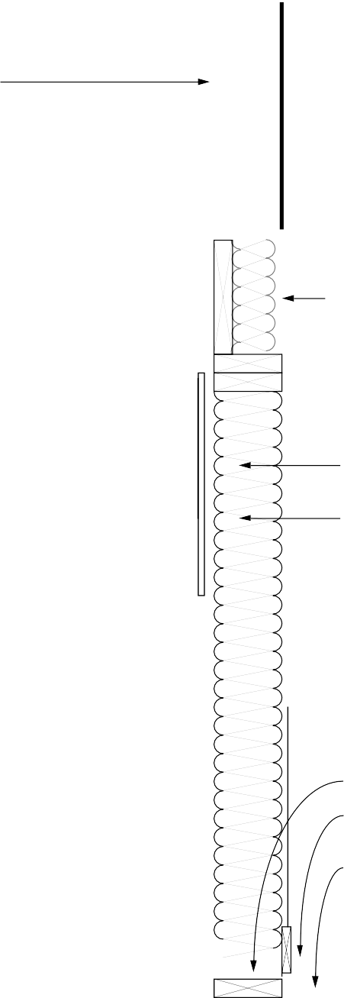

**BATT INSULATION**

**IN WOOD FRAME WALL**

**INTERIOR FINISH MATERIAL VAPOR RETARDER SUBFLOOR**

*Figure 2-13 illustrates a pressure-preservative-treated wood foundation wall.*

*Insulation is placed between the studs similar to a conventional wood frame wall.*

**RIM JOIST (OPTIONAL CAULKING ABOVE OR BELOW RIM JOIST) 10**

**FIELD-APPLIED TOP PLATE**

**WALL SYSTEM TOP PLATE 11**

**GROUND SLOPES AWAY FROM WALL AT 5% (6" IN 10 FT) 2**

**BATT INSULATION**

**RIGID INSULATION CAULKED AT ALL EDGES FORMS VAPOR RETARDER (OPTIONAL) 23**

**CEILING FINISH MATERIAL**

**PRESSURE-TREATED WOOD FRAME WALL 28**

**INSULATION 29 VAPOR RETARDER**

**INTERIOR FINISH MATERIAL**

**LOW PERMEABILITY SOIL (OPTIONAL) 3**

**COARSE GRAVEL BACKFILL ON LOWER HALF OF WALL 26**

**PRESSURE- TREATED PLYWOOD**

**6-MIL POLY WATER SHEDDING MEMBRANE 6**

**2-IN. AIR SPACE 35**

**4-IN. CONCRETE SLAB WITH OPTIONAL W. W. MESH 16 36**

**2-IN. SAND LAYER (OPTIONAL) 16**

**3/4-W MIN.**

**1/2-W MIN.**

**PRESSURE-TREATED FOOTING PLATE**

**GRAVEL FOOTING PAD BENEATH FOOTING PLATE 27**

**W 1/2-W**

**MIN.**

**VAPOR RETARDER 17**

**4-IN. GRAVEL DRAINAGE LAYER DRAINS TO SUMP 30**

##### Figure 2-13: Pressure-Preservative-Treated Wood Basement Wall

*Page 30 Chapter 2—Basement Construction*

**NOTES FOR ALL DETAILED BASEMENT DRAWINGS (FIGURES 2-8 THROUGH 2-13)**

1. **Insulation protection:** Exterior insulation materials should not be exposed above grade. They should be covered by a protective material — such as exterior grade plastic, fiberglass, galvanized metal or aluminum flashing, a cementitious coating, or a rigid protection board — extending at least 6 inches below grade.
2. **Surface drainage:** The ground surface should slope downward at least 5 percent (6 inches) over the first 10 feet surrounding the basement wall to direct surface runoff away from the building. Downspouts and gutters should be used to collect roof drainage and direct it away from the foundation walls.
3. **Backfill cover:** Backfill around the foundation should be covered with a low permeability soil, or a membrane beneath the top layer of soil, to divert surface runoff away from the foundation. (Optional)
4. **Backfill or drainage materials:** Porous backfill sand or gravel should be used against the walls to promote drainage. Backfill should be compacted so that settlement is minimized. In place of porous backfill, a drainage mat material or insulating drainage board can be placed against the foundation wall. The drainage mat should extend down to a drainpipe at the footing level. (Optional)
5. **Exterior insulation materials:** Acceptable materials for exterior insulation are: (1) extruded polystyrene boards (XEPS) under any condition, (2) molded expanded polystyrene boards (MEPS) for vertical applications when porous backfill and adequate drainage are provided, and (3) fiberglass or MEPS drainage boards when an adequate drainage system is provided at the footing.
6. **Dampproofing/waterproofing:** A dampproof coating covered by a 4-mil layer of polyethylene is recommended to reduce vapor transmission from the soil through the basement wall. Parging is recommended on the exterior surface of masonry walls before dampproofing. Waterproofing is recommended on sites with anticipated water problems or poor drainage. Waterproofing should be placed on the exterior directly over the concrete, masonry, or wood substrate. Exterior insulation should be placed over the waterproofing. Waterproofing should extend down to the level of the drainage system at the footing.
7. **Filter fabric:** A filter fabric over the gravel bed and drainpipe is recommended to prevent clogging of the drainage area with fine soil particles. Wrapping the filter fabric around the entire gravel bed is an optional technique for better protection against clogging.
8. **Drainage system:** Where drainage problems are not anticipated, a gravel bed placed along the footing will provide adequate drainage. Where conditions warrant, a 4-inch-diameter perforated drainpipe should be installed in the gravel. Perforated drainpipes should be placed with holes facing downward alongside the footing on either the outside or inside. Outside placement is preferred for drainage but inside placement is less susceptible to

failure. Drainpipes should slope 1 inch in 20 feet and lead to an outfall or sump. A vertical clean-out pipe with an above-grade capped end is recommended to flush out the system. The top of the pipe should be below the level of the underside of the basement floor slab. The pipe should be surrounded by at least 6 inches of gravel on the sides and 4 inches of gravel above and below the pipe. Surface or roof drainage systems should never be connected to the subsurface drainage system. (Optional)

1. **Concrete footing:** All concrete footings must be designed with adequate size to distribute the load to the soil and be placed beneath the maximum frost penetration depth or insulated to prevent frost penetration. Concrete used in spread footings should have a minimum compressive strength of 2500 psi.
2. **Caulking:** Caulking at the following interfaces minimizes air leakage: foundation wall/sill plate, sill plate/rim joist, rim joist/subfloor, subfloor/above-grade wall plate. An alternative is to cover these points on the exterior with an air barrier material. (Optional)
3. **Sill plate:** The sill plate should be at least 8 inches above grade and should be pressure- preservative treated to resist decay.
4. **Crack control reinforcing in walls:** Even when no structural reinforcing is required, reinforcing is desirable to minimize shrinkage cracking. Two No. 4 bars running continuously 2 inches below the top of the wall and above/below window openings are recommended. (Optional)
5. **Anchor bolts in concrete walls:** Anchor bolts should be embedded in the top of concrete foundation walls to resist uplift. Most codes require bolts of 1/2-inch minimum diameter to be embedded at least 7 inches into the wall. Generally, anchor bolts can be placed at a maximum spacing of 6 feet and no further than 1 foot from any corner.
6. **Cast-in-place concrete wall:** Concrete used in the wall should have a minimum compressive strength of 2500 psi with a 4- to 6-inch slump. No additional water should be added at the job site. Generally, where there are stable soils in areas of low seismic activity, no reinforcing is required in an 8- inch-thick basement wall with up to 7 feet of fill.
7. **Isolation joint:** An isolation joint should be provided at the slab edge to permit vertical movement without cracking. Where radon is a concern, a liquid sealant should be poured into the joint over a foam backing rod. Rigid insulation placed in the joint prevents a thermal bridge when there is insulation beneath the slab.
8. **Concrete slab:** A minimum slab thickness of 4 inches is recommended using concrete with a minimum compressive strength of 2500 psi. Welded wire fabric placed 2 inches below the slab surface is recommended to control shrinkage cracks in areas of high radon and termite hazard. Generally, concrete slabs should not rest on footings or ledges of foundation walls if possible to avoid cracking due to settlement. If a slab is poured directly over an impermeable vapor retarder or insulation board, a concrete mixture with a low water/cement ratio is recommended. An alternative technique is to pour the slab on a layer of sand or drainage board material above the vapor retarder to minimize cracking.
9. **Vapor retarder:** A 6-mil polyethylene vapor retarder should be placed beneath the slab to reduce moisture transmission and radon infiltration into the basement.
10. **Gravel layer under slab:** A 4-inch gravel layer should be placed under the concrete floor slab for drainage where local conditions suggest basement leakage may be a problem. (Optional)
11. **Moisture barrier and wall/footing connection:** The concrete wall should be anchored to the footing in one of three ways: (1) sufficient roughening of the top of the footing to prevent sliding, (2) by use of a keyway, or (3) by use of reinforcing dowels. A through-wall moisture barrier is recommended between a concrete wall and footing to prevent capillary draw. (Optional)
12. **Weep holes:** Two-inch-diameter weep holes through the footing 4 to 8 feet apart may be used to connect the underfloor drainage layer to the drainage system outside the footing. (Optional)
13. **Crack control reinforcing in footing:** Reinforcing bars placed 2 inches below the top of the footing running parallel to the wall are recommended where differential settlement is a potential problem. (Optional unless required)
14. **Masonry wall:** Generally where there are stable soils in areas of low seismic activity, no reinforcing is required in a 12-inch-thick masonry wall with up to 6 feet of fill. When reinforcing is required, it must be grouted into block cores. Vertical bars should be spaced no more than 48 inches apart or 6 times the wall thickness, whichever is less.
15. **Insulation inside rim joist:** Insulation can be placed on the inside of the rim joist but with greater risk of condensation problems and less access to wood joists and sills for inspection from the interior. Low permeability rigid insulation (such as extruded polystyrene) should be used, or a vapor retarder should be placed on the inside of the insulation and sealed to all surrounding surfaces.
16. **Interior insulation materials:** For interior placement, virtually any batt, blown, or foam insulation is acceptable. Most products require a thermal barrier for fire protection. The use of foam insulation does not require a frame wall—only furring strips are required.
17. **Ceiling insulation:** Insulation placement in the basement ceiling is an effective alternative where an unconditioned basement is acceptable and ducts are adequately insulated. With fiberglass insulation placed between the wood joists, the vapor retarder should be on the warm side of the insulation facing upwards.
18. **Gravel backfill for wood foundation:** Coarse gravel backfill should be placed against the lower half of the walls to promote drainage. Backfill should be lightly compacted so that settlement is minimized.
19. **Gravel bed beneath wood foundation wall:** A compacted gravel bed may serve as the footing under a wood foundation wall. Beneath the wall the gravel layer should be at least 6 inches thick (or three-quarters of the bottom wall plate width, whichever is greater), and the bed should extend out

from the footing at least 6 inches on each side (or one-half of the bottom wall plate width).

1. **Wood foundation walls:** Wood foundation walls must be designed to resist lateral and vertical loads and must be constructed of lumber and plywood that is properly treated to resist decay. Wall construction and material specifications are found in the National Forest Products Association design manual (NFPA 1987). Local codes should be consulted for specific requirements.
2. **Insulation in wood foundation walls:** Batt, blown, or foam insulations are placed within the stud cavities of a wood foundation system and a vapor retarder is placed on the warm side of the wall.
3. **Gravel beneath floor of wood foundation system:** A 4-inch layer of gravel should be beneath the floor of a wood foundation system with a sump area located in the middle of the basement. The sump area should be at least 24 inches deep and either 16 inches in diameter or 16 inches square, and can be formed with clay tile flue liner or concrete pipe. The sump must drain to daylight or be provided with a pump (National Forest Products Association, 1987).
4. **Anchor bolts in masonry walls:** Anchor bolts should be embedded in the top of masonry foundation walls. Most codes require bolts of 1/2- inch minimum diameter embedded at least 7 inches into the wall. In some locations, codes require bolts to be embedded 15 inches in masonry walls to resist uplift. To provide adequate anchorage in a masonry wall, bolts either must be embedded in a bond beam or the appropriate cores of the upper course of block must be filled with mortar. Generally, anchor bolts can be placed at a maximum spacing of 6 feet and no further than 1 foot from any corner.
5. **Insulation under the slab:** Acceptable materials for underslab insulation are: (1) extruded polystyrene boards (XEPS) under any condition, (2) molded expanded polystyrene boards (MEPS) when the compressive strength is sufficient and adequate drainage is provided, and (3) insulating drainage boards with sufficient compressive strength.
6. **Bond beam on masonry wall:** When required by code or structural consideration, a bond beam provides additional lateral strength in a masonry wall. Using a bond beam or filling the cores of the upper courses of block also are recommended as radon and termite prevention techniques. (Optional)
7. **Gasket:** To minimize air leakage, use a compressible foam plastic sill sealer or equivalent.
8. **Air space:** A 2-inch air space should be provided between the end of the insulation and the bottom plate.
9. **Pressure-preservative-treated wood floor:** Instead of a concrete floor slab, pressure- preservative-treated wood floors are sometimes used in conjunction with wood foundations. These floors are required to resist the lateral loads being imposed at the bottom of the foundation wall as well as to resist excessive deflection from the vertical floor load.

### 2.4 Checklist for Design and Construction of Basements

This checklist serves as a chapter summary, helps review the completeness of construction drawings and specifications, and provides general guidance on project management. The checklist could be used many ways. For example, use one set of blanks during design and the second set during construction inspection. Note that not all measures are necessary under all conditions. Use different symbols to distinguish items that have been satisfied (+) from those that have been checked but do not apply (x). Leave unfinished items unchecked.

#### SITEWORK

Locate building at the highest point if the site is wet

Define “finish subgrade” (grading contractor), “base grade” (construction contractor), “rough grade” level before topsoil is respread, “finish grade” (landscape contractor)

Establish elevations of finish grades, drainage swales, catch basins, foundation drain outfalls, bulkheads, curbs, driveways, property corners, changes in boundaries

Establish grading tolerances

Provide intercepting drains upgrade of foundation if needed

Locate dry wells and recharge pits below foundation level

Establish precautions for stabilizing excavation

Establish limits of excavation and determine trees, roots, buried cables, pipes, sewers, etc., to be protected from damage

Confirm elevation of water table

Determine type and dimensions of drainage systems

Discharge roof drainage away from foundation

Remove stumps and grubbing debris from site

Provide frost heave protection for winter construction

Call for test hole (full depth hole in proposed foundation location)

Locate stakes and benchmarks

Strip and stock pile topsoil

Define spoil site

#### FOOTINGS

Position bottom of footing at least 6 inches below frost depth around perimeter (frost wall at garage, slabs supporting roofs, other elements attached to structure). Make sure footing is deeper under basement walkouts

Confirm adequacy of footing sizes

Do not fill the overexcavated footing trench

Install longitudinal reinforcing (two No. 4 or No. 5 bars 2 inches from top)

Reinforce footing at spans over utility trenches

Do not bear footings partially on rock (sand fill)

Do not pour footings on frozen ground

Indicate minimum concrete compressive strength after 28 days

Call out elevations of top of footings and dimension elevation changes in plan

Use keyway or steel dowels to anchor walls

Dimension stepped footings according to local codes and good practice (conform to masonry dimensions if applicable)

Provide weep holes (minimum 2-inch diameter at 4 feet to 8 feet on center)

Provide through-joint flashing as a capillary break

#### BASEMENT CHECKLIST (PAGE 2 OF 5)

**CAST-IN-PLACE CONCRETE WALLS**

Determine minimum compressive strength after 28 days

Determine maximum water/cement ratio. (Note: add no water at site)

Determine allowable slump

Determine acceptable and unacceptable admixtures

Determine form-release agents acceptable to WPM manufacturer

Establish curing requirements (special hot, cold, dry conditions)

Establish surface finish requirements and preparation for WPM (plug all form tie holes)

For shrinkage control: use horizontal reinforcing at top of wall and/or control joints

Design width of wall to resist height of fill, seismic loads, and loads transmitted through soil from adjacent foundations

Use two-way reinforcing (horizontal and vertical) for strength, watertightness, termite and radon resistance

Establish anchor bolt depth and spacing requirements, and install accordingly

Provide cast-in-place anchors for joist ends

Establish beam pocket elevations, dimensions, details

Determine top of wall elevations and changes in wall height

Determine brick shelf widths and elevations

#### CONCRETE MASONRY WALLS

Specify mortar mixes and strengths

Size walls to resist height of fill, seismic loads, loads transmitted through soil from adjacent foundations

Grout top courses of block to receive anchor bolts

Indicate special details for proprietary masonry systems

Ensure that the surface quality is suitable to WPM

Prepare exterior surface for application of dampproofing or WPM (special preparation consisting of cement parging, priming)

For crack control, use bond beam or horizontal joint reinforcing

#### FLOOR SLAB

Determine minimum compressive strength after 28 days

Determine maximum water/cement ratio. (Note: add no water at site)

Determine allowable slump

Determine acceptable and unacceptable admixtures

Establish curing requirements (special hot, cold, dry conditions)

Determine surface finish

Provide shrinkage control: WWF reinforcement or control joints

Provide isolation joints at wall perimeter and column pads

Provide vapor retarder under slab

Provide sand layer over vapor retarder or insulation board

Compact fill under slab

#### BASEMENT CHECKLIST (PAGE 3 OF 5)

**BACKFILLING AND COMPACTION**

Establish minimum concrete strength or curing prior to backfilling

Use high early strength concrete if necessary

Install temporary wall support during backfilling

Establish condition of fill material (if site material stays in clump after soaking and squeezing in hand, do not use as backfill)

Determine proper compaction

Cap backfill with an impermeable cover

#### SUBDRAINAGE

**General considerations.** Footing drains (1) draw down the ground water level; (2) prevent ponds of rainwater and snow melt in the backfill. The underslab drainage layer (1) conveys rising groundwater laterally to collecting drain lines; (2) acts as a distribution and temporary storage pad for water that drains through the backfill and would otherwise form ponds at the bottom.

Use gravel pad and footing weep holes

Position high end of footing drains below underside of floor slab (Note: outside footing placement is preferred for drainage; inside placement is less susceptible to failure)

Ensure footing drain is pitched

Lay footing drain on compacted bedding (minimum 4 inches thick)

Set unperforated leaders to drain to outfall (hand backfill first 8 inches to avoid damaging pipe)

Ensure that transitions are smooth between pipes of different slopes

Separate surface, roof, and foundation drain systems

Call out gravel or crushed stone envelope around drainpipe and wrap with a synthetic filter fabric

Locate clean-outs for flushing the system

Install porous backfill or wall-mounted drainage product

Provide minimum 4-inch-thick gravel or stone layer under slab

If large flow of water is anticipated, use curtain drain to intercept

#### MOISTUREPROOFING

**General considerations.** Waterproofing is usually recommended for all below-grade living and work spaces. Dampproofing provides a capillary break and serves as a vapor retarder. Waterproof membranes (WPM) dampproof, but dampproofing does not waterproof.

Either dampproof or waterproof walls

Place a polyethylene vapor retarder under floor slabs (optional sand layer between polyethylene and slab)

Place a continuous WPM under slab for basements below groundwater (special detailing and reinforcement required for support)

Install control and expansion joints according to recommendations of WPM manufacturer

Provide protection board for WPM

#### BASEMENT CHECKLIST (PAGE 4 OF 5)

**THERMAL AND VAPOR CONTROLS**

**General considerations.** Exterior insulation maintains the wall close to indoor temperature. This can eliminate the need for vapor retarders on the interior and keeps rubber and asphalt-based moistureproofing warm and pliable. Interior and integral insulations require a vapor retarder at the inside surface. Difficulty of vapor sealing at the rim joist generally favors exterior insulation.

Verify that wall insulation R-value and depth meet local codes and/or recommendations from this handbook

Insulate ceiling in unconditioned basements

If used, specify exterior insulation product suitable for in-ground use

Install protective coating for exterior insulation

Install polyethylene slip sheet between soil and wall (nondrainage) insulation

Install vapor retarder at inside face of internally and integrally insulated walls

Place a fire-protective cover over combustible insulations

Install infiltration sealing gasket under sill plate

Seal air leakage penetrations through rim joists

Install an air barrier outside rim joist

#### DECAY AND TERMITE CONTROL

**General considerations.** Strategy: (1) Isolate wood members from soil by an air space or impermeable barrier; (2) expose critical areas for inspection. Pressure-treated lumber is less susceptible to attack, but is no substitute for proper detailing. Termite shields are not reliable barriers unless installed correctly.

Pressure-treat wood posts, sill plates, rim joists, wood members in contact with foundation piers, walls, floors, etc.

Pressure-treat all outdoor weather-exposed wood members

Install dampproof membrane under sill plate and beams in pockets (flashing or sill seal gasket)

Leave minimum 1/2-inch air space around beams in beam pockets

Expose sill plates and rim joists for inspection

Elevate sill plate minimum 8 inches above exterior grade

Elevate wood posts and framing supporting porches, stairs, decks, etc., above grade (6-inch minimum) on concrete piers

Elevate wood siding, door sills, other finish wood members at least 6 inches above grade (rain splash protection)

Separate raised porches and decks from the building by 2-inch horizontal clearance for drainage and termite inspection (or provide proper flashing)

Pitch porches, decks, patios for drainage (minimum 1/4 in/ft)

Treat soil with termiticide, especially with insulated foundations

Reinforce slab-on-grade

Remove all grade stakes, spreader sticks, and wood embedded in concrete during pour

Do not disturb treated soil prior to pouring concrete slab

Reinforce cast-in-place concrete walls (with No. 5 bars) along the top and bottom to resist settlement cracking

#### BASEMENT CHECKLIST (PAGE 5 OF 5)

**RADON CONTROL**

**General considerations.** The potential for radon hazard is present in all buildings.

Check state and local health agencies for need of protection. Strategies include: (1) barriers;

1. air management; and (3) provisions to simplify retrofit. Since radon is a gas, its rate of entry through the foundation depends on suction due to stack effect and superstructure air leakage.

Separate outdoor intakes for combustion devices

Install air barrier wrap around superstructure

Seal around flues, chases, vent stacks, attic stairs

Install polyethylene vapor retarder as floor underlayment between first floor and unconditioned basement

Reinforce cast-in-place concrete walls (with No. 5 bars) along the top and bottom to resist settlement cracking

For crack control in masonry walls, use bond beam or horizontal joint reinforcing

Seal top of hollow masonry walls with solid block, bond beam, or cap block

Parge exterior face of masonry walls

Install continuous moistureproofing on the outside of masonry walls

Reinforce slab-on-grade

Remove all grade stakes, spreader sticks, and wood embedded in concrete during pour

Form perimeter wall/floor joint trough for pour-in sealant

Place vapor retarder under slab (with optional sand layer)

Caulk joints around pipes and conduits

Install sump pit with airtight cover

Vent sump pit to outside

Do not use floor drains, unless mechanical trap valves are used

Lay minimum 4-inch-thick layer of coarse, clean gravel under slab

Cast 4-inch-diameter PVC tubing standpipes (capped) into slab

#### PLANS, CONTRACTS, AND BUILDING PERMITS

Complete plans and specifications

Complete bid package

Establish contractual arrangements (describe principals, describe the work by referencing the blueprints and specs, state the start/completion dates, price, payment schedule, handling of change orders, handling of disputes, excavation allowance, and procedure for firing)

Acquire building permits

#### SITE INSPECTIONS DURING CONSTRUCTION

After excavation and before concrete is poured for the footings

After the footings have been poured before foundation wall construction

After foundation construction and dampproofing before rough framing

After rough framing

After rough plumbing and electrical

After insulation installation before drywall and backfilling in case of exterior insulation

Final

## CHAPTER 3

**Crawl Space Construction**

This chapter summarizes suggested practices related to crawl spaces. Section 3.1 presents various insulation configurations along with recommended optimal levels of insulation for vented and unvented crawl spaces.



Section 3.2 summarizes crawl space design and construction practices in the following areas: structural design, location of insulation, drainage and waterproofing, termite and decay control, and radon control. Section 3.3 includes a series of alternative construction details with accompanying notes indicating specific practices. Section 3.4 is a checklist to be used during the design, construction, and site inspection of a crawl space.

### Crawl Space Insulation Placement and Thickness

###### Figure 3-1: Concrete Crawl Space Wall with Exterior Insulation

To provide energy use information for buildings with crawl space foundations, heating and cooling loads were simulated for a variety of insulation placements and thicknesses in representative U.S. climates (Labs et al. 1988). Two types of crawl spaces were analyzed for energy purposes — vented and unvented. Generally most major building codes require vents near each corner. These vents may have operable louvers. The vented crawl space is assumed to have venting area openings of 1 square foot per 1500 square feet of floor area. The temperature of the vented crawl space varies between the interior house temperature and the exterior temperature. The unvented crawl space is assumed to have vents fully

closed, leaving only gaps in construction that could allow infiltration. Unvented crawl spaces insulated at the perimeter are similar to unheated basements, with temperatures that fluctuate between 50OF and 70OF most of the year, depending on climate and insulation placement.

Crawl spaces can vary in height and relationship to exterior grade. It is assumed in the analysis that follows that crawl space walls are 2 feet high with only the upper 8 inches of the foundation wall exposed above grade on the exterior side.

**Insulation Configurations and Costs**

Table 3-1 includes illustrations and descriptions of a variety of crawl space insulation configurations. Two basic construction systems are shown for unvented crawl spaces — a concrete (or masonry) foundation wall and a pressure-preservative- treated wood foundation wall. For vented crawl spaces, concrete (or masonry) walls are shown.

In a vented crawl space, insulation is placed between the floor joists in the crawl space ceiling. In an unvented crawl space, the two most common approaches to insulating concrete/ masonry walls are

* 1. covering the entire wall on the exterior, and (2) covering the entire wall on the interior. In addition to these conventional approaches, insulation can be placed on the interior wall and horizontally on the perimeter of the crawl space floor (extending either 2 or 4 feet into the space). With pressure-preservative-treated wood construction, batt insulation is placed in the cavities between the wood studs.

##### Recommended Insulation Levels

While increasing the amount of crawl space insulation produces greater energy savings, the cost of installation must be compared to these savings. Such a comparison can be done in several ways; however, a life cycle cost analysis (presented in worksheet form in Chapter 5) is recommended since it takes into account a number of economic variables including installation costs, mortgage rates, HVAC efficiencies, and fuel escalation rates. In order to identify the most economical amount of insulation for the crawl space configurations shown in Table 3-1, the case with the lowest 30-year life cycle cost was

determined for five U.S. cities at three different fuel cost levels. See the *Building Foundation Design Handbook* (Labs et al. 1988) to find recommendations for a greater number of cities and for a detailed explanation of the methodology. The economic methodology used to determine the insulation levels in Table 3-1 is consistent with ASHRAE standard 90.2P. The simple payback averages 13 years for all U.S. climate zones, and never exceeds 18 years for any of the recommended levels.

Economically optimal configurations are shown by the darkened circles in Table 3-1 in the following categories: (1) unvented crawl spaces with concrete/ masonry walls and exterior insulation, (2) unvented crawl spaces with concrete/ masonry walls and interior insulation, (3) unvented crawl spaces with wood walls, and (4) vented crawl spaces with concrete walls. Configurations are recommended for a range of climates and fuel prices in each of these categories, but the different categories of cases are not directly compared with each other. In other words, there is an optimal amount of exterior insulation recommended for a given climate and fuel price, and there is a different optimal amount of insulation for interior insulation. Where there is no darkened circle in a particular category, insulation is not economically justified under the assumptions used.

For unvented crawl spaces with concrete/ masonry walls, exterior insulation ranging from R-5 to R-10 is justified at all fuel

price levels (shown in Table 3-2) in all climate zones except the warmest one. Similar levels of interior insulation are recommended.

However in colder climates, placing insulation horizontally on the crawl space floor in addition to the wall is frequently the optimal configuration. If the crawl space wall is higher than 2 feet, as it often must be to reach frost depth in a colder climate, it is advisable to extend the vertical insulation to the footing. Although simulation results for crawl spaces with higher walls and deeper footings are not shown here, the need for insulation placed deeper than 2 feet in cold climates is obvious and is reflected by the economic benefits of placing insulation on the floor of a shallower crawl space.

For unvented crawl spaces with pressure-preservative-treated wood walls, insulation ranging from R-11 to R-19 is justified in moderate and colder climates. In vented crawl spaces, ceiling insulation

**Table 3-1: Insulation Recommendations for Crawl Spaces**

**A: Unvented Crawl Space - Concrete or Masonry Foundation Walls with Exterior Insulation**

|  |  |  |  |  |  |  |
| --- | --- | --- | --- | --- | --- | --- |
| **CONFIGURATION** | **DESCRIPTION** | **RECOMMENDED CONFIGURATIONS AT THREE FUEL PRICE LEVELS**  **0-2000 HDD 2-4000 HDD 4-6000 HDD 6-8000 HDD 8-10000 HDD** | | | | |
| **(LOS ANG)**  **L M H** | **(FT WORTH)**  **L M H** | **(KAN CITY)**  **L M H** | **(CHICAGO)**  **L M H** | **(MPLS)**  **L M H** |
| **EXTERIOR VERTICAL** | NO INSULATION 2 FT: R-5 RIGID  2 FT: R-10 RIGID |  |  |  |  |  |

**B: Unvented Crawl Space - Concrete or Masonry Foundation Walls with Interior Insulation**

|  |  |  |  |  |  |  |
| --- | --- | --- | --- | --- | --- | --- |
| **INTERIOR VERTICAL** | NO INSULATION 2 FT: R-5 RIGID  2 FT: R-10 RIGID |  |  |  |  |  |
| **INTERIOR VERTICAL AND HORIZONTAL** | 2 FT/2 FT: R-5 RIGID |  |  |  |  |  |
|  | 2 FT/4 FT: R-5 RIGID |
|  | 2 FT/2 FT: R-10 RIGID |
|  | 2 FT/4 FT: R-10 RIGID |

**C: Unvented Crawl Space - Pressure-Treated Wood Foundation Walls**



|  |  |  |
| --- | --- | --- |
|  |  | |
|  |  |
|  |
|  | | |
|  | | |

|  |  |  |  |  |  |  |
| --- | --- | --- | --- | --- | --- | --- |
| **WITHIN WOOD WALL** | NO INSULATION 2 FT: R-11 BATT  2 FT: R-19 BATT |  |  |  |  |  |

**D: Vented Crawl Space - Concrete or Masonry Foundation Walls with Ceiling Insulation**



**CEILING**

NO INSULATION R-11 BATT

R-19 BATT R-30 BATT

|  |  |  |
| --- | --- | --- |
|  |  |  |
|  | |
|  |  |
|  |  |
|  | | |

1. L, H, and M refer to the low, medium, and high fuel cost levels indicated in Table 3-2.
2. The darkened circle represents the recommended level of insulation in each column for each of the four basic insulation configurations.
3. These recommendations are based on assumptions that are summarized at the end of section 3.1 and further explained in chapter 5.

##### Table 3-2: Fuel Price Levels Used to Develop Recommended Insulation Levels in Table 3-1

|  |  |  |  |  |
| --- | --- | --- | --- | --- |
| **SEASON** | **FUEL TYPE** | **LOW PRICE LEVEL ($)** | **MEDIUM PRICE LEVEL ($)** | **HIGH PRICE LEVEL ($)** |
| **HEATING** | NATURAL GAS FUEL OIL PROPANE | .374 / THERM  .527 / GALLON  .344 / GALLON | .561 / THERM  .791 / GALLON  .516 / GALLON | .842 / THERM  1.187 / GALLON  .775 / GALLON |
| **COOLING** | ELECTRICITY | .051 / KWH | .076 / KWH | .114 / KWH |

ranging from R-11 to R-30 is recommended in all climates at all fuel price levels.

##### Comparison of Insulation Systems

Insulating the ceiling of a vented crawl space is generally more cost-effective than insulating the walls of an unvented crawl space to an equivalent level. This is because placing mineral wool batt insulation into the existing spaces between floor joists represents a much smaller incremental cost than placing rigid insulation on the walls.

Thus higher levels of insulation are recommended in the floor above a vented crawl space than for the walls of an unvented space.

When exterior and interior insulation are compared for an unvented crawl space with concrete/ masonry walls, thermal results are very similar for equivalent amounts of insulation. Since it is assumed that exterior insulation costs more to install, however, interior placement is always economically optimal in comparison. This increased cost for an exterior insulation is attributed to the need for protective covering and a higher quality rigid insulation that can withstand exposure to water and soil pressure.

Generally, insulating pressure- preservative-treated wood walls is more cost- effective than insulating concrete/ masonry walls to an equivalent level. This is because the cavity exists between studs in a wood wall system and the incremental cost of installing batt insulation in these cavities is relatively low. Thus, a higher R-value is economically justified for wood wall systems.

In spite of the apparent energy efficiency of wood versus concrete/ masonry basement walls, this is only one of many cost and performance issues to be considered.

Likewise, on a concrete/ masonry foundation

wall, the economic benefit of interior versus exterior insulation may be offset by other practical, performance, and aesthetic considerations discussed elsewhere in this book. Although ceiling insulation in a vented crawl space appears more cost-effective than wall insulation in an unvented space, a vented crawl space may be undesirable in colder climates since pipes and ducts may be exposed to freezing temperatures. In all cases the choice of foundation type and insulation system must be based on many factors in addition to energy cost- effectiveness.

##### Assumptions

These general recommendations are based on a set of underlying assumptions. Fuel price assumptions used in this analysis are shown in Table 3-2. The total heating system efficiency is 68 percent and the cooling system SEER is 9.2 with 10 percent duct losses. Energy price inflation and mortgage conditions are selected to allow maximum simple payback of 18 years with average paybacks of about 13 years.

The total installed costs for all insulation systems considered in this analysis are shown in Table 5-2 in chapter 5. Installation costs used in this analysis are based on average U.S. costs in 1987. For the exterior cases, costs include labor and materials for extruded polystyrene insulation and the required protective covering and flashing above grade. For the interior cases, costs include labor and materials for expanded polystyrene. All costs include a 30 percent builder markup and a 30 percent subcontractor markup for overhead and profit.

With pressure-preservative-treated wood construction, batt insulation is placed in the

cavities between the wood studs. Costs for wood foundations reflect the additional cost of installing insulation with an ASTM E-84 flame spread index of 25 or less in a wood foundation wall.

If the general assumptions used in this analysis are satisfactory for the specific project, the reader can determine the approximate recommended insulation level for a location by finding the heating degree days from Table 5-1 in chapter 5 and selecting the appropriate climate zone and fuel price level shown in Table 3-1. If not, project-specific optimal insulation levels can be determined using actual estimated construction costs with the worksheet provided in chapter 5. The worksheet enables the user to select economic criteria other than allowing maximum simple paybacks of 18 years. In addition, the user can incorporate local energy prices, actual insulation costs, HVAC efficiencies, mortgage conditions, and fuel escalation rates. Cost- effectiveness can vary considerably, depending on the construction details and cost assumptions.

### Recommended Design and Construction Details

#### VENTED VERSUS UNVENTED CRAWL SPACES

The principal perceived advantage of a vented crawl space over an unvented one is that venting can minimize radon and moisture-related decay hazards by diluting the crawl space air. Venting can complement other moisture and radon control measures such as ground cover and proper drainage. However, although increased air flow in the crawl space may offer some dilution potential for ground source moisture and radon, it will not necessarily solve a serious problem. The principal disadvantages of a vented crawl space over an unvented one are that (1) pipes and ducts must be insulated against heat loss and freezing, (2) a larger area usually must be insulated, which may increase the cost, and

(3) in some climates warm humid air circulated into the cool crawl space can actually cause excessive moisture levels in wood. Vented crawl spaces are often provided with operable vents that can be closed to reduce winter heat losses, but also

potentially increase radon infiltration. Although not their original purpose, the vents can also be closed in summer to keep out moist exterior air that can have a dew point above the crawl space temperature.

It is not necessary to vent a crawl space for moisture control if it is open to an adjacent basement, and venting is clearly incompatible with crawl spaces used as heat distribution plenums. In fact, there are several advantages to designing crawl spaces as semi-heated zones. Duct and pipe insulation can be reduced, and the foundation is insulated at the crawl space perimeter instead of its ceiling. This usually requires less insulation, simplifies installation difficulties in some cases, and can be detailed to minimize condensation hazards.

Nevertheless, venting of crawl spaces may be desirable in areas of high radon hazard.

However, venting should not be considered a reliable radon mitigation strategy.

Pressurizing the crawl space is one potentially effective method of minimizing soil gas uptake, but the crawl space walls and ceiling must be tightly constructed for this approach to be effective.

Although unvented crawl spaces have been recommended, “except under severe moisture conditions,” by the University of Illinois’s Small Homes Council (Jones 1980), moisture problems in crawl spaces are common enough that many agencies are unwilling to endorse closing the vents year- round. Soil type and the groundwater level are key factors influencing moisture conditions. It should be recognized that a crawl space can be designed as a short basement (with slurry slab floor), and, having a higher floor level, is subject to less moisture hazard in most cases. Viewed in this way, the main distinction between unvented crawl spaces and basements is in the owner’s accessibility and likelihood of noticing moisture problems.

#### STRUCTURAL DESIGN

The major structural components of a crawl space are the wall and the footing (see Figure 3-2). Crawl space walls are typically constructed of cast-in-place concrete, concrete masonry units, or pressure-treated wood.

Crawl space walls must resist any lateral loads from the soil and vertical loads from the structure above. The lateral loads on the wall depend on the height of the fill, the soil

type and moisture content, and whether the building is located in an area of low or high seismic activity. Some simple guidelines for wall thickness, concrete strength, and reinforcing are given in the construction details that follow. Where simple limits are exceeded, a structural engineer should be consulted.

In place of a structural foundation wall and continuous spread footing, the structure can be supported on piers or piles with beams in between. These beams between piers support the structure above and transfer the load back to the piers.

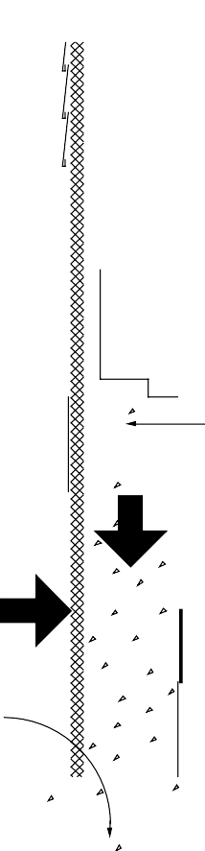

**ANCHOR BOLT CONNECTS FOUNDATION WALL TO SUPERSTRUCTURE AND RESISTS WIND UPLIFT**

**WALL RESISTS VERTICAL LOAD FROM ABOVE-GRADE STRUCTURE**

**WALL RESISTS LATERAL LOAD FROM SOIL**

**SPREAD FOOTING DISTRIBUTES VERTICAL LOAD TO GROUND**

Concrete spread footings provide support beneath concrete and masonry crawl space walls and/ or columns. Footings must be designed with adequate size to distribute the load to the soil and be placed beneath the maximum frost penetration depth unless founded on bedrock or proven non-frost- susceptible soil or insulated to prevent frost penetration. A compacted gravel bed serves as the footing under a wood foundation wall when designed in accordance with the National Forest Products Association’s wood foundation specification (NFPA 1987). Since the interior temperature of a vented crawl space may be below freezing in very cold climates, footings must be below the frost depth with respect to both interior and exterior grade unless otherwise protected.

Where expansive soils are present or in areas of high seismic activity, special foundation construction techniques may be necessary. In these cases, consultation with local building officials and a structural engineer is recommended.

#### DRAINAGE AND WATERPROOFING

Although a crawl space foundation is not as deep as a full basement, it is highly desirable to keep it dry. Good surface drainage is always recommended and, in many cases, subsurface drainage systems may be desirable. The goal of surface drainage is to keep water away from the foundation by sloping the ground surface and using gutters and downspouts for roof drainage. Where the crawl space floor is at the same level or above the surrounding exterior grade, no subsurface drainage system is required (see Figure 3-3). On sites with a high water table or poorly draining soil, one recommended solution is to keep the

##### Figure 3-2: Components of Crawl Space Structural System

crawl space floor above or at the same level as exterior grade.



**SURFACE DRAINAGE TECHNIQUES:**

* **SLOPE GROUND AWAY**
* **USE GUTTERS AND DOWNSPOUTS**

**WHEN THE CRAWL SPACE FLOOR IS AT OR ABOVE EXTERIOR**

**GRADE, A SUBSURFACE DRAINAGE SYSTEM**

**IS NOT NECESSARY**

On sites with porous soil and no water table near the surface, placing the crawl space floor below the surface is acceptable with no requirement for a subdrainage system.

Where it is necessary or desirable to place the crawl space floor beneath the existing grade and the soil is nonporous, a subsurface perimeter drainage system similar to that used for a basement is recommended (see Figure 3-4). In some cases a sump may be necessary. On a sloping site, subdrainage may be required on the uphill side if the soil is nonporous. Generally no waterproofing or dampproofing on the exterior foundation walls of crawl spaces is considered necessary, assuming drainage is adequate.

#### LOCATION OF INSULATION

##### Figure 3-3: Crawl Space Drainage Techniques



**SURFACE DRAINAGE TECHNIQUES:**

* **SLOPE GROUND AWAY**
* **USE GUTTERS AND DOWNSPOUTS**

**WHEN THE CRAWL SPACE FLOOR IS BELOW EXTERIOR GRADE, A SUBSURFACE DRAINAGE SYSTEM**

**IS RECOMMENDED IF SOIL IS NONPOROUS**

**Figure 3-4: Crawl Space Drainage Techniques**

If a vented crawl space is insulated, the insulation is always located in the ceiling. Most commonly, batt insulation is placed between the floor joists. The depth of these joist spaces accommodates high insulation levels at a relatively low incremental cost. This placement usually leaves sill plates open to inspection for termites or decay.

A key question in the design of an unvented crawl space is whether to place insulation inside or outside the wall. In terms of energy use, there is not a significant difference between the same amount of insulation applied to the exterior versus the interior of a concrete or masonry wall.

However, the installation costs, ease of application, appearance, and various technical concerns can be quite different.

Rigid insulation placed on the exterior surface of a concrete or masonry wall has some advantages over interior placement in that it can provide continuous insulation with no thermal bridges, protect structural walls at moderate temperatures, and minimize moisture condensation problems. Exterior insulation at the rim joist leaves joists and sill plates open to inspection from the interior for termites and decay. On the other hand, exterior insulation on the wall can be a path for termites and can prevent inspection of the wall from the exterior. If needed a termite screen should be installed through the insulation where the sill plate rests on the foundation wall. Vertical exterior insulation on a crawl space wall can extend as deep as the top of the footing and,

*Page 44 Chapter 3—Crawl Space Construction*

if desired, be supplemented by extending the insulation horizontally from the face of the foundation wall.

Interior crawl space wall insulation is more common than exterior, primarily because it is less expensive since no protective covering is required. On the other hand, interior wall insulation may be considered less desirable than exterior insulation because it (1) increases the exposure of the wall to thermal stress and freezing, (2) may increase the likelihood of condensation on sill plates, band joists, and joist ends, (3) often results in some thermal bridges through framing members, and (4) may require installation of a flame spread resistant cover. Rigid board insulation is easier to apply to the interior wall than batt insulation since it requires no framing for support, is continuous, can be installed prior to backfilling against the foundation wall or installing the floor, and may require no additional vapor retarder. Insulation placed around the crawl space floor perimeter can provide additional thermal protection; however, it may also create additional paths for termite entry. Batt insulation is commonly placed inside the rim joist. This rim joist insulation should be covered on the inside face with a polyethylene vapor retarder or a rigid foam insulation, sealed around the edges, to act as a vapor retarder. In place of batts, simply using tight-fitting rigid foam pieces in the spaces between the floor joists is an effective solution.

Less expensive batts are an alternative to rigid foam insulation on the interior crawl space wall. It is possible to install them in a crawl space similar to a basement installation. One way is to provide a furred- out stud wall and a vapor retarder on the studs. This is a more expensive and less likely approach than simply using rigid foam with no furring. A common, low-cost approach to insulating crawl space walls is simply draping batts with a vapor retarder facing over the inside of the wall. In most states, codes require the batt vapor retarder cover be approved with respect to flame spread. These can be laid loosely on the ground at the perimeter to reduce heat loss through the footing. With this approach it is difficult to maintain the continuity of the vapor retarder around the joist ends and to seal the termination of the vapor retarder.

Good installations are difficult because of cramped working conditions, and a vapor- proof installation will prevent easy

inspection for termites.

With a pressure-preservative-treated wood foundation system, insulation is placed in the stud cavities similar to above-grade insulation in a wood frame wall. This approach has a relatively low cost and provides sufficient space for considerable insulation thickness.

In addition to more conventional interior or exterior placement covered in this handbook, there are several systems that incorporate insulation into the construction of the concrete or masonry walls. These include (1) rigid foam plastic insulation cast within concrete walls, (2) polystyrene beads or granular insulation materials poured into the cavities of conventional masonry walls,

1. systems of concrete blocks with insulating foam inserts, (4) formed, interlocking rigid foam units that serve as a permanent insulating form for cast-in-place concrete, and (5) masonry blocks made with polystyrene beads instead of aggregate in the concrete mixture, resulting in significantly higher R-values. However, the effectiveness of systems that insulate only a portion of the wall area should be evaluated closely because thermal bridges through the insulation can impact the total performance significantly.

#### TERMITE AND WOOD DECAY CONTROL TECHNIQUES

Techniques for controlling the entry of termites through residential foundations are advisable in much of the United States (see Figure 3-5). The following recommendations apply where termites are a potential problem. Consult with local building officials and codes for further details.

* 1. Minimize soil moisture around the foundation by using gutters and downspouts to remove roof water, and by installing a complete subdrainage system around the foundation.
  2. Remove all roots, stumps, and scrap wood from the site before, during, and after construction, including wood stakes and formwork from the foundation area.
  3. Treat soil with termiticide on all sites vulnerable to termites.
  4. Place a bond beam or course of solid cap blocks on top of all concrete masonry foundation walls to ensure that no open cores

**PRESSURE-PRESERVATIVE TREATED SILL PLATE**



**8-IN. MIN. ABOVE GRADE**

**WOOD SIDING 6-IN. MIN. ABOVE GRADE**

**REMOVE ROOTS, TRUNKS, AND SCRAP WOOD FROM FOUNDATION AREA**

**TREAT SOIL FOR TERMITES**

**MINIMIZE SOIL MOISTURE**

* **USE GUTTERS AND DOWNSPOUTS**
* **INSTALL SUBSURFACE DRAINAGE SYSTEM**

**BOND BEAM, CAP BLOCK, OR FILLED UPPER COURSE OF MASONRY WALL**

**WOOD POSTS SHOULD BE TREATED, PLACED ON FLASHING, OR PLACED ON A CONCRETE PEDESTAL**

**8 IN. ABOVE FLOOR**

are left exposed. Alternatively, fill all cores on the top course with mortar, and reinforce the mortar joint beneath the top course.

* 1. Place the sill plate at least 8 inches above grade; it should be pressure- preservative treated to resist decay. The sill plate should be visible for inspection from the interior. Since termite shields are often damaged or not installed carefully enough, they are considered optional and should not be regarded as sufficient defense by themselves.
  2. Be sure that exterior wood siding and trim is at least 6 inches above the final grade.
  3. Construct porches and exterior slabs so that they slope away from the foundation wall and are at least 2 inches below exterior siding. In addition, porches and exterior slabs should be separated from all wood members by a 2-inch gap visible for inspection or by a continuous metal flashing soldered at all seams.
  4. Use pressure-preservative-treated wood posts within a crawl space, or place posts on flashing or on a concrete pedestal raised 8 inches above the interior grade.

Plastic foam and batt insulation materials have no food value to termites, but they can provide protective cover and easy tunnelling. Insulation installations can be detailed for ease of inspection, although often by sacrificing thermal efficiency. In principle, termite shields offer protection through detailing, but should not be relied upon as a barrier.

These concerns over insulation and the unreliability of termite shields have led to the conclusion that soil treatment is the most effective technique to control termites with an insulated foundation. However, the restrictions on some traditionally used termiticides may make this option either unavailable or cause the substitution of products that are more expensive and possibly less effective. This situation should

##### Figure 3-5: Termite Control Techniques for Crawl Spaces

encourage insulation techniques that enhance visual inspection and provide effective barriers to termites.

#### RADON CONTROL TECHNIQUES

Construction techniques for minimizing radon infiltration into a crawl space are appropriate if there is a reasonable

probability that radon is present (see Figure 3-6). To determine this, contact the state health department or environmental protection office.

* + 1. For crawl spaces susceptible to low radon exposure, provide substantial outside air ventilation. Place vents on all four sides of the crawl space. A second more reliable radon control solution is to control and isolate the source as suggested for basement construction in Chapter 2.



**CONSTRUCT FLOOR WITH CONTINUOUS AIR BARRIER**

**SEAL ALL PENETRATIONS THROUGH FLOOR WITH CAULKING**

**PROVIDE SUBSTANTIAL OUTSIDE AIR FOR VENTILATION**

**IF CRAWL SPACE IS UNVENTED, APPLY RADON CONTROL TECHNIQUES FOR BASEMENTS**

**(SEE FIG. 2-4)**

**SECURELY TAPE ALL JOINTS IN DUCTWORK -**

**IF POSSIBLE AVOID PLACING DUCTWORK IN CRAWL SPACE**

**PLACE 6-MIL POLY OVER FLOOR AND SEAL TO WALLS**

* + 1. Place a 6-mil polyethylene vapor retarder over all exposed soil floor areas. Overlap edges 12 inches and seal. Seal edges to the interior face of the foundation wall.
    2. If the crawl space is unvented or if indoor radon levels could be moderate to high, follow the radon control techniques recommended for basements (see Chapter 2). This may also include pressurization of the crawl space or soil gas removal from beneath the crawl space soil covering.
    3. Construct floors above unconditioned spaces with a continuous air infiltration barrier. Tongue and groove plywood floor decking should be applied with butt joints continuously glued to floor joists with a waterproof construction adhesive. Seal all penetrations through the subfloor with caulk. Enclose large openings such as at bath tub drains with sheet metal or other rigid material and sealants.
    4. Avoid duct work in the crawl space if possible, but it may be installed providing all joints are securely taped or otherwise tightly sealed.
    5. Render crawl space walls separating an attached vented crawl space from a basement or living space as airtight as possible.

##### Figure 3-6: Radon Control Techniques for Crawl Spaces

* 1. **Crawl Space Construction Details**

In this section several typical crawl space wall sections are illustrated and described.

Figure 3-8 shows a typical vented crawl space with insulation placed in the floor joists above the space. In Figure 3-9 insulation placed outside the foundation wall of an unvented crawl space is shown, while Figures 3-10 and 3-11 show insulation placed inside the wall of an unvented crawl space.

Included in this group of illustrations are variations in construction systems and

approaches to insulating the rim joist area. Numbers that occur within boxes in each drawing refer to the notes on pages 53 and 54 that follow the drawings (see Figure 3-7).

The challenge is to develop integrated solutions that address all key considerations without unnecessarily complicating the construction or increasing the cost. There is no one set of perfect solutions; recommended practices or details often represent trade-offs and compromises. The purpose of this section is to show and describe a variety of reasonable alternatives. Individual circumstances will dictate final design choices.

**RIM JOIST**



EXAMPLE OF NOTES CORRESPONDING TO CONSTRUCTION DRAWING:

1. **Insulation protection:** Exterior insulation materials should not be exposed above grade. They should be covered by a protective material — such as exterior grade plastic, fiberglass, galvanized metal or aluminum flashing, a cementitious coating, or a rigid protection board — extending at least 6 inches below grade.
2. **Surface drainage:** The ground surface should slope downward at least 5 percent (6 inches) over the first 10 feet surrounding the basement wall to direct surface runoff away from the building. Downspouts and gutters should be used to collect roof drainage and direct it away from the foundation walls.

**PROTECTION BOARD OR COATING EXTENDS 6 IN. BELOW GRADE 1**

**GROUND SLOPES AWAY FROM WALL AT 5% (6" IN 10 FT) 2**

1. **IN. MIN.**

**7-IN. MIN.**

###### Figure 3-7: System of Key Numbers in Construction Drawings that Refer to Notes on Following Pages

*Page 48 Chapter 3—Crawl Space Construction*

*Figure 3-8 illustrates a vented crawl space with a concrete foundation wall. The insulation is placed between the floor joists over the crawl space. The crawl space floor is at the same level as the surrounding grade resulting in no major drainage concerns.*

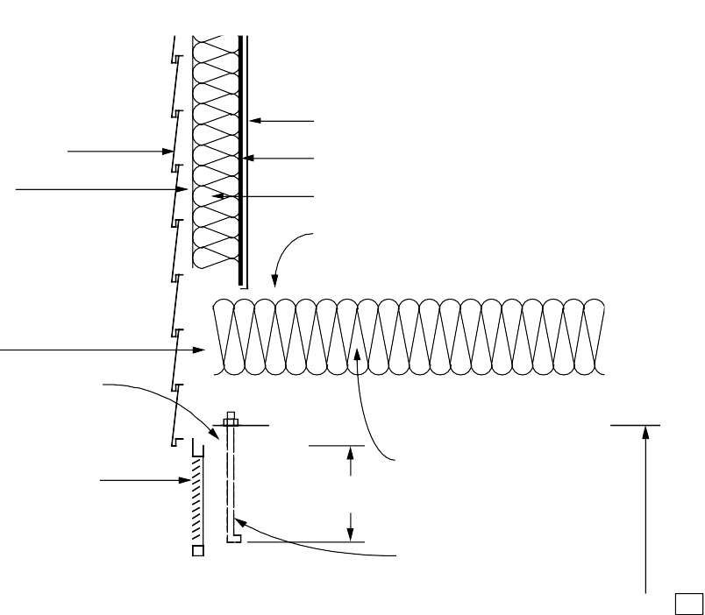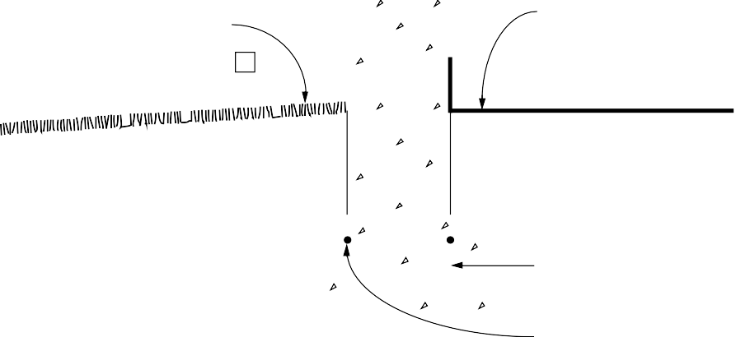

**EXTERIOR SIDING**

**SHEATHING**

**INTERIOR FINISH MATERIAL**

**VAPOR RETARDER INSULATION IN 2 x 4 WALL SUBFLOOR**

**RIM JOIST**

**PRESSURE-TREATED SILL PLATE 11**

**CRAWL SPACE VENT**

**AT TOP OF FOUNDATION WALL 21**

**7-IN. MIN.**

**BATT INSULATION BETWEEN FLOOR JOISTS WITH VAPOR RETARDER ON TOP 20**

**1/2-IN. ANCHOR BOLTS AT 6 FT. O. C. MAX. 12**

**CONCRETE FOUNDATION WALL 13**

**24-IN. 17**

**GROUND SLOPES AWAY FROM WALL AT 5% (6" IN 10 FT) 2**

**CONTINUOUS VAPOR DIFFUSION RETARDER (GROUND COVER) 18**

**CONCRETE FOOTING 8**

**REINFORCING (OPTIONAL) 19**

##### Figure 3-8: Vented Crawl Space Wall with Ceiling Insulation

*Figure 3-9 illustrates an unvented crawl space with a concrete masonry foundation wall. The exterior insulation is covered by a flashing at the top. There is no limit to the thickness of insulation that can be used with this approach.*

*The crawl space floor is below the level of the surrounding grade. A perimeter drainage system is shown.*

**EXTERIOR SIDING**

**SHEATHING**

**FLASHING COVERS TOP OF INSULATION**

**PROTECTION BOARD, COATING 1**

**RIGID INSULATION 5 RIM JOIST**

**GROUND SLOPES AWAY FROM WALL AT 5% (6" IN 10 FT) 2**

**LOW PERMEABILITY SOIL (OPTIONAL) 3**

**8-IN. MIN.**

**INTERIOR FINISH MATERIAL VAPOR RETARDER INSULATION IN 2 x 4 WALL SUBFLOOR**

**CAULKING (OPTIONAL) 9**



**PRESSURE-TREATED SILL PLATE 11**

**GASKET UNDER SILL PLATE**

**1/2-IN. ANCHOR BOLTS AT 6 FT. O. C. MAX. EMBEDDED 7 TO 15 IN. AS REQUIRED BY CODE 23**

**FILLED BLOCK CORES**

**17**

**DRAINAGE MAT, INSULATING DRAINAGE BOARD, OR GRANULAR BACKFILL (OPTIONAL) 4**

**FILTER FABRIC ABOVE GRAVEL (OPTIONAL ON SIDES AND BELOW) 6**

**COARSE GRAVEL (OPTIONAL)**

**4-IN. PERFORATED DRAIN PIPE WITH HOLES FACING DOWN (OPTIONAL) 7**

**OR BOND BEAM 22**

**CONCRETE MASONRY FOUNDATION WALL 14**

**VAPOR RETARDER 18**

**CONCRETE FOOTING 8**

**REINFORCING (OPTIONAL) 19**

**24-IN.**

##### Figure 3-9: Unvented Crawl Space Wall with Exterior Insulation

**EXTERIOR SIDING SHEATHING**

**RIM JOIST (OPTIONAL CAULKING ABOVE AND BELOW RIM JOIST) 9**

**PRESSURE-TREATED SILL PLATE 11**

**GROUND SLOPES AWAY FROM WALL AT 5% (6" IN 10 FT) 2**

**LOW PERMEABILITY SOIL (OPTIONAL) 3**

**8-IN. MIN.**

**INTERIOR FINISH MATERIAL VAPOR RETARDER INSULATION IN 2 x 4 WALL SUBFLOOR**

**BATT INSULATION RIGID INSULATION**

**CAULKED AT ALL EDGES FORMS VAPOR RETARDER (OPTIONAL) 10**

**1/2-IN. ANCHOR BOLTS AT 6 FT. O. C. MAX. 12**

**RIGID INSULATION 15**

**17**

*Figure 3-10 illustrates an unvented crawl space with a concrete foundation wall.*

*Rigid insulation is placed vertically on the interior. There is no limit to the thickness of insulation that can be used with this approach.*

*The crawl space floor is below the level of the surrounding grade. A perimeter drainage system is shown.*

**DRAINAGE MAT, INSULATING DRAINAGE BOARD, OR GRANULAR BACKFILL (OPTIONAL) 4**

**FILTER FABRIC ABOVE GRAVEL (OPTIONAL ON SIDES AND BELOW) 6**

**COARSE GRAVEL**

**4-IN. PERFORATED DRAIN PIPE WITH HOLES FACING DOWN (OPTIONAL) 7**

**CONCRETE FOUNDATION WALL 13**

**VAPOR RETARDER 18**

**RIGID INSULATION MAY EXTEND HORIZONTALLY ON FLOOR (OPTIONAL)**

**CONCRETE FOOTING 8**

**REINFORCING (OPTIONAL) 19**

**24-IN.**

##### Figure 3-10: Unvented Crawl Space Wall with Interior Insulation

*Figure 3-11 illustrates an unvented crawl space with a concrete foundation wall. Batt insulation is placed vertically on the interior wall and extends horizontally onto the perimeter of the floor. The crawl space floor is below the level of the surrounding grade. A perimeter drainage system is shown.*

**EXTERIOR SIDING SHEATHING**

**RIM JOIST (OPTIONAL CAULKING ABOVE AND BELOW RIM JOIST) 9**

**PRESSURE-TREATED SILL PLATE 11**

**GROUND SLOPES AWAY FROM WALL AT 5% (6" IN 10 FT) 2**

**LOW PERMEABILITY SOIL (OPTIONAL) 3**

**8-IN. MIN.**

**INTERIOR FINISH MATERIAL VAPOR RETARDER INSULATION IN 2 x 4 WALL SUBFLOOR**

**BATT INSULATION**

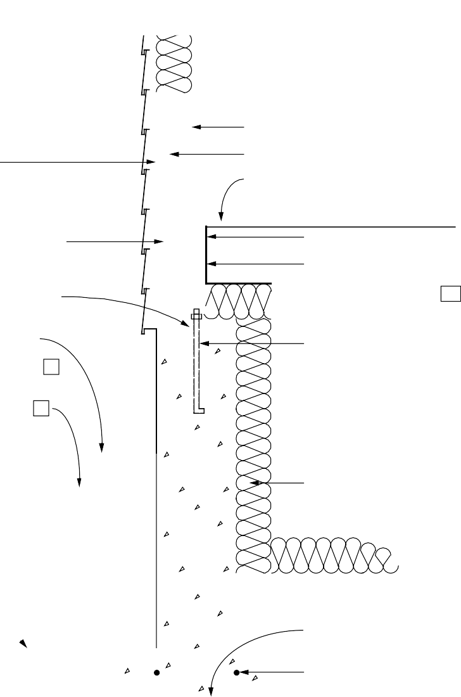

**VAPOR RETARDER SEALED TO SUBFLOOR AND FLOOR JOISTS 16**

**1/2-IN. ANCHOR BOLTS AT 6 FT. O. C. MAX. 12**

**VAPOR RETARDER EXTENDS ABOVE GRADE ON WALL (OPTIONAL) 18**

**17**

**CONCRETE FOUNDATION WALL 13**

**24-IN.**

**DRAINAGE MAT, INSULATING DRAINAGE BOARD, OR GRANULAR BACKFILL (OPTIONAL) 4**

**FILTER FABRIC ABOVE GRAVEL (OPTIONAL ON SIDES AND BELOW) 6**

**COARSE**

**GRAVEL**

**4-IN. PERFORATED DRAIN PIPE WITH HOLES FACING DOWN (OPTIONAL) 7**

**FIBERGLASS INSULATION WITH VAPOR RETARDER ON INSIDE 16**

**VAPOR RETARDER 18**

**CONCRETE FOOTING 8**

**REINFORCING (OPTIONAL) 19**

##### Figure 3-11: Unvented Crawl Space Wall with Interior Insulation

#### NOTES FOR ALL DETAILED CRAWL SPACE DRAWINGS (FIGURES 3-8 THROUGH 3-11)

* 1. **Insulation protection:** Exterior insulation materials should not be exposed above grade. The above-grade portion should be covered by a protective material — such as exterior grade plastic, fiberglass, galvanized metal or aluminum flashing, a cementitious coating, or a rigid protection board — extending at least 6 inches below grade.
  2. **Surface drainage:** The ground surface should slope downward at least 5 percent (6 inches) over the first 10 feet surrounding the crawl space wall to direct surface runoff away from the building. Downspouts and gutters should be used to collect roof drainage and direct it away from the foundation walls.
  3. **Backfill cover:** Backfill around the foundation should be covered with a low permeability soil, or a membrane beneath the top layer of soil, to divert surface runoff away from the foundation. (Optional)
  4. **Backfill or drainage materials:** When the crawl space floor is below exterior grade, porous backfill sand or gravel should be used against the walls to promote drainage. Backfill should be compacted so that settlement is minimized. In place of porous backfill, a drainage mat material or insulating drainage board can be placed against the foundation wall. The drainage mat should extend down to a drainpipe at the footing level. (Optional)
  5. **Exterior insulation materials:** Acceptable materials for exterior insulation are: (1) extruded polystyrene boards (XEPS) under any condition,

(2) molded expanded polystyrene boards (MEPS) for vertical applications when porous backfill and adequate drainage are provided, and (3) fiberglass or expanded polystyrene drainage boards. The portion above grade could be polyurethane or MEPS.

* 1. **Filter fabric:** Where a drainage system is used, a filter fabric over the gravel bed and drainpipe is recommended to prevent clogging of the drainage area with fine soil particles. Wrapping the filter fabric around the entire gravel bed is an optional technique for better protection against clogging.
  2. **Drainage system:** Where porous soils are present and drainage problems are not anticipated, no subdrainage system is necessary. Where conditions warrant and the crawl space floor is below that of the exterior grade, a gravel drainage system should be installed. An optional 4-inch-diameter perforated drainpipe may be installed in the gravel. Perforated drainpipes should be placed with holes facing downward alongside the footing on either the outside or inside. Outside placement is preferred for drainage but inside placement is less susceptible to failure. Drainpipes should slope 1 inch in 20 feet and lead to an outfall or sump. A vertical clean-out pipe with an above-grade capped end is recommended to flush out the system. The pipe should be surrounded by at least 6 inches of gravel on the sides and 4 inches of gravel above and below the pipe. Surface or roof drainage systems should never be connected to the subsurface drainage system. (Optional)
  3. **Concrete footing:** All concrete footings must be designed with adequate size to distribute the load to the soil and be placed beneath the maximum frost penetration depth unless founded upon bedrock or proven non-frost-susceptible soil, or insulated to prevent frost penetration. Concrete used in spread footings should have a minimum compressive strength of 2500 psi.
  4. **Caulking:** Caulking at the following interfaces will minimize air leakage: foundation wall/sill plate, sill plate/rim joist, rim joist/subfloor, subfloor/above-grade wall plate. An alternative is to cover these points on the exterior with an air barrier material. (Optional)
  5. **Insulation inside rim joist:** Insulation can be placed on the inside of the rim joist but with greater risk of condensation problems and less access to wood joists and sills for inspection from the interior. Low permeability rigid insulation (such as extruded polystyrene) should be used, or a vapor retarder should be placed on the inside of the insulation and sealed to all surrounding surfaces.
  6. **Sill plate:** The sill plate should be at least 8 inches above grade and should be pressure- preservative treated to resist decay.
  7. **Anchor bolts for concrete walls:** Anchor bolts should be embedded in the top of concrete foundation walls. Most codes require bolts of 1/2- inch minimum diameter to be embedded at least 7 inches into the wall. Generally, anchor bolts can be placed at a maximum spacing of 6 feet and no further than 1 foot from any corner.
  8. **Cast-in-place concrete wall:** Concrete used in the wall should have a minimum compressive strength of 2500 psi with a 4- to 6-inch slump. No additional water should be added at the job site. Generally, where there are stable soils in areas of low seismic activity, no reinforcing is required in a 6-inch- thick basement wall with up to 4 feet of fill.
  9. **Masonry wall:** Generally, where there are stable soils in areas of low seismic activity, no reinforcing is required in an 8-inch-thick masonry wall with up to 4 feet of fill. When reinforcing is required, it must be grouted into block cores. Vertical bars should be spaced no more than 48 inches apart or 6 times the wall thickness, whichever is less.
  10. **Interior rigid insulation materials:** Acceptable materials for placement inside a crawl space wall include (1) extruded polystyrene boards (XEPS) and

(2) expanded polystyrene boards (MEPS). An ignition barrier may be required for some of these materials for fire protection.

* 1. **Interior fiberglass batt insulation:** Fiberglass batts can be draped over the wall and laid loosely on the ground at the crawl space perimeter. Special care is necessary to maintain continuity of the vapor retarder on the insulation face. If left exposed the batts should have “low flame spread” facing.
  2. **Crawl space height:** There should be adequate space under all beams, pipes, and ducts to allow a person to access all areas of the crawl space, and especially the perimeter. Leaving adequate space also prevents ventilation from being impeded. Codes and standard practice guides usually call for a minimum of 18 inches between the crawl space floor

and the underside of the joists, but this is often inadequate after ducts and plumbing are installed. Instead, a minimum of 24 inches under the joists is advisable. An access way into the crawl space must also be provided.

* 1. **Vapor retarder (ground cover):** In regions with 20 inches or more annual precipitation or if radon mitigation is necessary, a 6-mil polyethylene vapor retarder should be placed over the entire crawl space floor. All debris must be removed and the soil leveled before laying the membrane. Edges of the membrane should be lapped 12 inches. No sealing is required for moisture but is suggested for radon mitigation. It is not necessary to carry the ground cover membrane up the face of the wall unless the interior grade is below that outside, or radon is of particular concern. A membrane on the wall helps confine water that may leak through the wall to the underside of the membrane on the floor.
  2. **Reinforcing in footing:** Reinforcing bars placed 2 inches below the top of the footing running parallel to the wall are recommended where differential settlement is a potential problem. (Optional)
  3. **Ceiling insulation:** Insulation is placed in the crawl space ceiling when the space is vented. With fiberglass insulation placed between the wood joists, the vapor retarder should be above the insulation.
  4. **Vent requirements:** A rectangular crawl space requires a minimum of four vents, one on each wall, located no farther than 3 feet from each corner. The vents should be as high on the wall as possible but below the floor insulation to best capture breezes, and landscaping should be planned to prevent obstruction of the vents. The total free (open) area of all vents should be no less than 1/1500 of the floor area. The gross area of vents required depends on the type of vent. In the absence of a ground cover, the vent area should be increased to 1/150 of the floor area. Ventilation alone should not be relied upon where soils are known to be moist.
  5. **Bond beam on masonry wall:** When required by code or a structural engineer, a bond beam provides additional lateral strength in a masonry wall. Using a bond beam or filling the cores of the upper course of block also are recommended as radon and termite prevention techniques. (Optional)
  6. **Anchor bolts for masonry walls:** Anchor bolts should be embedded in the top of masonry foundation walls. Most codes require bolts of 1/2- inch minimum diameter embedded at least 7 inches into the wall. In some locations, codes require bolts to be embedded 15 inches in masonry walls to resist uplift. To provide adequate anchorage in a masonry wall, bolts either must be embedded in a bond beam or the appropriate cores of the upper course of block must be filled with mortar. Generally, anchor bolts can be placed at a maximum spacing of 6 feet and no further than 1 foot from any corner.

### Checklist for Design and Construction of Crawl Space Foundations

This checklist serves as a chapter summary, helps review the completeness of construction drawings and specifications, and provides general guidance on project management. The checklist could be used many ways. For example, use one set of blanks during design and the second set during construction inspection. Note that not all measures are necessary under all conditions. Use different symbols to distinguish items that have been satisfied (+) from those that have been checked but do not apply (x). Leave unfinished items unchecked.

#### OVERALL

**General considerations.** Under adverse conditions, crawl spaces should be designed with the same drainage measures as basements. All areas of the crawl space must be accessible for inspection of pipes, ducts, insulation, sill plates, rim joists, posts, etc. A crawl space floor above exterior grade is preferred for positive drainage.

Provide access into crawl space

Provide clearance under floor structure and ducts to provide access to entire perimeter

Call for trenches under girders and ducts to allow passage

Use 2-inch slurry slab (vermin control and ground cover protection)

Locate footing frost depth with respect to interior for well-vented recessed crawl spaces

Consider optional floor drain

#### SITEWORK

Locate building at the highest point if the site is wet

Define “finish subgrade” (grading contractor), “base grade” (construction contractor), “rough grade” level before topsoil is respread, “finish grade” (landscape contractor)

Establish elevations of finish grades, drainage swales, catch basins, foundation drain outfalls, bulkheads, curbs, driveways, property corners, changes in boundaries

Establish grading tolerances

Provide intercepting drains upgrade of foundation if needed

Locate dry wells and recharge pits below foundation level

Establish precautions for stabilizing excavation

Establish limits of excavation and determine trees, roots, buried cables, pipes, sewers, etc., to be protected from damage

Confirm elevation of water table

Determine type and dimensions of drainage systems

Discharge roof drainage away from foundation

Remove stumps and grubbing debris from site

Provide frost heave protection for winter construction

Call for test hole (full depth hole in proposed foundation location)

Locate stakes and benchmarks

Strip and stock pile topsoil

Define spoil site

#### CRAWL SPACE CHECKLIST (PAGE 2 OF 4)

**FOOTINGS**

Position bottom of footing at least 6 inches below frost depth around perimeter (frost wall at garage, slabs supporting roofs, other elements attached to structure). Make sure footing is deeper under basement walkouts

Confirm adequacy of footing sizes

Do not fill the overexcavated footing trench

Install longitudinal reinforcing (two No. 4 or No. 5 bars 2 inches from top)

Reinforce footing at spans over utility trenches

Do not bear footings partially on rock (sand fill)

Do not pour footings on frozen ground

Indicate minimum concrete compressive strength after 28 days

Call out elevations of top of footings and dimension elevation changes in plan

Use keyway or steel dowels to anchor walls

Dimension stepped footings according to local codes and good practice (conform to masonry dimensions if applicable)

Provide weep holes (minimum 2-inch diameter at 4 feet to 8 feet on center)

Provide through-joint flashing as a capillary break

#### STRUCTURAL DESIGN

**General considerations.** Walls with high unbalanced fill should be designed as a basement.

Confirm wall engineering and accessories:

Wall sized to resist height of fill and seismic loads

Anchor bolt requirements for sill plate (minimum code)

Anchors for joist ends (typically 6-foot spacing)

Beam pocket elevations, dimensions, details

Top of wall elevations and changes in wall height

Brick shelf widths and elevations

Determine concrete specifications:

Minimum compressive strength after 28 days

Maximum water/ cement ratio. Note: add no water at site

Allowable slump

Acceptable and unacceptable admixtures

Curing requirements (special hot, cold, dry conditions)

Two-way reinforcing

No. 5 bars at top and bottom of wall to resist settlement cracking (for termite resistance)

Determine concrete masonry wall specifications:

Specify mortar mixes and strengths

Special details for proprietary masonry systems

Use either bond beam or joint reinforcing for crack control (for termite resistance)

Use special measures for high termite hazard areas

#### CRAWL SPACE CHECKLIST (PAGE 3 OF 4)

**THERMAL AND VAPOR CONTROLS**

**General considerations.** Vented crawl spaces are insulated in the ceiling, and enclosed crawl spaces are insulated either inside or outside the wall. Ceiling insulation requires insulating ducts and plumbing. Wall insulations require special moisture control measures and may conceal termite infestations. Exterior insulation may reduce condensation hazard at rim joists.

Confirm that wall or ceiling insulation R-value meets local codes and/ or recommendations provided by this handbook

If used, specify exterior insulation product suitable for in-ground use

Cover exterior insulation above grade with a protective coating

#### DECAY AND TERMITE CONTROL

**General considerations.** Strategy: (1) Isolate wood members from soil by an air space or impermeable barrier; (2) expose critical areas for inspection. Pressure-treated lumber is less susceptible to attack, but is no substitute for proper detailing. Termite shields are not reliable barriers unless installed correctly.

Locate and specify foundation vents

Install ground cover vapor retarder

Elevate interior wood posts on concrete pedestals

Locate floor (area) and footing drains if crawl space floor is below exterior grade (see Subdrainage under basement checklist in chapter 2)

Pressure-treat wood posts, sill plates, rim joists, wood members in contact with foundation piers, walls, floors, etc.

Pressure-treat all outdoor weather-exposed wood members

Install dampproof membrane under sill plate and beams in pockets (flashing or sill seal gasket)

Leave minimum 1/ 2-inch air space around beams in beam pockets

Expose sill plates and rim joists for inspection

Elevate sill plate minimum 8 inches above exterior grade

Elevate wood posts and framing supporting porches, stairs, decks, etc., above grade (6-inch minimum) on concrete piers

Elevate wood siding, door sills, other finish wood members at least 6 inches above grade (rain splash protection)

Separate raised porches and decks from the building by 2-inch horizontal clearance for drainage and termite inspection (or provide proper flashing)

Pitch porches, decks, patios for drainage (minimum 1/ 4 in/ ft)

Treat soil with termiticide, especially with insulated foundations

#### CRAWL SPACE CHECKLIST (PAGE 4 OF 4)

**RADON CONTROL MEASURES**

**General considerations.** The potential for radon hazard is present in all buildings.

Check state and local health agencies for need of protection. Strategies: (1) barriers; (2) air management; (3) provisions to simplify retrofit. Since radon is a gas, its rate of entry through the foundation depends on suction due to stack effect and superstructure air leakage.

Separate outdoor intakes for combustion devices

Install air barrier wrap around superstructure

Seal around flues, chases, vent stacks, attic stairs

Install polyethylene vapor retarder as floor underlayment between first floor and crawl space

#### PLANS, CONTRACTS, AND BUILDING PERMITS

Complete plans and specs

Bid package

Contractual arrangements (describe principals, describe the work by referencing the blueprints and specs, state the start/ completion dates, price, payment schedule, handling of change orders, handling of disputes, excavation allowance, and procedure for firing)

Building permits

#### SITE INSPECTIONS DURING CONSTRUCTION

After excavation and before concrete is poured for the footings

After the footings have been poured before foundation wall construction

After foundation construction and dampproofing before rough framing

After rough framing

After rough plumbing

After rough electrical

After insulation installation before drywall and backfilling in case of exterior insulation

Final

## CHAPTER 4

**Slab-on-Grade Construction**

This chapter summarizes the major recommendations and practices related to slab-on-grade foundation design. Section 4.1 shows typical recommended levels of insulation for each of five representative U.S. climates.

Section 4.2 summarizes design and construction practices covering the following areas: structural aspects, location of insulation, drainage, termite and wood decay control, and radon control. Section 4.3 includes a series of alternative construction details with accompanying notes indicating specific practices. Section 4.4 is a checklist to be used during the design and construction of a slab-on-grade foundation.

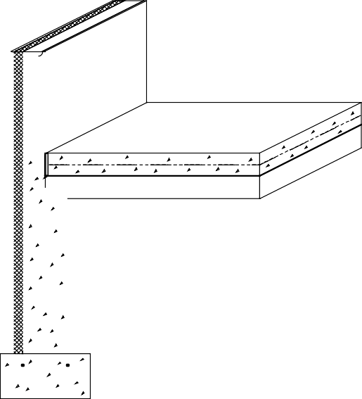

### Slab-on-Grade Insulation Placement and Thickness

To provide energy use information for buildings with slab-on-grade foundations, heating and cooling loads were simulated for different insulation placements and thicknesses in a variety of U.S. climates (Labs et al. 1988). Key assumptions are that the interior space above the slab is heated to a temperature of 70OF and cooled to a temperature of 78OF when required.

##### Insulation Configurations and Costs

Table 4-1 includes illustrations and descriptions of a variety of slab-on-grade insulation configurations. The construction system in all cases is a concrete (or masonry)

###### Figure 4-1: Slab-on-Grade Foundation with Exterior Insulation

**Table 4-1: Insulation Recommendations for Slab-on-Grade Foundations**

**A: Concrete or Masonry Foundation Wall with Exterior Insulation Placed Vertically**

|  |  |  |  |  |  |  |
| --- | --- | --- | --- | --- | --- | --- |
| **CONFIGURATION** | **DESCRIPTION** | **RECOMMENDED CONFIGURATIONS AT THREE FUEL PRICE LEVELS**  **0-2000 HDD 2-4000 HDD 4-6000 HDD 6-8000 HDD 8-10000 HDD** | | | | |
| **(LOS ANG)**  **L M H** | **(FT WORTH)**  **L M H** | **(KAN CITY)**  **L M H** | **(CHICAGO)**  **L M H** | **(MPLS)**  **L M H** |
| **EXTERIOR VERTICAL** | NO INSULATION 2 FT DEEP: R-5  2 FT DEEP: R-10  4 FT DEEP: R-5  4 FT DEEP: R-10  4 FT DEEP: R-15  4 FT DEEP: R-20 |  |  |  |  |  |

**B: Concrete or Masonry Foundation Walls with Interior Insulation Placed Vertically**

|  |  |  |  |  |  |  |
| --- | --- | --- | --- | --- | --- | --- |
| **INTERIOR VERTICAL** | NO INSULATION 2 FT DEEP: R-5  2 FT DEEP: R-10  4 FT DEEP: R-5  4 FT DEEP: R-10  4 FT DEEP: R-15  4 FT DEEP: R-20 |  |  |  |  |  |

**C: Concrete or Masonry Foundation Walls with Interior Insulation Placed Horizontally Under Slab Perimeter**

|  |  |  |  |  |  |  |
| --- | --- | --- | --- | --- | --- | --- |
| **INTERIOR HORIZONTAL** | NO INSULATION 2 FT WIDE: R-5  2 FT WIDE: R-10  4 FT WIDE: R-5  4 FT WIDE: R-10 |  |  |  |  |  |

**D: Concrete or Masonry Foundation Walls with Exterior Insulation Extending Outward Horizontally**

|  |  |  |  |  |  |  |
| --- | --- | --- | --- | --- | --- | --- |
| **EXTERIOR HORIZONTAL** | NO INSULATION 2 FT WIDE: R-5  2 FT WIDE: R-10  4 FT WIDE: R-5  4 FT WIDE: R-10 |  |  |  |  |  |

1. L, H, and M refer to the low, medium, and high fuel cost levels indicated in Table 4-2.
2. The darkened circle represents the recommended level of insulation in each column for each of the four basic insulation configurations.
3. These recommendations are based on assumptions that are summarized at the end of section 4.1 and further explained in chapter 5.

##### Table 4-2: Fuel Price Levels Used to Develop Recommended Insulation Levels in Table 4-1

|  |  |  |  |  |
| --- | --- | --- | --- | --- |
| **SEASON** | **FUEL TYPE** | **LOW PRICE LEVEL ($)** | **MEDIUM PRICE LEVEL ($)** | **HIGH PRICE LEVEL ($)** |
| **HEATING** | NATURAL GAS FUEL OIL PROPANE | .374 / THERM  .527 / GALLON  .344 / GALLON | .561 / THERM  .791 / GALLON  .516 / GALLON | .842 / THERM  1.187 / GALLON  .775 / GALLON |
| **COOLING** | ELECTRICITY | .051 / KWH | .076 / KWH | .114 / KWH |

foundation wall extending either 2 or 4 feet deep with the upper 8 inches of the foundation wall exposed on the exterior.

The three most common approaches to insulating slab-on-grade foundations with concrete/ masonry walls are (1) placing insulation vertically on the entire exterior surface of the foundation wall (2 or 4 feet deep), (2) placing insulation vertically on the entire interior surface of the foundation wall (2 or 4 feet deep), and (3) placing insulation horizontally under the slab perimeter (extending 2 or 4 feet). When insulation is placed either vertically or horizontally on the interior, it is important to place insulation in the joint between the slab edge and foundation wall. It is not necessary to place more than R-5 insulation in this joint. For example, even when R-15 insulation is recommended for the foundation wall, only R-5 insulation in the joint proves to be cost- effective.

In addition to these conventional approaches, some cases were simulated where insulation is placed horizontally on the building exterior (extending either 2 or 4 feet into the surrounding soil). In some regions it is common practice to have a shallower footing than 2 feet or have no foundation wall at all—just a thickened slab edge. In these cases, a full 2 feet of vertical insulation is not an option; however, additional horizontal insulation placement on the exterior is possible.

##### Recommended Insulation Levels

While increasing the amount of foundation insulation produces greater energy savings, the cost of installation must be compared to these savings. Such a comparison can be done in several ways; however, a life cycle cost analysis (presented in worksheet form in chapter 5) is

recommended since it takes into account a number of economic variables including installation costs, mortgage rates, HVAC efficiencies, and fuel escalation rates. In order to identify the most economical amount of insulation for the crawl space configurations shown in Table 4-1, the case with the lowest 30-year life cycle cost was determined for five U.S. cities at three different fuel cost levels. See the *Building Foundation Design Handbook* (Labs et al. 1988) to find recommendations for a greater number of cities and for a detailed explanation of the methodology. The economic methodology used to determine the insulation levels in Table 3-1 is consistent with ASHRAE standard 90.2P. The simple payback averages 13 years for all U.S. climate zones, and never exceeds 18 years for any of the recommended levels.

Economically optimal configurations are shown by the darkened circles in Table 4-1 in the following categories: (1) exterior insulation placed vertically on the foundation wall, (2) interior insulation placed vertically on the foundation wall, (3) interior insulation placed horizontally beneath the slab perimeter, and (4) exterior insulation extending outward horizontally from the foundation wall. Configurations are recommended for a range of climates and fuel prices in each of these categories, but the different categories of cases are not directly compared with each other. In other words, there is an optimal amount of exterior vertical insulation recommended for a given climate and fuel price, and there is a different optimal amount of interior insulation placed vertically. Where there is no darkened circle in a particular category, insulation is not economically justified under the assumptions used.

Exterior vertical insulation ranging from R-5 to R-10 is justified in all climate zones

except the warmest one. As the climate becomes colder and fuel prices increase, the recommended R-value and depth of insulation increase as well. Similar levels of interior insulation are recommended for both vertical and horizontal placement. For exterior insulation extending outward horizontally, a 2-foot-wide section of R-5 insulation is recommended at all fuel price levels and in all climate zones except the warmest one.

It should be noted that for all cases with interior vertical or horizontal insulation, it is assumed that R-5 insulation is placed in the gap between the slab edge and the foundation wall. A simulation with no insulation in the gap indicates that energy savings are reduced by approximately 40 percent, compared with a similar configuration with the R-5 slab edge insulation in place.

##### Comparison of Insulation Approaches

When exterior and interior vertical insulation are compared, thermal results are very similar for equivalent amounts of insulation. Since it is assumed that exterior insulation costs more to install, however, interior placement is always economically optimal in comparison. This increased cost for an exterior insulation is attributed to the need for protective covering.

Interior insulation placed horizontally beneath the slab perimeter performs almost identically to interior vertical insulation in terms of energy savings. However, interior vertical insulation is slightly more cost- effective than placement beneath the slab perimeter because the installation cost of the horizontal approach is slightly higher (although not as high as exterior vertical insulation).

Exterior horizontal insulation actually saves more energy for an equivalent amount of insulation compared with the other alternatives; however, it is the least cost- effective approach. In fact, exterior horizontal insulation is not directly comparable to the other cases since it actually requires an extra foot of vertical insulation before it extends horizontally. Thus, costs are higher due to the protective cover as well as the additional amount of material.

In spite of the apparent cost-effectiveness of interior vertical insulation compared with the other approaches, this is only one of many cost and performance issues to be

considered. The economic benefit of interior vertical insulation may be offset by other practical, performance, and aesthetic considerations discussed elsewhere in this book.

##### Assumptions

These general recommendations are based on a set of underlying assumptions. Fuel price assumptions used in this analysis are shown in Table 4-2. The total heating system efficiency is 68 percent and the cooling system SEER is 9.2 with 10 percent duct losses. Energy price inflation and mortgage conditions are selected to allow maximum simple payback of 18 years with average paybacks of about 13 years.

The total installed costs for all insulation systems considered in this analysis are shown in Table 5-2 in chapter 5. Installation costs used in this analysis are based on average U.S. costs in 1987. Costs include labor and materials for extruded polystyrene insulation and the required protective covering and flashing above grade (for the exterior cases). All costs include a 30 percent builder markup and a 30 percent subcontractor markup for overhead and profit.

If the general assumptions used in this analysis are satisfactory for the specific project, the reader can determine the approximate recommended insulation level for a location by finding the heating degree days from Table 5-1 in chapter 5 and selecting the appropriate climate zone and fuel price level shown in Table 4-1. If not, project-specific optimal insulation levels can be determined using actual estimated construction costs with the worksheet provided in chapter 5. The worksheet enables the user to select economic criteria other than allowing maximum simple paybacks of 18 years. In addition, the user can incorporate local energy prices, actual insulation costs, HVAC efficiencies, mortgage conditions, and fuel escalation rates. Cost- effectiveness can vary considerably, depending on the construction details and cost assumptions.

### Recommended Design and Construction Details



**SLAB SUPPORTS FLOOR LOAD**

**ANCHOR BOLT CONNECTS FOUNDATION WALL TO SUPERSTRUCTURE AND RESISTS WIND UPLIFT**

**GRADE BEAM DISTRIBUTES VERTICAL LOAD FROM ABOVE-GRADE STRUCTURE TO GROUND**

#### STRUCTURAL DESIGN

The major structural components of a slab-on-grade foundation are the floor slab itself and either grade beams or foundation walls with footings at the perimeter of the slab (see Figures 4-2 and 4-3). In some cases additional footings (often a thickened slab) are necessary under bearing walls or columns in the center of the slab. Concrete slab-on- grade floors are generally designed to have sufficient strength to support floor loads without reinforcing when poured on undisturbed or compacted soil. The proper use of welded wire fabric and concrete with a low water/ cement ratio can reduce shrinkage cracking, which is an important concern for appearance and for reducing potential radon infiltration.

Foundation walls are typically constructed of cast-in-place concrete or concrete masonry units. Foundation walls must be designed to resist vertical loads from the structure above and transfer these loads to the footing. Concrete spread footings must provide support beneath foundation walls and columns. Similarly, grade beams at the edge of the foundation support the superstructure above. Footings must be designed with adequate bearing area to distribute the load to the soil and be placed beneath the maximum frost penetration depth or be insulated to prevent frost penetration.

Where expansive soils are present or in areas of high seismic activity, special foundation construction techniques may be necessary. In these cases, consultation with local building officials and a structural engineer is recommended.

#### DRAINAGE AND WATERPROOFING

Good surface drainage techniques are always recommended for slab-on-grade foundations (see Figure 4-4). The goal of surface drainage is to keep water away from the foundation by sloping the ground surface and using gutters and downspouts for roof drainage. Because a slab-on-grade floor is above the surrounding exterior grade, no

##### Figure 4-2: Structural Components of Slab-on-Grade Foundation with Grade Beam



**SLAB SUPPORTS FLOOR LOAD**

**ANCHOR BOLT CONNECTS FOUNDATION WALL TO SUPERSTRUCTURE AND RESISTS WIND UPLIFT**

**WALL RESISTS VERTICAL LOAD FROM ABOVE-GRADE STRUCTURE**

**SPREAD FOOTING DISTRIBUTES VERTICAL LOAD TO GROUND**

**FOOTING MUST BE BELOW MAXIMUM FROST PENETRATION DEPTH**

**Figure 4-3: Structural Components of Slab-on-Grade Foundation with Stem Wall and Footing**

*Builder’s Foundation Handbook Page 63*

subsurface drainage system or waterproofing is required. On sites with a high water table, the floor should be raised above existing grade as much as possible and a layer of gravel can be placed beneath the slab to ensure that drainage occurs and moisture problems are avoided.

#### LOCATION OF INSULATION

Good construction practice demands elevating the slab above grade by no less than 8 inches to isolate the wood framing from rain splash, soil dampness, and termites, and to keep the subslab drainage



**SURFACE DRAINAGE TECHNIQUES:**

**- SLOPE GROUND AWAY**

**GRAVEL DRAINAGE LAYER RECOMMENDED BENEATH SLAB IF A HIGH WATER TABLE IS PRESENT**

**- USE GUTTERS AND DOWNSPOUTS**

**NO SUBSURFACE DRAINAGE REQUIRED**

##### Figure 4-4: Drainage Techniques for Slab-on-Grade Foundations

layer above the surrounding ground. The most intense heat losses are through this small area of foundation wall above grade, so it requires special care in detailing and installation. Heat is also lost from the slab to the soil, through which it migrates to the exterior ground surface and the air. Heat losses to the soil are greatest at the edge, and diminish rapidly with distance from it. Both components of the slab heat loss — at the edge and through the soil — must be considered in designing the insulation system.

Insulation can be placed vertically outside the foundation wall or grade beam. This approach effectively insulates the exposed slab edge above grade and extends down to reduce heat flow from the floor slab to the ground surface outside the building. Vertical exterior insulation is the only method of reducing heat loss at the edge of an integral grade beam and slab foundation. A major advantage of exterior insulation is that the interior joint between the slab and foundation wall need not be insulated, which simplifies construction. Several drawbacks, however, are that rigid insulation should be covered above grade with a protective board, coating, or flashing material, and with brick facings, a thermal short can be created that bypasses both the foundation and above- grade insulation. A limitation is that the depth of the exterior insulation is controlled by the footing depth. Additional exterior insulation can be provided by extending insulation horizontally from the foundation wall. Since this approach can control frost penetration near the footing, it can be used to reduce footing depth requirements under certain circumstances. This can substantially reduce the initial foundation construction cost.

Insulation also can be placed vertically on the interior of the foundation wall or horizontally under the slab. In both cases, heat loss from the floor is reduced and the difficulty of placing and protecting exterior insulation is avoided. Interior vertical insulation is limited to the depth of the footing but underslab insulation is not limited in this respect. Usually the outer 2 to 4 feet of the slab perimeter is insulated but the entire floor may be insulated if desired.

It is essential to insulate the joint between the slab and the foundation wall whenever insulation is placed inside the foundation wall or under the slab. Otherwise, a significant amount of heat transfer occurs through the thermal bridge at the slab edge.

*Page 64 Chapter 4—Slab-on-Grade Construction*

The insulation is generally limited to no more than 1 inch in thickness at this point. Both the American Concrete Institute (1985) and the Building Research Advisory Board (1968) recommend against pouring the slab on a shelf formed in the foundation wall, regardless of whether or not the joint is insulated or an expansion joint is provided.

A solution to designing this floor/ wall joint is shown in Figure 4-10 for a cast-in- place concrete foundation wall. The notched wall section permits 1 inch of rigid insulation to be placed in the joint and also permits the slab to move vertically. This detail can be used for vertical interior or subslab insulation. Concrete masonry foundation walls are more difficult to resolve successfully. Figures 4-14 and 4-15 illustrate two solutions. The detail in Figure 4-14 uses a 6-inch-thick block on the top course that permits insulation in the joint and vertical movement of the slab. This detail is designed for a 2-by-6 above-grade wall. In Figure 4-15 a similar detail with a 2-by-4 above-grade wall on a 4-inch-thick block on the top course is shown. This last alternative effectively provides insulation in the joint but diverges from ideal structural practice. The slab rests on a ledge and becomes thinner near the insulated edge.

Another option for insulating a slab-on- grade foundation is to place insulation above the floor slab. A wood floor deck can be placed on sleepers, leaving cavities that can be filled with rigid board or batt insulation, or a wood floor deck can be placed directly on rigid insulation above the slab. This approach avoids some of the construction detail problems inherent in the more conventional approaches discussed above, but may lead to greater frost depth in the vicinity of the slab edge.

#### TERMITE AND WOOD DECAY CONTROL TECHNIQUES

Techniques for controlling the entry of termites through residential foundations are necessary in much of the United States (see Figure 4-5). Consult with local building officials and codes for further details.

* + 1. Minimize soil moisture around the foundation by surface drainage and by using gutters, downspouts, and runouts to remove roof water.
    2. Remove all roots, stumps, and wood

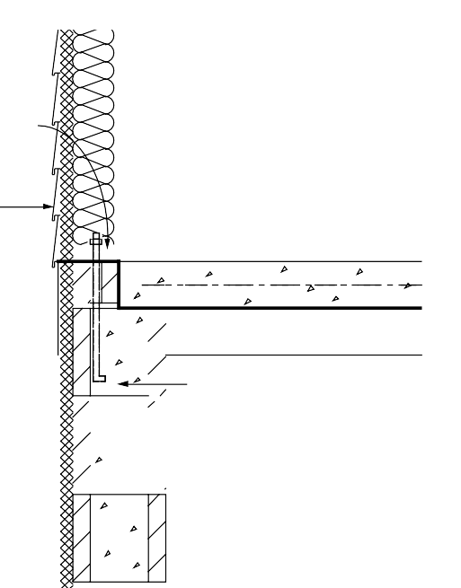

**PRESSURE-PRESERVATIVE TREATED SILL PLATE**

**8-IN. MIN. ABOVE GRADE**

**WOOD SIDING 6-IN. MIN. ABOVE GRADE**

**REMOVE ROOTS, TRUNKS, AND SCRAP WOOD FROM FOUNDATION AREA**

**FILL JOINT WITH CAULKING**

**TREAT SOIL FOR TERMITES**

**MINIMIZE SOIL MOISTURE USING SURFACE DRAINAGE TECHNIQUES**

* **USE GUTTERS AND DOWNSPOUTS**
* **SLOPE GROUND AWAY**

**BOND BEAM, CAP BLOCK, OR FILLED UPPER COURSE**

**OF MASONRY WALL**

##### Figure 4-5: Termite Control Techniques for Slab-on-Grade Foundations

from the site. Wood stakes and form work should also be removed from the foundation area.

* + 1. Treat soil with termiticide on all sites vulnerable to termites (Labs et al. 1988).
    2. Place a bond beam or course of solid cap blocks on top of all concrete masonry foundation walls to ensure that no open cores are left exposed. Alternatively, fill all cores on the top course with mortar. The mortar joint beneath the top course or bond beam should be reinforced for additional insurance.
    3. Place the sill plate at least 8 inches

above grade; it should be pressure- preservative treated to resist decay. Since termite shields are often damaged or not installed carefully enough, they are considered optional and should not be regarded as sufficient defense by themselves.

* + 1. Be sure that exterior wood siding and trim are at least 6 inches above grade.
    2. Construct porches and exterior slabs so that they slope away from the foundation wall, are reinforced with steel or wire mesh, usually are at least 2 inches below exterior siding, and are separated from all wood members by a 2-inch gap visible for inspection or a continuous metal flashing soldered at all seams.



**SEAL AROUND ALL DUCTS AND PIPES IN SLAB**

**USE SOLID DRAINPIPES IN FLOOR WITH MECHANICAL TRAPS**

**FILL JOINT WITH CAULKING**

**REINFORCE SLAB AND USE CONCRETE WITH LOW WATER/ CEMENT RATIO TO REDUCE CRACKING**

**BOND BEAM, CAP BLOCK, OR FILLED UPPER COURSE OF MASONRY WALL**

**6-MIL POLY LAYER UNDER SLAB EXTENDED OVER TOP OF FOUNDATION WALL**

##### Figure 4-6: Radon Control Techniques for Slab-on-Grade Foundations

* + 1. Fill the joint between a slab-on-grade floor and foundation wall with liquid-poured urethane caulk or coal tar pitch to form a termite and radon barrier.

#### RADON CONTROL TECHNIQUES

The following techniques for minimizing radon infiltration through a slab-on-grade foundation are appropriate where there is a reasonable probability that radon may be present (see Figure 4-6). To determine this, contact the state health department or environmental protection office.

1. Use solid pipes for floor discharge drains to daylight or provide mechanical traps if they discharge to subsurface drains.
2. Lay a 6-mil polyethylene film on top of the gravel drainage layer beneath the slab. This film serves both as a radon and moisture retarder. Slit an “x” in the polyethylene membrane at penetrations. Turn up the tabs and tape them. Care should be taken to avoid unintentionally puncturing the barrier; consider using riverbed gravel if available at a reasonable price. The round riverbed gravel allows for freer movement of the soil gas and has no sharp edges to penetrate the polyethylene. The edges should be lapped at least 12 inches. The polyethylene should extend over the top of the foundation wall, or extend to the outer bottom edge of a monolithic slab-grade beam or patio. Use concrete with a low water/ cement ratio to minimize cracking. A 2-inch-thick sand layer on top of the polyethylene improves concrete curing and prevents the concrete from infiltrating the aggregate base under the slab. The sand should be dampened, but not saturated, before the concrete is poured. The sand will also offer some puncture protection for the polyethylene during the concrete pouring operation.
3. Provide an isolation joint between the foundation wall and slab floor where vertical movement is expected. After the slab has cured for several days, seal the joint by pouring polyurethane or similar caulk into the 1/ 2-inch channel formed with a removable strip. Polyurethane caulks adhere well to masonry and are long-lived. They do not stick to polyethylene. Do not use latex caulks.
4. Install welded wire in the slab to reduce the impact of shrinkage cracking. Consider control joints or additional reinforcing near the inside corner of “L” shaped slabs. Two pieces of No. 4 reinforcing bar, 3 feet long and on 12-inch centers, across areas where additional stress is anticipated, should reduce cracking. Use of fibers within concrete will also reduce the amount of plastic shrinkage cracking.
5. Control joints should be finished with a 1/ 2-inch depression. Fill this recess fully with polyurethane or similar caulk.
6. Minimize the number of pours to avoid cold joints. Begin curing the concrete immediately after the pour, according to recommendations of the American Concrete Institute (1980; 1983). At least three days are required at 70OF, and longer at lower temperatures. Use an impervious cover sheet or wetted burlap.
7. Form a gap of at least 1/ 2-inch width around all plumbing and utility lead-ins through the slab to a depth of at least 1/ 2 inch. Fill with polyurethane or similar caulking.
8. Place HVAC condensate drains so that they run to daylight outside the building envelope. Condensate drains that connect to dry wells or other soil may become direct conduits for soil gas, and can be a major entry point for radon.
9. Place a solid brick course, bond beam, or cap block on top of all masonry foundation walls to seal cores, or fill open block cores in the top course with concrete. An alternative approach is to leave the masonry cores open and fill solid at the time the floor slab is cast by flowing concrete into the top course of block.

##### Intercepting Soil Gas

At this time the best strategy for mitigating radon hazard seems to be to reduce stack effects by building a tight foundation in combination with a generally tight above-grade structure, and to make sure a radon collection system and, at the very least, provisions for a discharge system are an integral part of the initial construction.

This acts as an insurance policy at modest cost. Once the house is built, if radon levels are excessive, a passive discharge system can be connected and if further mitigation effort

is needed, the system can be activated by installing an in-line duct fan (see Figure 4-7).

Subslab depressurization has proven to be an effective technique for reducing radon concentrations to acceptable levels, even in homes with extremely high concentrations (Dudney 1988). This technique lowers the pressure around the foundation envelope, causing the soil gas to be routed into a collection system, avoiding the inside spaces and discharging to the outdoors. This system could be installed in two phases. The first phase is the collection system located on the soil side of the foundation, which should be installed during construction. The collection system, which may consist of nothing more than 4 inches of gravel beneath the slab floor, can be installed at little or no additional cost in new construction. The second phase is the discharge system, which could be installed later if necessary.

A foundation with good subsurface drainage already has a collection system. The underslab gravel drainage layer can be used to collect soil gas. It should be at least 4 inches thick, and of clean aggregate no less than 1/ 2 inch in diameter. Weep holes provided through the footing or gravel bed extending beyond the foundation wall will

help assure good air communication between the foundation perimeter soil and the underside of the slab. The gravel should be covered with a 6-mil polyethylene radon and moisture retarder, which in turn could be covered with a 2-inch sand bed.

A 3- or 4-inch diameter PVC 12-inch section of pipe should be inserted vertically into the subslab aggregate and capped at the top. Stack pipes could also be installed horizontally through below-grade walls to the area beneath adjoining slabs. A single standpipe is adequate for typical house-size floors with a clean, coarse gravel layer. If necessary, the standpipe can be uncapped and connected to a vent pipe. The standpipe can also be added by drilling a 4-inch hole through the finished slab. The standpipe should be positioned for easy routing to the roof through plumbing chases, interior walls, or closets. Note, however, that it is normally less costly to complete the vent stack routing through the roof during construction than to install or complete the vent stack after the building is finished. Connecting the vent pipe initially without the fan provides a passive depressurization system which may be adequate in some cases and could be designed for easy modification to an active



**ROOF VENT FOR**

**SOIL GAS DISCHARGE**

**DISCHARGE FAN LOCATED IN ATTIC**

**RISER PIPE FROM AREA UNDER SLAB**

**STANDPIPES CAN BE CAPPED FOR FUTURE USE**

**SUCTION TAP CAST IN SLAB**

**CONCRETE SLAB OVER POLY VAPOR BARRIER**

**GRAVEL DRAINAGE LAYER**

##### Figure 4-7: Soil Gas Collection and Discharge Techniques

system if necessary.

A subslab depressurization system requires the floor slab to be nearly airtight so that collection efforts are not short-circuited by drawing excessive room air down through the slab and into the system. Cracks, slab penetrations, and control joints must be sealed. Floor drains that discharge to the gravel beneath the slab should be avoided, but when used, should be fitted with a mechanical trap capable of providing an airtight seal.

It is desirable to avoid dependence on a continuously operating fan. Ideally, a passive depressurization system should be installed, radon levels tested and, if necessary, the system activated by adding a fan. Active systems use quiet, in-line duct fans to draw gas from the soil. The fan should be located in an accessible section of the stack so that any leaks from the positive pressure side of the fan are not in the living space. The fan should be oriented to prevent accumulation of condensed water in the fan housing. The stack should be routed up through the building and extend 2 to 4 feet above the roof. It can also be carried out through the band joist and up along the outside of wall, to a point at or above the

eave line. The exhaust should be located away from doors and windows to avoid re- entry of the soil gas into the above-grade space.

A fan capable of maintaining 0.2 inch of water suction under installation conditions is adequate for serving subslab collection systems for most houses (Labs 1988). This is often achieved with a 0.03 hp (25W), 160 cfm centrifugal fan (maximum capacity) capable of drawing up to 1 inch of water before stalling. Under field conditions of 0.2 inch of water, such a fan operates at about 80 cfm.

It is possible to test the suction of the subslab system by drilling a small (1/ 4-inch) hole in an area of the slab remote from the collector pipe or suction point, and measuring the suction through the hole. A suction of 5 Pascals is considered satisfactory. The hole must be sealed after the test.

Active subslab depressurization does raise some long-term concerns which at this time are not fully understood. If the radon barrier techniques are not fully utilized along with the subslab depressurization, considerable indoor air could be discharged, resulting in a larger than expected energy penalty. System durability is of concern, particularly motor-driven components. This system is susceptible to owner interference.

### Slab-on-Grade Construction Details

In this section, typical slab-on-grade foundation details are illustrated and described. Figure 4-9 shows exterior insulation applied to a grade beam foundation. A grade beam supporting a brick veneer facade is shown in Figure 4-10 with exterior insulation. Insulation applied to the exterior of concrete and concrete masonry foundation walls is shown in Figures 4-11 and 4-12. Figure 4-13 illustrates insulation placed beneath the slab perimeter. The inside insulation case is illustrated for masonry foundation walls in Figures 4-14

and 4-15. A foundation wall supporting a brick veneer facade is shown in Figure 4-16 with interior insulation. Numbers that occur within boxes in each drawing refer to the notes on page 75 that follow the drawings (see Figure 4-8).

The challenge at this stage of design is to develop integrated solutions that address all key considerations without significantly complicating the construction or increasing the cost. There is no one set of perfect solutions; recommended practices or details often represent compromises and trade-offs. No particular approach is considered superior in all cases. This section shows and describes a variety of reasonable alternatives. Individual circumstances will dictate final design choices.

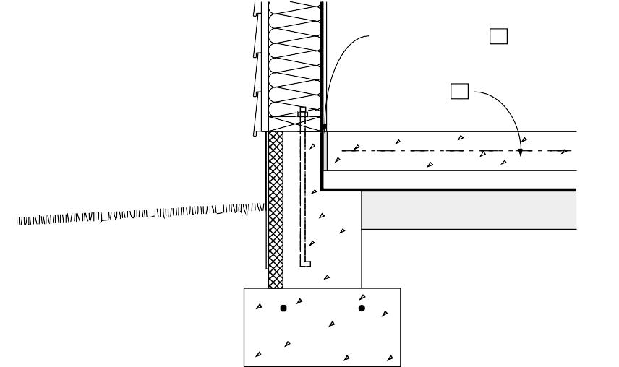

**ISOLATION JOINT 11**

**4-IN. CONCRETE SLAB WITH OPTIONAL**

**W.W. MESH 12**

###### Figure 4-8: System of Key Numbers in Construction Drawings that Refer to Notes on Following Pages

EXAMPLE OF NOTES CORRESPONDING TO CONSTRUCTION DRAWING:

1. **Isolation joint:** An isolation joint should be provided at the slab edge to permit independent movement without cracking. Where radon is a concern, a liquid sealant should be poured into the joint over a foam backing rod.
2. **Concrete slab:** A minimum slab thickness of 4 inches is recommended using concrete with a minimum compressive strength of 2500 psi. Welded wire fabric placed 2 inches below the slab surface is recommended to control shrinkage cracks. Generally, concrete slabs should not rest on footings or ledges of foundation walls if possible to avoid cracking due to settlement. If a slab is poured over an impermeable vapor retarder or insulation board, a concrete mixture with a low water/cement ratio is recommended. An alternative technique is to pour the slab on a layer of sand or drainage board above the vapor retarder to minimize cracking.

*Figure 4-9 illustrates a slab- on-grade foundation with an integral grade beam. The rigid insulation is placed vertically on the exterior face of the grade beam. Additional insulation may be extended horizontally around the foundation perimeter.*

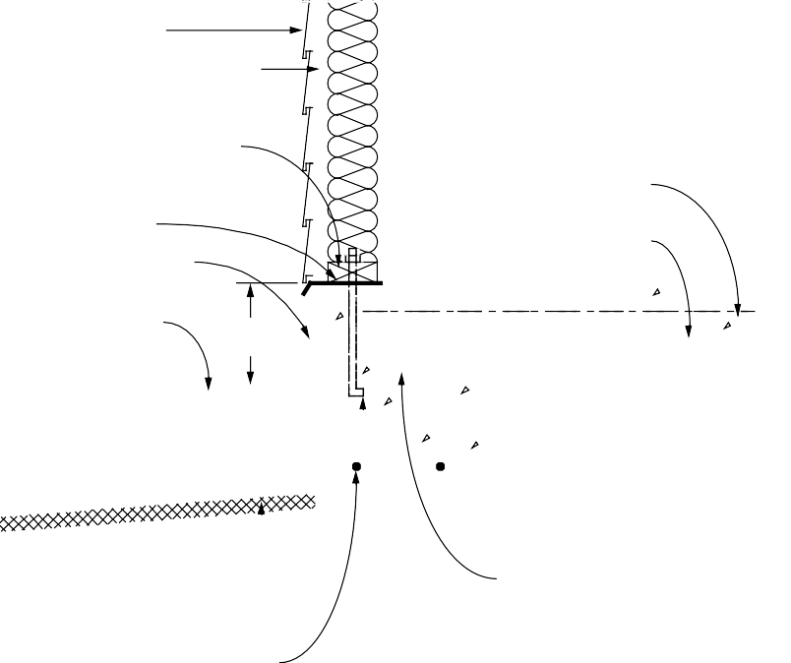

**EXTERIOR SIDING**

**RIGID INSULATION USED AS SHEATHING EXTENDS DOWN TO COVER GRADE BEAM 6**

**INTERIOR FINISH MATERIAL**

**VAPOR RETARDER INSULATON IN 2 x 4 WALL**

**PRESSURE-TREATED SILL PLATE (GASKET UNDER SILL PLATE) 1**

**TERMITE SHIELD**

**PROTECTION BOARD OR COATING 2**

**4-IN. CONCRETE SLAB WITH OPTIONAL**

**W.W. MESH 12**

**VAPOR RETARDER 13**

**GROUND SLOPES AWAY FROM WALL AT 5% 3**

**8-IN. MIN.**

**RIGID INSULATION MAY EXTEND HORIZONTALLY INTO THE SOIL, SLOPING AWAY FROM SLAB EDGE**

**REINFORCING (OPTIONAL) 9**

**4-IN. GRAVEL**

**LAYER (OPTIONAL) 14**

**CONCRETE GRADE BEAM 10**

**SILL ANCHORS AT 6 FT. O. C. MAX. 4**

**Figure 4-9: Slab-on-Grade with Integral Grade Beam (Exterior Insulation)**

*Figure 4-10 illustrates a slab- on-grade foundation with an integral grade beam. This differs from Figure 4-9 in that the above grade wall is wood frame with brick veneer. The rigid insulation is placed vertically on the exterior face of the grade beam and extends upward into the cavity between the wood frame wall and the brick veneer.*

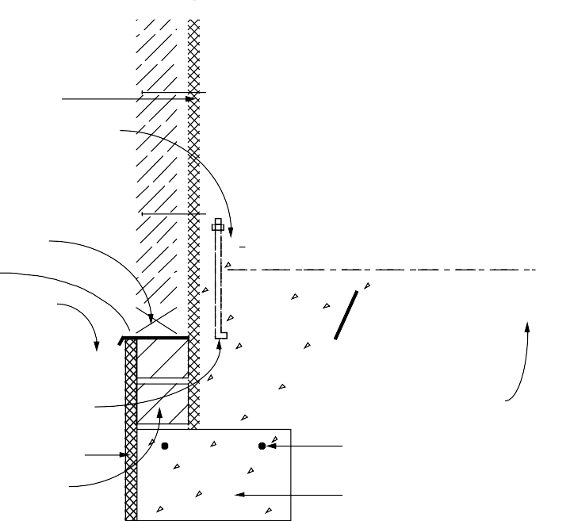

**BRICK VENEER**

**1-IN. AIRSPACE RIGID INSULATION**

**PRESSURE-TREATED SILL PLATE (GASKET UNDER SILL PLATE) 1**

**INTERIOR FINISH MATERIAL**

**INSULATION IN 2 x 4 WALL**

**4-IN. CONCRETE SLAB WITH OPTIONAL**

**W.W. MESH 12**

**VAPOR RETARDER 13**

**OPENING IN EVERY OTHER VERTICAL JOINT**

**FLASHING**

**GROUND SLOPES AWAY FROM WALL AT 5% 3**

**1/2-IN. ANCHOR BOLTS AT 6 FT. O.C. MAX. 4**

**RIGID INSULATION 6**

**INSULATED BLOCK SUPPORT FOR BRICK VENEER**

**4-IN. GRAVEL LAYER (OPTIONAL) 14**

**REINFORCING (OPTIONAL) 9**

**CONCRETE GRADE BEAM 10**

##### Figure 4-10: Slab-on-Grade with Brick Veneer (Exterior Insulation)

*Figure 4-11 illustrates a slab- on-grade with a concrete foundation wall. Rigid insulation is placed vertically on the exterior face of the foundation wall. The 2 x 6 above-grade wood frame wall overhangs the insulation. The foundation wall is designed to permit vertical movement of the floor slab.*

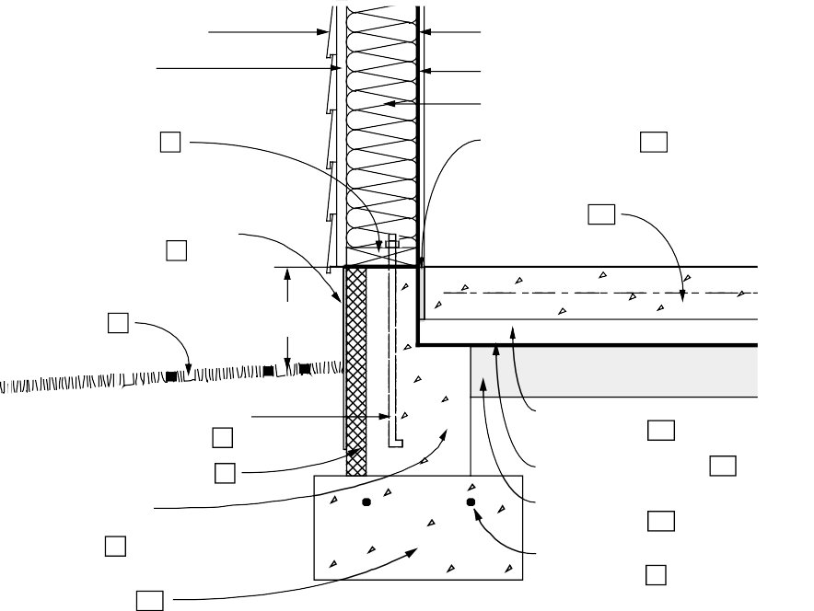

**EXTERIOR SIDING**

**INTERIOR FINISH MATERIAL**

**SHEATHING VAPOR RETARDER**

**PRESSURE-TREATED SILL PLATE (GASKET UNDER SILL PLATE) 1**

**INSULATION IN 2 x 6 WALL**

**ISOLATION JOINT 11**

**4-IN. CONCRETE SLAB WITH OPTIONAL**

**W.W. MESH 12**

**PROTECTION BOARD OR COATING 2**

**GROUND SLOPES AWAY FROM WALL AT 5% 3**

**8-IN. MIN.**

**1/2-IN. ANCHOR BOLTS AT 6 FT. O.C. MAX. 4**

**2-IN. SAND LAYER (OPTIONAL) 12**

**RIGID INSULATION 6**

**CONCRETE FOUNDATION WALL 7**

**VAPOR RETARDER 13**

**4-IN. GRAVEL LAYER (OPTIONAL) 14**

**CONCRETE FOOTING 10**

**REINFORCING (OPTIONAL) 9**

##### Figure 4-11: Slab-on-Grade with Concrete Wall (Exterior Insulation)

*Figure 4-12 illustrates a slab- on-grade foundation with a concrete masonry foundation wall. Rigid insulation is placed vertically on the exterior face of the foundation wall. The top of the insulation is covered by flashing. Because the floor slab rests on the ledge of the foundation wall, it is important to compact the soil beneath the slab to minimize settlement and cracking of the slab.*

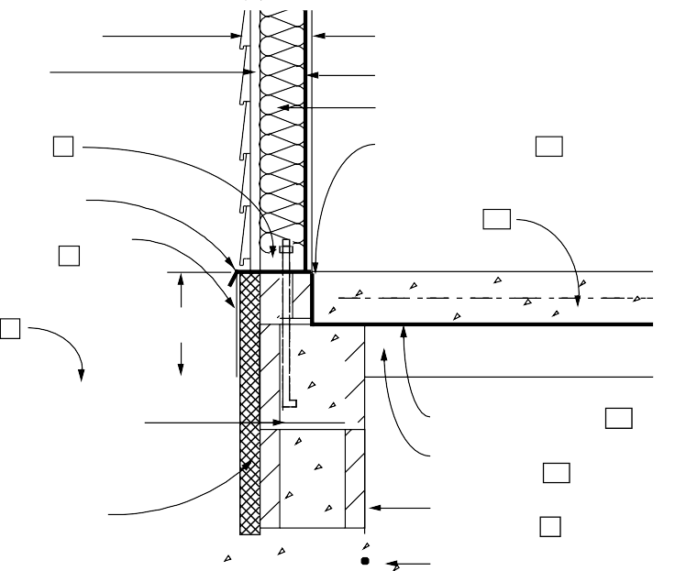

**EXTERIOR SIDING**

**SHEATHING**

**PRESSURE-TREATED SILL PLATE (GASKET UNDER SILL PLATE) 1**

**INTERIOR FINISH MATERIAL**

**VAPOR RETARDER INSULATION IN 2 x 4 WALL**

**ISOLATION JOINT 11**

**FLASHING COVERS TOP 4-IN. CONCRETE SLAB**

**OF INSULATION WITH OPTIONAL**

**W.W. MESH 12**

**PROTECTION BOARD OR COATING 2**

**GROUND SLOPES AWAY FROM WALL AT 5% 3**

**8-IN. MIN.**

**1/2-IN. ANCHOR BOLTS AT 6 FT. O.C. MAX. EMBEDDED 15 IN. INTO FILLED CORES 5**

**RIGID INSULATION OVER CONCRETE MASONRY WALL 6 8**

**VAPOR RETARDER 13**

**4-IN. GRAVEL LAYER (OPTIONAL) 14**

**REINFORCING (OPTIONAL) 9**

**CONCRETE FOOTING 10**

##### Figure 4-12: Slab-on-Grade with Masonry Wall (Exterior Insulation)

*Figure 4-13 illustrates a slab- on-grade with a concrete foundation wall. Rigid insulation is placed horizontally under the slab perimeter and vertically in the joint at the slab edge. An optional sand layer beneath the slab is shown. The foundation wall is designed to permit vertical movement of the floor slab.*

**4**

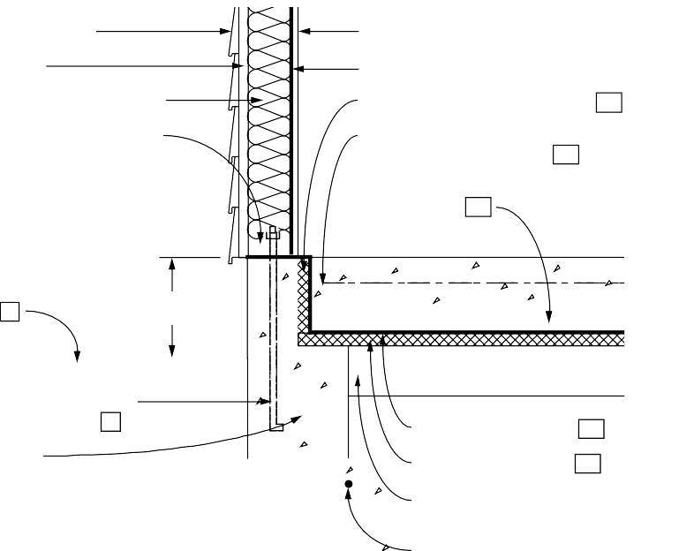

**EXTERIOR SIDING**

**SHEATHING**

**INTERIOR FINISH MATERIAL**

**VAPOR RETARDER**

**INSULATION IN 2 x 6 WALL RIGID INSULATION IN JOINT 11**

**PRESSURE-TREATED SILL 4-IN. CONCRETE SLAB WITH**

**PLATE (GASKET UNDER OPTIONAL W.W. MESH 12 SILL PLATE) 1**

**2-IN. SAND LAYER (OPTIONAL) 12**

**GROUND SLOPES AWAY FROM WALL AT 5% 3**

**8-IN. MIN.**

**1/2-IN. ANCHOR BOLTS AT 6 FT. O.C. MAX.**

**CONCRETE FOUNDATION WALL 7**

**VAPOR RETARDER 13**

**RIGID INSULATION 15**

**CONCRETE FOOTING 10**

**4-IN. GRAVEL LAYER (OPTIONAL) 14**

**REINFORCING (OPTIONAL) 9**

##### Figure 4-13: Slab-on-Grade with Concrete Wall (Insulation Under Slab)

*Figure 4-14 illustrates a slab- on-grade with a concrete masonry foundation wall.*

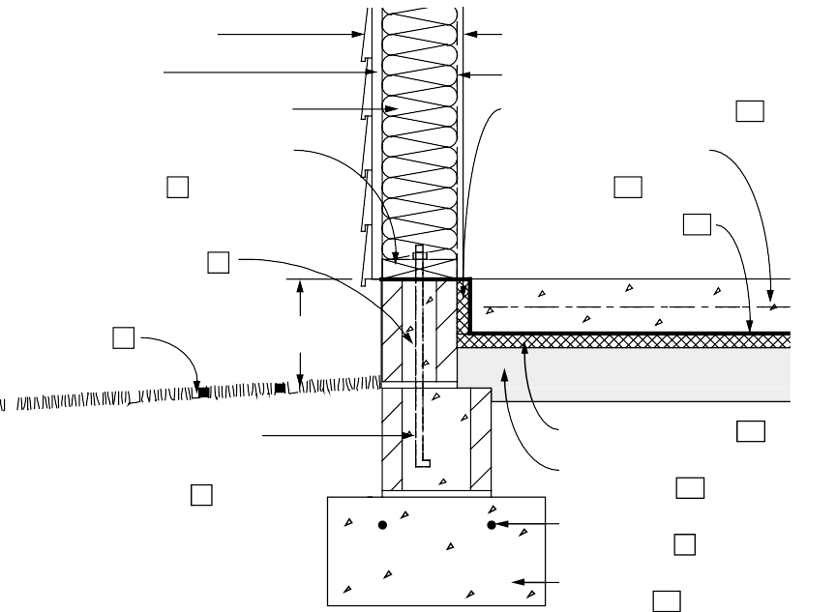

**EXTERIOR SIDING**

**SHEATHING**

**INTERIOR FINISH MATERIAL**

**VAPOR RETARDER**

**INSULATION IN 2 x 6 WALL RIGID INSULATION JOINT 11**

**PRESSURE-TREATED SILL 4-IN. CONCRETE SLAB**

**PLATE (GASKET UNDER WITH OPTIONAL**

**SILL PLATE) 1 W.W. MESH 12**

**6-IN. CONCRETE BLOCK VAPOR RETARDER 13 ON 8-IN. CONCRETE**

**MASONRY WALL 8**

**GROUND SLOPES AWAY FROM WALL AT 5% 3**

**8-IN. MIN.**

**1/2-IN. ANCHOR BOLTS AT 6 FT. O.C. MAX. EMBEDDED 15 IN. INTO FILLED CORES 5**

**RIGID INSULATION 15**

**4-IN. GRAVEL LAYER (OPTIONAL) 14**

**REINFORCING (OPTIONAL) 9**

**CONCRETE FOOTING 10**

*Rigid insulation is placed horizontally under the slab perimeter and vertically in the joint at the slab edge. In order to permit vertical movement of the floor slab, 6-inch wide concrete blocks are used in the top course. This approach utilizes a 2 x 6 above-grade wood frame wall.*

##### Figure 4-14: Slab-on-Grade with Masonry Wall (Insulation Under Slab)

*Figure 4-15 illustrates a slab- on-grade foundation with a concrete masonry foundation wall. Rigid insulation is placed vertically on the interior face of the foundation wall and extends into the joint at the slab edge. Because the floor slab rests on the ledge of the foundation wall, it is important to compact the soil beneath the slab to minimize settlement and cracking of the slab. This approach utilizes a 2 x 4 above-grade wood frame wall.*

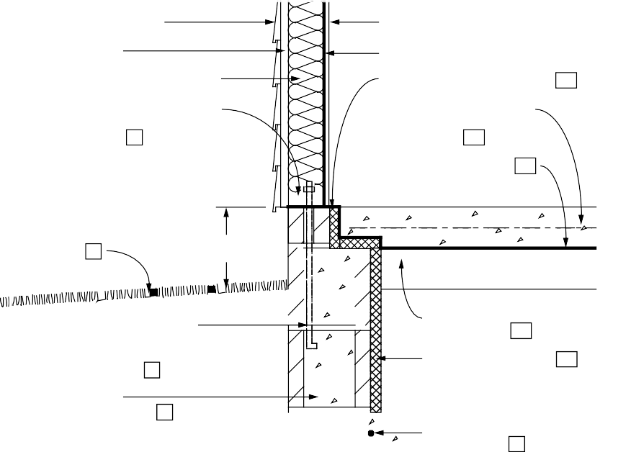

**EXTERIOR SIDING**

**INTERIOR FINISH MATERIAL**

**SHEATHING VAPOR RETARDER**

**INSULATION IN 2 x 4 WALL RIGID INSULATION JOINT 11**

**PRESSURE-TREATED SILL 4-IN. CONCRETE SLAB**

**PLATE (GASKET UNDER WITH OPTIONAL**

**SILL PLATE) 1 W.W. MESH 12**

**VAPOR RETARDER 13**

**GROUND SLOPES AWAY FROM WALL AT 5% 3**

**8-IN. MIN.**

**1/2-IN. ANCHOR BOLTS AT 6 FT. O.C. MAX. EMBEDDED 15 IN. INTO FILLED CORES 5**

**4-IN. GRAVEL LAYER (OPTIONAL) 14**

**RIGID INSULATION 16**

**CONCRETE MASONRY WALL 8**

**REINFORCING (OPTIONAL) 9**

**CONCRETE FOOTING 10**

##### Figure 4-15: Slab-on-Grade with Masonry Wall (Interior Insulation)

*Figure 4-16 illustrates a slab- on-grade with a concrete foundation wall. The approach above-grade wall system consists of a 2 x 4 wood frame wall with brick veneer. Rigid insulation is placed horizontally under the slab perimeter and vertically in the joint at the slab edge. Because the floor slab rests on the ledge of the foundation wall, it is important the compact the soil beneath the slab to minimize settlement and cracking of the slab.*

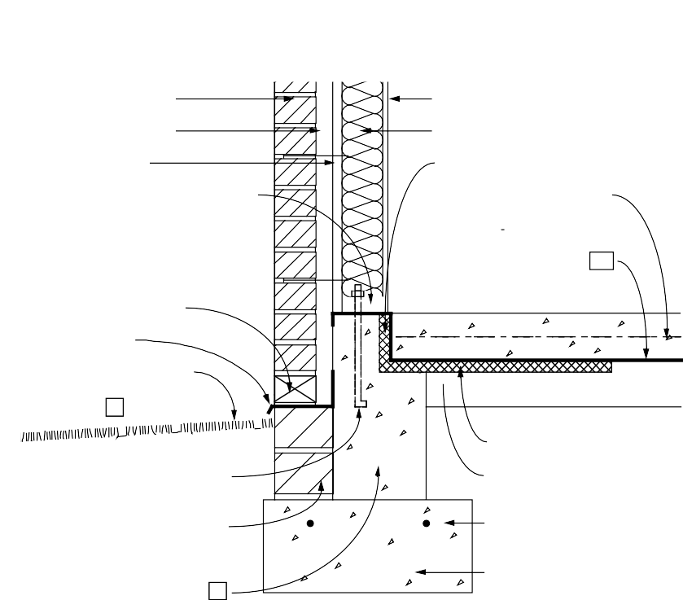

**BRICK VENEER**

**1-IN. AIRSPACE**

**INTERIOR FINISH MATERIAL**

**INSULATION IN 2 x 4 WALL**

**SHEATHING RIGID INSULATION IN JOINT 11**

**PRESSURE-TREATED SILL 4-IN. CONCRETE SLAB**

**PLATE (GASKET UNDER WITH OPTIONAL**

**SILL PLATE) 1 W.W. MESH 12**

**VAPOR RETARDER 13**

**OPENING IN EVERY OTHER VERTICAL JOINT**

**FLASHING**

**GROUND SLOPES AWAY FROM WALL AT 5% 3**

**RIGID INSULATION 15**

**1/2-IN. ANCHOR BOLTS AT 6 FT. O.C. MAX. 4**

**6-IN. BLOCK SUPPORT FOR BRICK VENEER**

**CONCRETE FOUNDATION WALL 7**

**4-IN. GRAVEL LAYER (OPTIONAL) 14**

**REINFORCING (OPTIONAL) 9**

**CONCRETE FOOTING 10**

##### Figure 4-16: Slab-on-Grade with Brick Veneer (Insulation Under Slab)

**NOTES FOR ALL DETAILED SLAB-ON-GRADE DRAWINGS (FIGURES 4-9 THROUGH 4-16)**

1. **Sill plate:** The sill plate should be at least 8 inches above grade and pressure-preservative treated to resist decay.
2. **Insulation protection:** Exterior insulation materials should not be exposed above grade. The above-grade material should be covered by a protective material — such as exterior grade plastic, fiberglass, galvanized metal or aluminum flashing, or a cementitious coating — extending at least 6 inches below grade.
3. **Surface drainage:** The ground surface should slope downward at least 5 percent (6 inches) over the first 10 feet surrounding the foundation edge to direct surface runoff away from the building. Downspouts and gutters should be used to collect roof drainage and direct it away from the foundation walls.
4. **Anchor bolts for concrete walls:** Anchor bolts should be embedded in the top of concrete foundation walls. Most codes require bolts of 1/2- inch minimum diameter to be embedded at least 7 inches into the wall. Generally, anchor bolts can be placed at a maximum spacing of 6 feet and no further than 1 foot from any corner.
5. **Anchor bolts for masonry walls:** Anchor bolts should be embedded in the top of masonry foundation walls. Most codes require bolts of 1/2- inch minimum diameter embedded at least 7 inches into the wall. In some locations, codes require bolts to be embedded 15 inches in masonry walls to resist uplift. To provide adequate anchorage in a masonry wall, bolts either must be embedded in a bond beam or the appropriate cores of the upper course of block must be filled with mortar. Anchor bolts can be placed at a maximum spacing of 6 feet and no further than 1 foot from any corner.
6. **Exterior insulation materials:** Acceptable materials for exterior foundation insulation are: (1) extruded polystyrene boards (XEPS) under any condition, (2) molded expanded polystyrene boards (MEPS) for vertical applications when porous backfill and adequate drainage are provided, and (3) fiberglass or polystyrene drainage boards when installed with an appropriate drainage system.
7. **Cast-in-place concrete wall:** Concrete used in the wall should have a minimum compressive strength of 2500 psi with a 4- to 6-inch slump. No additional water should be added at the job site. Generally, where there are stable soils and low seismic activity, no reinforcing is required.
8. **Concrete/masonry wall:** Generally, where there are stable soils and in areas of low seismic activity, no reinforcing is required.
9. **Crack control reinforcing in footing:** Reinforcing bars placed 2 inches below the top of the footing or 2 inches above the bottom of the grade beam, running parallel to the wall, are recommended where differential settlement is a potential problem. (Optional)
10. **Concrete footings or grade beams:** Concrete footings or grade beams should be designed to distribute the load to the soil and be placed beneath the maximum frost penetration depth unless founded on bedrock or proven non-frost-susceptible soil, or insulated to prevent frost penetration. Concrete should have a minimum compressive strength of 2500 psi.
11. **Isolation joint:** An isolation joint should be provided at the slab edge to permit independent movement without cracking. Where radon is a concern, a liquid sealant should be poured into the joint over a foam backing rod.
12. **Concrete slab:** A minimum slab thickness of 4 inches is recommended using concrete with a minimum compressive strength of 2500 psi. Welded wire fabric placed 2 inches below the slab surface is recommended to control shrinkage cracks. Generally, concrete slabs should not rest on footings or ledges of foundation walls if possible to avoid cracking due to settlement. If a slab is poured directly over an impermeable vapor retarder or insulation board, a concrete mixture with a low water/ cement ratio is recommended. An alternative technique is to pour the slab on a layer of sand or drainage board material above the vapor retarder to minimize cracking.
13. **Vapor retarder:** A 6-mil polyethylene vapor retarder should be placed beneath the slab to reduce moisture transmission and radon infiltration into the building.
14. **Gravel layer under slab:** A 4-inch compacted gravel layer should be placed under the concrete floor slab for drainage unless local conditions have proven this to be unnecessary. (Optional)
15. **Insulation under the slab:** Acceptable materials for underslab insulation are: (1) extruded polystyrene boards (XEPS) under any condition, (2) molded expanded polystyrene boards (MEPS) when the compressive strength is sufficient and adequate drainage is provided, and (3) insulating drainage boards with sufficient compressive strength.
16. **Interior rigid insulation materials:** Acceptable materials for placement inside a foundation wall include (1) extruded polystyrene boards (XEPS) and

(2) expanded polystyrene boards (MEPS).

### Checklist for Design and Construction of Slab-on-Grade Foundations

This checklist serves as a chapter summary, helps review the completeness of construction drawings and specifications, and provides general guidance on project management. The checklist could be used many ways. For example, use one set of blanks during design and the second set during construction inspection. Note that not all measures are necessary under all conditions. Use different symbols to distinguish items that have been satisfied (+) from those that have been checked but do not apply (x). Leave unfinished items unchecked.

#### OVERALL SLAB CONSTRUCTION

**General considerations.** Slab floors require advance planning for plumbing and electrical service. They generally minimize moisture and radon hazard but make detection of termite intrusions especially difficult. Expansive soils require special measures.

Elevate slab above existing grade

Provide minimum 4-inch-thick aggregate drainage layer under slab

Locate plumbing to be cast in slab

Locate electrical service to be cast in slab

Locate gas service to be cast in slab

#### SITEWORK

Locate building at the highest point if the site is wet

Define “finish subgrade” (grading contractor), “base grade” (construction contractor), “rough grade” level before topsoil is respread, “finish grade” (landscape contractor)

Establish elevations of finish grades, drainage swales, catch basins, foundation drain outfalls, bulkheads, curbs, driveways, property corners, changes in boundaries

Establish grading tolerances

Provide intercepting drains upgrade of foundation if needed

Locate dry wells and recharge pits below foundation level

Establish precautions for stabilizing excavation

Establish limits of excavation and determine trees, roots, buried cables, pipes, sewers, etc., to be protected from damage

Confirm elevation of water table

Determine type and dimensions of drainage systems

Discharge roof drainage away from foundation

Remove stumps and grubbing debris from site

Provide frost heave protection for winter construction

Call for test hole (full depth hole in proposed foundation location)

Locate stakes and benchmarks

Strip and stock pile topsoil

Define spoil site

#### SLAB-ON-GRADE FOUNDATION CHECKLIST (PAGE 2 OF 4)

**FOOTINGS**

Position bottom of footing at least 6 inches below frost depth around perimeter (frost wall at garage, slabs supporting roofs, other elements attached to structure).

Confirm adequacy of footing sizes

Do not fill the overexcavated footing trench

Install longitudinal reinforcing (two No. 4 or No. 5 bars 2 inches from top)

Reinforce footing at spans over utility trenches

Do not bear footings partially on rock (sand fill)

Do not pour footings on frozen ground

Indicate minimum concrete compressive strength after 28 days

Call out elevations of top of footings and dimension elevation changes in plan

Use keyway or steel dowels to anchor foundation walls

Dimension stepped footings according to local codes and good practice (conform to masonry dimensions if applicable)

Provide through-joint flashing as a capillary break

#### STRUCTURAL

Avoid ledge-supported slabs unless structurally reinforced

Place isolation joints at frost wall, columns, footings, fireplace foundations, mechanical equipment pads, steps, sidewalks, garage and carport slabs, drains

Check that partition load does not exceed 500 pounds per linear foot on unreinforced slab

Call out depressed bottom of slab where top is depressed

Reinforce slab at depressions greater than 1-1/ 2 inch

Use wire chairs or precast pedestals to support WWF

Place sand layer over vapor retarder or insulation board

Compact fill under slab

Determine general concrete specifications:

Minimum compressive strength after 28 days

Maximum water/ cement ratio. Note: add no water at site

Allowable slump

Acceptable and unacceptable admixtures

Curing requirements (special hot, cold, dry conditions)

Dampening of subgrade prior to pour

Surface finish

Shrinkage control: WWF reinforcement or control joints

Key or dowelling for construction joints

#### SLAB-ON-GRADE FOUNDATION CHECKLIST (PAGE 3 OF 4)

**THERMAL AND MOISTURE CONTROLS**

**General considerations.** Heat loss rate is greatest at the exposed slab edge or frost wall above grade, and at the floor perimeter. Continuity of insulation is difficult except for exterior placement. Horizontal exterior insulation reduces frost penetration depth.

Confirm that insulation R-value meets local codes and/ or recommendations from this handbook

Install insulation product suitable for in-ground use

Install infiltration sealing gasket under sole plate

Place vapor retarder under slab

#### DECAY AND TERMITE CONTROL MEASURES

**General considerations.** Strategy: (1) Isolate wood members from soil by an air space or impermeable barrier; (2) expose critical areas for inspection. Pressure-treated lumber is less susceptible to attack, but is no substitute for proper detailing. Termite shields are not reliable barriers unless installed correctly.

Reinforce slab

Remove all grade stakes, spreader sticks, wood embedded in concrete during pour

Do not disturb treated soil prior to concreting

Avoid ducts beneath floor slab top surface

Specify pressure-treated wall sole plates and sleepers

Pressure-treat sill plates, rim joists, wood members in contact with foundation walls and floors

Pressure-treat all outdoor weather-exposed wood members

Install dampproof membrane under sill plate (flashing or sill seal gasket)

Elevate sill plate minimum 8 inches above exterior grade

Elevate wood posts and framing supporting porches, stairs, decks, etc., above grade (6-inch minimum) on concrete piers

Elevate wood siding, door sills, other finish wood members at least 6 inches above grade (rain splash protection)

Separate raised porches and decks from the building by 2-inch horizontal clearance or provide proper flashing (for drainage and termite inspection)

Pitch solid surface porches, decks, patios for drainage (minimum 1/ 4 in/ ft)

Detail slab porch and patios to prevent termite access to superstructure (structural slab over inspectable crawl space)

Treat soil with termiticide, especially with insulated slab

#### SLAB-ON-GRADE FOUNDATION CHECKLIST (PAGE 4 OF 4)

**RADON CONTROL MEASURES**

**General considerations.** The potential for radon hazard is present in all buildings.

Check state and local health agencies for need of protection. Strategies: (1) barriers; (2) air management; (3) provisions to simplify retrofit. Since radon is a gas, its rate of entry through the foundation depends on suction due to stack effect and superstructure air leakage.

Reinforce slab

Remove all grade stakes, spreader sticks, wood embedded in concrete during pour

Form perimeter wall joint with trough, fill with pour-in sealant

Place vapor retarder under slab (optional sand layer)

Caulk joints around pipes and conduits

Place minimum 4-inch-thick layer of coarse, clean gravel under the slab

Separate outdoor intakes for combustion devices

Install air barrier wrap around superstructure

Seal around flues, chases, vent stacks, attic stairs

#### PLANS, CONTRACTS, AND BUILDING PERMITS

Plans and specs

Bid package

Contractual arrangements (describe principals, describe the work by referencing the blueprints and specs, state the start/ completion dates, price, payment schedule, handling of change orders, handling of disputes, excavation allowance, and procedure for firing)

Building permits

#### SITE INSPECTIONS DURING CONSTRUCTION

After excavation and before concrete is poured for the footings

After the footings have been poured before foundation wall construction

After foundation construction and dampproofing before rough framing

After rough framing

After rough plumbing

After rough electrical

After insulation installation before drywall and backfilling in case of exterior insulation

Final

## CHAPTER 5

**Worksheet for Selection of Optimal Foundation Insulation**

**STEP A:**



**IDENTIFY FOUNDATION**

**CHARACTERISTICS**

**DETERMINE HEATING**

**CLIMATE**

**DETERMINE HEATING**

**LOAD SAVINGS**

**DETERMINE HEATING**

**ENERGY DOLLAR SAVINGS**

**DETERMINE COOLING**

**CLIMATE**

**DETERMINE COOLING**

**LOAD SAVINGS**

**DETERMINE COOLING**

**ENERGY DOLLAR SAVINGS**

**DETERMINE NET**

**DOLLAR SAVINGS**

**STEP B:**

**STEP C:**

**STEP D:**

**STEP E:**

**STEP F:**

**STEP G:**

**STEP H:**

###### Figure 5-1: Steps in Worksheet to Determine Optimal Foundation Insulation

This worksheet will help you choose the optimal foundation insulation location and amount for a new or existing residential building based on your specific building construction, climate, heating and cooling equipment, insulation cost, and other economic considerations. The energy savings of various foundation insulation configurations can be determined from the same heating and cooling load data used to develop the general recommendations in chapters 2, 3, and 4. However, here you may input your current local energy prices and actual insulation costs, and you may choose from three different economic decision criteria: (1) a 20-year minimum life cycle cost (suggested for retrofit); (2) a 30-year minimum life cycle cost, as used in ASHRAE 90.2P (ASHRAE 1989), the CABO Model

Energy Code (CABO 1989), and to develop the general recommendations in chapter 2, 3, and 4 of this handbook; or (3) a second-year positive cash flow.

The major steps of the worksheet are shown schematically in Figure 5-1. The formulas used as a basis for Worksheet 1 are shown in Figure 5-2. Step-by-step instructions guide you through the fill-in-the- blank worksheet. Most of the blanks may be filled with inputs you select from the accompanying tables. Included in the tables are representative insulation R-values and installation costs. However, optional worksheets are provided to help you estimate your actual insulation installation cost (Worksheet 2), and to determine additional R-values not included in the list of typical values shown in Table 5-2 (Worksheet 3). The worksheets and tables as well as accompanying descriptions and instructions appear in section 5.1. This is followed by some examples of how to use the worksheets in section 5.2.

*Page 80 Chapter 5—Worksheet for Determining Optimal Foundation Insulation*

**5.1 Descriptions and Instructions for Worksheets**

##### THERMAL PERFORMANCE

Worksheet 1 helps you estimate the heating and cooling load changes resulting from the foundation insulation options you are considering. The first page of the worksheet addresses the heating season savings while the second page addresses cooling season savings. On each page you identify your climate by entering the local heating degree days (HDD base 65OF) and

cooling degree hours (CDH base 74OF), from Table 5-1. Table 5-2 provides the list of foundation types and insulation configurations covered by the worksheet.

You can specify any reasonable effective R- value and installed insulation cost. Examples of typical average installed costs for new construction in 1987 are provided in Table 5- 2, which includes a markup for the subcontractor and the builder. However, you may choose to estimate your own foundation insulation costs by using Worksheet 2. If a desired level of insulation is not provided in Table 5-2, you may use Worksheet 3 for determining the U-values needed to consider this option in the optimization.

Heating Load Factor = HLFI + (HLFS x HDD)

Heating Load Savings = Heating Load Factor x UDELTA x HDD

1,000,000

Heating Energy Dollar Savings = Heating Load Savings x Economic Scalar Ratio

HEEF x Duct Efficiency

x (Heating Energy Price Rate x Conversion Factor)

Cooling Load Factor = CLFI + (CLFS x CDH)

Cooling Load Savings = Cooling Load Factor x UDELTA x CDH

1,000

Cooling Energy Dollar Savings = Cooling Load Savings x Economic Scalar Ratio

CEEF x Duct Efficiency

x (Cooling Energy Price Rate x Conversion Factor)

Net Dollar Savings = Heating Energy Dollar Savings + Cooling Energy Dollar Savings

- Installation Costs

Notes:

1. HLFI and HLFS are factors found in Table 5-3.
2. CLFI and CLFS are factors found in Table 5-4.
3. HDD are heating degree days found in Table 5-1.
4. CDH are cooling degree hours found in Table 5-1.
5. UDELTA is the difference in U-value between the uninsulated case and an insulated case. UDELTA can be found in Table 5-2 or calculated using Worksheet 3.
6. HEEF is the heating system efficiency and CEEF is the cooling system efficiency (see Table 5-6).
7. Economic scalar ratio is found in Table 5-7.

##### Figure 5-2: Formulas Used as a Basis for Worksheet 1

*Builder’s Foundation Handbook Page 81*

##### ENERGY SAVINGS

Once the load changes are derived for each case, the energy savings can be estimated. The selection of the present worth scalar ratios is where you define your desired economic decision criteria. Table 5-7 provides a variety of scalar ratios derived using three different economic decision criteria: second-year positive cash flow, 20- year life cycle cost, and 30-year life cycle cost. Also shown are seven different fuel escalation rates (0 to 6 percent) which include inflation, and three mortgage rates: 10, 11, and 12 percent.

The scalar ratio is the ratio of the present worth factor for energy savings divided by the present worth factor of mortgage payments for the added foundation insulation cost. The present worth factor for the mortgage payments adjusts for income tax savings and accounts for points paid at the beginning of occupancy as a loan placement fee. It is based on no additional down payment, 1 percent loan placement fee “points”, 10 percent after tax equivalent discount rate, and 30 percent marginal income tax (state and federal combined). The higher the scalar ratio, the greater the present worth value of the energy savings, which leads to higher recommended insulation levels. A simple way of thinking about the scalar ratio is that it is the maximum allowable simple payback to the homeowner of any foundation insulation cost.

##### NET DOLLAR SAVINGS

The last step in the worksheet derives the net dollar savings of each foundation insulation option. Installed costs are presented in Table 5-2 or may be determined using Worksheet 2. The option with the highest positive net savings value in step H of Worksheet 1 is the most cost-effective option.

##### VALIDATION OF WORKSHEET 1

The objective of this worksheet is to lead you to the most cost-effective foundation insulation level based on your specific economic and HVAC performance characteristics. This procedure has been shown to reproduce the recommended insulation configuration tables in chapters 2, 3, and 4 of this handbook. Over 200 cases were run through this worksheet and the

results compared to more detailed computer simulations. The worksheet led to the exact same recommended configuration over 80 percent of the time. Most of the cases that were different resulted from the relatively similar net savings values from a number of different configurations.

**INSTRUCTIONS FOR WORKSHEET 1**

*Suggestion: Make photocopies of the worksheets, keep the originals for future jobs.*

**Step A.** Select the foundation type and insulation configuration from Table 5-2. You may choose more than one insulation configuration from Table 5-2 in order to compare the results. For example, for the slab foundation type you can include the following insulation configurations: *2 ft vertical exterior, 4 ft vertical exterior, and 2 ft vertical interior*. Enter the installation cost for each configuration on line 4. Some typical values for new construction costs are shown in Table 5-2. These costs were national average values in 1987, but you must use Worksheet 2 to obtain current costs.

**Step B.** Determine heating degree days base 65OF (HDD) for your climate from Table 5-1 and enter on line 5.

**Step C.** For determining the heating load savings, enter coefficients (HLFI, HLFS) from Table 5-3 for the appropriate climate and

foundation system on lines 6 and 7. Multiply line 7 (HLFS) by line 5 (HDD) and enter the result on line 8. Add lines 6 and 8 and enter

the results on line 9 (this is the heating load factor). Enter UDELTA from Table 5-2 (or Worksheet 3) on line 10. The heating load

savings of each foundation option are determined by multiplying UDELTA from line 10 by the heating load factor on line 9, then

multiplying that result by HDD from line 5 and finally dividing by 1,000,000 for each option.

**Step D.** Suggested values for the heating equipment efficiency (HEEF) are listed in Table 5-6. The data base on which this worksheet is based uses 0.9 for the HVAC duct efficiency (line 15) for unconditioned spaces like attics and crawl spaces. Duct efficiencies can be much lower. ASHRAE 90.2P used a heating duct efficiency of 0.75 when ducts are in unconditioned spaces.

When ducts are located within the

*Page 82 Chapter 5—Worksheet for Determining Optimal Foundation Insulation*

##### CASE 1 CASE 2 CASE 3 STEP A: IDENTIFY FOUNDATION CHARACTERISTICS

|  |  |  |  |
| --- | --- | --- | --- |
| 1. Enter foundation type (basement, crawl space, or slab) 2. Enter insulation configuration from Table 5-2 3. Enter nominal R-value from Table 5-2 4. Enter installation cost from Table 5-2 or use Worksheet 2 |  |  |  |
| [units: $/lin ft or $/sq ft]* |  |  |  |
| **STEP B: DETERMINE HEATING CLIMATE** |  |  |  |
| 5. Enter heating degree days (HDD) from Table 5-1 |  |  |  |

**STEP C: DETERMINE HEATING LOAD SAVINGS**

|  |  |  |  |
| --- | --- | --- | --- |
| 6. Enter HLFI from Table 5-3 |  |  |  |
| 7. Enter HLFS from Table 5-3 |  |  |  |
| 8. Multiply line 7 (HLFS) by line 5 (HDD) |  |  |  |
| 9. Add lines 6 and 8 [units: Btu/(HDD x UDELTA)] |  |  |  |
| 10. Enter UDELTA from Table 5-2 (or Worksheet 3) |  |  |  |
| 11. Multiply line 9 by line 10 |  |  |  |
| 12. Multiply line 11 by line 5 (HDD) |  |  |  |
| 13. Divide line 12 by 1,000,000 [units: MBtu/lin ft or sq ft]* |  |  |  |

**STEP D: DETERMINE HEATING ENERGY DOLLAR SAVINGS**

|  |  |  |  |
| --- | --- | --- | --- |
| 14. Enter heating system efficiency from Table 5-6 (HEEF) |  |  |  |
| 15. Multiply line 14 by 0.9 (duct efficiency) |  |  |  |

(see instructions for alternative duct efficiency numbers)

* 1. Divide line 13 (heating load savings) by line 15
  2. Enter heating energy price rate and multiply by conversion factor:

|  |  |  |  |  |
| --- | --- | --- | --- | --- |
| A. Electricity: $ per kWh | X | 293 = |  |  |
| B. Natural gas: $ per therm | X | 10 = |  |  |
| C. Fuel oil: $ per gallon | X | 7.2 = |  |  |
| D. Propane: $ per gallon | X | 10.9 = |  |  |
| 18. Multiply line 16 by line 17 | |  |  |  |
| 19. Enter the economic scalar ratio from Table 5-7 | |  |  |  |
| 20. Multiply line 18 by line 19 [units: $/lin ft or sq ft]* | |  |  |  |

(NOTE: If cooling energy savings are not to be included in the calculation, go directly to STEP H.)

* If the configuration utilizes perimeter insulation then all units are expressed *per lineal foot*. If the configuration utilizes ceiling insulation then all units are expressed *per square foot*.

*Builder’s Foundation Handbook Page 83*

|  |  |  |  |
| --- | --- | --- | --- |
| **STEP E: DETERMINE COOLING CLIMATE** | **CASE 1** | **CASE 2** | **CASE 3** |
| 21. Enter cooling degree hours (CDH) from Table 5-1 |  |  |  |

##### STEP F: DETERMINE COOLING LOAD SAVINGS

1. Enter CLF from Table 5-4

I

1. Enter CLF from Table 5-4

S

1. Multiply line 23 (CLF ) by line 21 (CDH) 25. Add lines 22 and 24 [units: Btu/ (CDH x U )] .._____________

S

DELTA

1. Enter U from line 10 ( Table 5-2 or Worksheet 3) .._____________

DELTA

1. Multiply line 26 (U ) by line 25 (CLF)

DELTA

1. Multiply line 27 by line 21 (CDH)
2. Divide line 28 by 1,000 [units: KBtu/ lin ft or sq ft]*

##### STEP G: DETERMINE COOLING ENERGY DOLLAR SAVINGS

|  |  |  |  |
| --- | --- | --- | --- |
| 1. Enter cooling system efficiency from Table 5-6 (CEEF) 2. Multiply line 30 by 0.9 (duct efficiency) |  |  |  |
| 32. Divide line 29 (cooling load savings) by line 31 |  |  |  |
| 33. Enter cooling energy electric rate (i.e., $ 0.078 per kWh) |  |  |  |
| 34. Multiply line 32 by line 33 |  |  |  |
| 35. Enter the economic scalar ratio from Table 5-7 |  |  |  |
| 36. Multiply line 34 by line 35 [units: $/ lin ft or sq ft]* |  |  |  |

**STEP H: DETERMINE NET DOLLAR SAVINGS**

|  |  |  |  |
| --- | --- | --- | --- |
| 1. Add line 20 (heating) and line 36 (cooling) 2. Subtract line 4 (costs) from line 37 (savings) |  |  |  |
| [units: $/ lin ft or sq ft]* |  |  |  |

* If the configuration utilizes perimeter insulation then all units are expressed *per lineal foot*. If the configuration utilizes ceiling insulation then all units are expressed *per square foot*.

#### INSTRUCTIONS FOR WORKSHEET 1 (CONTINUED)

conditioned space, use a value between 0.9 and 1.0. Line 17 is the current year's heating energy price. Multiplying the energy price rate by the conversion factors shown on line 17 expresses the result in $/ MBtu.

The economic scalar ratio is used to determine the present worth of the foundation insulation heating energy savings. Table 5-7 provides a variety of scalar ratios calculated with different mortgage rates, fuel escalation rates, and three different economic decision criteria: (1) second-year positive cash flow, (2) 20-year minimum life cycle cost analysis, and (3) 30- year minimum life cycle cost analysis. The second-year positive cash flow criteria requires that after the second year the additional mortgage payment for the foundation insulation be less than the resulting annual energy savings. The *Building Foundation Design Handbook* (Labs et al. 1988), ASHRAE Standard 90.2P (ASHRAE

1989), and the Model Energy Code (CABO 1989) are all based on a scalar ratio of about

18. To be consistent with these codes and standards, use 18 in line 19. The result on line 20 is the heating energy dollar savings.

**Step E.** Determine cooling degree hours base 74OF (CDH) for your climate from Table 5-1 and enter on line 21.

**Step F.** For determining the cooling load savings, enter coefficients (CLFI, CLFS) from Table 5-4 for the appropriate climate and

foundation system on lines 22 and 23. Multiply line 23 (CLFS) by line 21 (CDH) and enter the result on line 24. Add lines 22 and

24 and enter the results on line 25 (this is the cooling load factor). Enter UDELTA from Table 5-2 (or Worksheet 3) on line 26. The cooling

load savings of each foundation option are determined by multiplying UDELTA from line 26 by the cooling load factor on line 25, then

multiplying that result by CDH from line 21 and finally dividing by 1,000 for each option.

**Step G.** Suggested values for the cooling equipment efficiency (CEEF) are shown in Table 5-6. Line 31 is the HVAC duct efficiency while providing cooling. The *Building Foundation Design Handbook* assumes

0.9 for cooling duct efficiency. ASHRAE 90.2p uses 0.8 for cooling duct efficiency, when ducts are in unconditioned spaces. Line 33 is the current year's cooling energy

price (consult your local electric utility for prices). The value to be entered in line 33 must be in dollars per kWh. Line 35 is the scalar ratio used to estimate the present worth of the cooling energy savings resulting from foundation insulation. Table 5-7 provides a variety of scalar ratios based on different economic criteria, mortgage rates, and real fuel escalation rates. To be consistent with various codes and standards listed in Step D, use a scalar ratio of 18 in line

35. The result on line 36 is the cooling energy dollar savings.

**Step H.** The option with the largest positive value in line 38 is the most cost- effective option. This step subtracts the first cost of each option (line 4) from the corresponding present worth value of the energy savings. If all the net savings values in line 38 are negative, this indicates that none of the cases meet your cost-effectiveness criteria. Select a set of options that have lower installed costs and repeat the worksheet. If still none exist, foundation insulation may not be a good investment for this project.

#### Worksheet 2: Optional Method for Estimating Foundation Insulation Installation Cost

**CASE 1**

**CASE 2**

**CASE 3**

**STEP A: DETERMINE MATERIAL COST**

**STEP B: DETERMINE LABOR COST**

**STEP C: DETERMINE TOTAL INSTALLED COST**

1. Multiply line 11 by the general contractor markup

(example: 1.3)

1. Divide line 12 by the foundation perimeter length in feet

|  |  |  |  |
| --- | --- | --- | --- |
| 1. Enter the total material cost of insulation 2. Enter the total material cost of fasteners 3. Enter the cost of protective covering or required flame |  |  |  |
| spread protection |  |  |  |
| 4. Add lines 1, 2, and 3 to determine the total material cost |  |  |  |

|  |  |  |  |
| --- | --- | --- | --- |
| 5. Enter site preparation cost |  |  |  |
| 6. Enter installation cost for insulation |  |  |  |
| 7. Enter installation cost for any framing or furring |  |  |  |
| 8. Enter installation cost for any protective covering |  |  |  |
| 9. Add lines 5, 6, 7, and 8 to determine total labor cost |  |  |  |

|  |  |  |  |
| --- | --- | --- | --- |
| 1. Add lines 4 and 9 2. Multiply line 10 by the subcontractor markup |  |  |  |
| (example: 1.3) |  |  |  |

**INSTRUCTIONS FOR WORKSHEET 2**

**Step A.** Material costs should be for the entire job. Line 1 represents the material costs for the entire area to be covered. Line 2 includes the insulation attachment materials; examples are fasteners for exterior systems and framing for interior systems. Line 3 includes the above-grade protection needed for exterior insulation or flame spread protection for interior applications. If the covering provides other amenities such as aesthetics (basement finishing needed anyway) then this cost should be zero.

**Step B.** Line 5 includes surface preparation that may be needed such as cleaning prior to liquid adhesive application. In retrofit installations the cost of excavation for exterior systems and interior wall fixture

relocation for interior systems should be entered. Lines 6 and 7 cover total labor cost of attaching the insulation. Line 8 includes the labor for applying either the exterior above-grade covering or flame spread protection covering on the interior if done only to meet safety standards.

**Step C.** The total installed cost may include subcontractor markup (line 11) and builder markup (line 12). These markups account for indirect charges, overhead, and profit. The costs for new construction foundation insulation in Table 5-2 include 30 percent for both markups. For insulation retrofits, the builder markup should be 1.0. For homeowner retrofit the subcontractor markup could also be 1.0. Line 13 converts the total cost into dollars per foundation perimeter foot, for use in Steps A and H of Worksheet 1 for selection of optimal foundation insulation.

*Page 86 Chapter 5—Worksheet for Determining Optimal Foundation Insulation*

#### INSTRUCTIONS FOR WORKSHEET 3

**Step A.** The U-value of only the insulation layer for foundation walls can be calculated by assuming parallel heat flow paths through areas with different thermal resistances. Lines 1a through 1e are fractions of the total area transverse to heat flow representing the component materials of the wall system. For stud walls 16 inches on center, the fraction of framing is usually assumed to be approximately 0.15; for studs 24 inches on center, it is approximately 0.12. Lines 2a through 2e are the R-values of materials contained in the insulation layer.

For example, an insulated stud wall will have wood and mineral batts.

**Step B.** RBASE must be selected from Table 5-5. It represents the system that was modeled and cannot be varied in this

worksheet. If the fasteners are to be ignored for board insulations as was done in Table 5- 2, the nominal R-value can be added to RBASE

to obtain REFF. Insert REFF in line 6.

**Step C.** Use Table 5-5 to obtain the effective R-value of the uninsulated foundation construction (RBASE) and the

effective R-value of the adjacent soil (RSOIL). These are not actual R-values, rather they are

values that produce the best representation of the annual heating and cooling load savings data base on which this worksheet is based. These values should not be varied from those shown for each system in Table 5-5. Choose the set of values listed for the foundation system options you would like to consider, then follow the calculation procedure on lines 9 and 10 to find UBASE. This is the U-

value of the uninsulated case.

**Step D.** Add REFF from line 6 to RSOIL from line 8 and enter the result on line 11. Follow the calculation procedure on line 12 to find

UTOTAL. This is the U-value of the insulated case.

**Step E.** The difference in U-value for each insulation level is determined by subtracting UTOTAL (line 12) from UBASE (line

1. for each option.

Effective R-value (REFF) = RBASE + 1

(Area1 / R1 + Area2 / R2 + ...)

UBASE =

UTOTAL =

1

RBASE + RSOIL 1

REFF + RSOIL

UDELTA = UBASE - UTOTAL

Notes:

1. RBASE and RSOIL are found in Table 5-5.
2. Area1 is the fraction of the total area covered by material 1 (i.e. material 1 may be insulation covering 90% of the wall while material 2 may be wood framing covering 10% of the wall)
3. R1 and R2 represent the R-values of material 1 and material 2
4. REFF, UBASE, UTOTAL, and UDELTA are all defined in the instructions for worksheet 3 above

##### Figure 5-3: Formulas Used as a Basis for Worksheet 3

#### Worksheet 3: Optional Method for Determining UDELTA

##### STEP A: CALCULATE THE U-VALUE OF INSULATION ASSEMBLY

* 1. Enter the fraction of the total area covered by each component

**CASE 1 CASE 2 CASE 3**

|  |  |  |  |
| --- | --- | --- | --- |
| a. Component 1 (example: insulation) |  |  |  |
| b. Component 2 (example: framing) |  |  |  |
| c. Component 3 |  |  |  |
| d. Component 4 |  |  |  |
| e. Component 5 |  |  |  |

* 1. Divide the fractional values in line 1 by the corresponding R-values

|  |  |  |  |
| --- | --- | --- | --- |
| 1. Line 1a divided by R-value for component 1 2. Line 1b divided by R-value for component 2 |  |  |  |
| c. Line 1c divided by R-value for component 3 |  |  |  |
| d. Line 1d divided by R-value for component 4 |  |  |  |
| e. Line 1e divided by R-value for component 5 |  |  |  |

* 1. Add the results of line 2 to determine the overall U-value

(2a + 2b + 2c + ...)

##### STEP B: CALCULATE THE EFFECTIVE R-VALUE (REFF)

|  |  |  |
| --- | --- | --- |
|  |  |  |
|  |  |  |

* 1. Enter the appropriate R from Table 5-5

BASE

* 1. Divide 1 by line 3
  2. Add lines 4 and 5 to determine R

EFF

##### STEP C: DETERMINE THE U-VALUE OF UNINSULATED CASE (UBASE)

|  |  |  |
| --- | --- | --- |
|  |  |  |
|  |  |  |
|  |  |  |
|  |  |  |

* 1. Enter R from Table 5-5

BASE

* 1. Enter R from Table 5-5

SOIL

* 1. Add lines 7 and 8
  2. Divide 1 by line 9 [units: Btu/ OF x ft2 x h]

##### STEP D: DETERMINE THE U-VALUE OF INSULATED CASE (UTOTAL)

|  |  |  |
| --- | --- | --- |
|  |  |  |
|  |  |  |

* 1. Add line 6 (R ) and line 8 (R )

EFF SOIL

* 1. Divide 1 by line 11 [units: Btu/ OF x ft2 x h]

##### STEP E: DETERMINE U-VALUE DIFFERENCE (UDELTA)

* 1. Subtract line 12 from line 10 [units: Btu/ OF x ft2 x h]

|  |  |  |
| --- | --- | --- |
| Jacksonville | 25200 | 1402 |
| Miami | 32951 | 199 |
| Orlando | 25072 | 656 |
| Tallahassee | 18051 | 1652 |
| Tampa | 26167 | 739 |
| Palm Beach | 32531 | 262 |

|  |  |  |
| --- | --- | --- |
| Atlanta | 15710 | 3021 |
| Augusta | 20921 | 2563 |
| Macon | 22388 | 2279 |
| Savannah | 19953 | 1921 |

|  |  |  |
| --- | --- | --- |
| Chicago | 6665 | 6455 |
| Springfield | 12117 | 5654 |

#### Table 5-1: Weather Data for Selected Cities (page 1 of 2)

**Connecticut**

Hartford

5151

6174

**District of Columbia**

Washington, D.C. 12121

5004

**Florida**

**Georgia**

**Idaho**

Boise

9804

5802

**Illinois**

1. Cooling degree hours - base 74 degrees Fahrenheit
2. Heating degree days - base 65 degrees Fahrenheit

|  |  |  |
| --- | --- | --- |
| **Location** | **CDH1** | **HDD2** |
| **Alabama** |  |  |
| Birmingham | 19497 | 2943 |
| Mobile | 20047 | 169 |
| Montgomery | 23355 | 2277 |
| **Arizona** | | |
| Phoenix | 52408 | 1442 |
| Tucson | 38743 | 1734 |
| **Arkansas** |  |  |
| Fort Smith | 22474 | 3477 |
| Little Rock | 22467 | 3152 |
| **California** |  |  |
| Bakersfield | 27919 | 2128 |
| Fresno | 21311 | 2647 |
| Los Angeles | 2416 | 1595 |
| Sacramento | 14026 | 2772 |
| San Diego | 2514 | 1284 |
| San Francisco | 843 | 3161 |
| **Colorado** |  |  |
| Colorado Springs | 6089 | 6346 |
| Denver | 8586 | 6014 |

|  |  |  |
| --- | --- | --- |
| **Location** | **CDH1** | **HDD2** |
| **Indiana** |  |  |
| Evansville | 14947 | 4260 |
| Ft. Wayne | 7990 | 6320 |
| Indianapolis | 9091 | 5650 |
| South Bend | 6311 | 6377 |
| **Iowa** |  |  |
| Des Moines | 9512 | 6554 |
| Sioux City | 10581 | 6947 |
| **Kansas** |  |  |
| Topeka | 16433 | 5319 |
| Wichita | 19757 | 4787 |
| **Kentucky** |  |  |
| Lexington | 9472 | 4814 |
| Louisville | 14868 | 4525 |
| **Louisiana** |  |  |
| Baton Rouge | 24267 | 1673 |
| Lake Charles | 24628 | 1579 |
| New Orleans | 23546 | 1490 |
| Shreveport | 26043 | 2269 |
| **Maine** |  |  |
| Bangor | 2234 | 7947 |
| Portland | 2796 | 7501 |
| **Maryland** |  |  |
| Baltimore | 10688 | 4706 |
| **Massachusetts** |  |  |
| Boston | 5413 | 5593 |
| **Michigan** |  |  |
| Detroit | 6519 | 6563 |
| Flint | 4216 | 7068 |
| Grand Rapids | 5813 | 6927 |
| Lansing | 4938 | 6987 |
| **Minnesota** |  |  |
| Duluth | 1672 | 9901 |
| Minneapolis | 6344 | 8007 |
| **Mississippi** |  |  |
| Jackson | 23321 | 2389 |
| **Missouri** |  |  |
| Kansas City | 18818 | 5283 |
| Springfield | 13853 | 4660 |
| St. Louis | 16302 | 4938 |
| **Montana** |  |  |
| Billings | 6991 | 7212 |
| Great Falls | 4498 | 7766 |

|  |  |  |
| --- | --- | --- |
| Albany | 5461 | 6927 |
| Binghamton | 2304 | 7344 |
| Buffalo | 4284 | 6798 |
| New York City | 8337 | 4922 |
| Rochester | 5224 | 6713 |
| Syracuse | 5274 | 6787 |
| **North Carolina**  Charlotte | 15940 | 3342 |
| Greensboro | 12261 | 3874 |
| Raleigh | 13851 | 3342 |
| Winston-Salem | 11673 | 3679 |
| **North Dakota**  Bismarck | 6861 | 9075 |
| Grand Forks | 4329 | 9881 |
| **Ohio** |  |  |
| Canton | 5041 | 6241 |
| Cincinnati | 10178 | 4950 |
| Cleveland | 6834 | 6178 |
| Columbus | 9341 | 5447 |
| Dayton | 8401 | 5255 |
| Toledo | 6209 | 6570 |
| Youngstown | 4734 | 6560 |

|  |  |  |
| --- | --- | --- |
| Eugene | 4436 | 4799 |
| Medford | 9500 | 4798 |
| Portland | 2711 | 4691 |
| Salem | 4443 | 4974 |
| **Pennsylvania**  Harrisburg | 8091 | 5335 |
| Philadelphia | 9303 | 4947 |
| Pittsburgh | 5024 | 5950 |
| Scranton | 4219 | 6114 |

#### Table 5-1: Weather Data for Selected Cities (page 2 of 2)

**New Mexico**

Albuquerque

15538

4414

**New York**

**Oklahoma**

Tulsa

23642

3731

**Oregon**

**Rhode Island**

Providence

4359

5908

1. Cooling degree hours - base 74 degrees Fahrenheit
2. Heating degree days - base 65 degrees Fahrenheit

|  |  |  |
| --- | --- | --- |
| **Location** | **CDH1** | **HDD2** |
| **Nebraska** |  |  |
| Omaha | 12448 | 6194 |
| **Nevada** | | |
| Las Vegas | 44433 | 2532 |
| Reno | 9403 | 6030 |

|  |  |  |
| --- | --- | --- |
| **Location** | **CDH1** | **HDD2** |
| **South Carolina** |  |  |
| Charleston | 16473 | 2147 |
| Columbia | 21060 | 2629 |
| **South Dakota** |  |  |
| Sioux Falls | 7872 | 7885 |
| **Tennessee** |  |  |
| Chattanooga | 16361 | 3583 |
| Knoxville | 14641 | 3658 |
| Memphis | 21614 | 3207 |
| **Texas** |  |  |
| Amarillo | 16968 | 4231 |
| Austin | 32314 | 1760 |
| Brownsville | 34029 | 609 |
| Corpus Chris | 32684 | 945 |
| Dallas-Ft. Worth | 34425 | 2301 |
| El Paso | 28602 | 2664 |
| Houston | 47650 | 1549 |
| Laredo | 48983 | 926 |
| Lubbock | 19974 | 3516 |
| Midland | 26098 | 2658 |
| Nashville | 17728 | 3756 |
| San Antonio | 31614 | 1606 |
| Waco | 31843 | 2126 |
| Wichita Falls | 29921 | 3011 |
| **Utah** |  |  |
| Salt Lake City | 12874 | 5802 |
| **Vermont** |  |  |
| Burlington | 3163 | 7953 |
| **Virginia** |  |  |
| Norfolk | 12766 | 3446 |
| Richmond | 13546 | 3960 |
| Roanoke | 10576 | 4315 |
| **Washington** |  |  |
| Seattle | 1222 | 4681 |
| Spokane | 5567 | 6882 |
| **Wisconsin** |  |  |
| Green Bay | 3129 | 8143 |
| La Crosse | 5738 | 7540 |
| Madison | 6164 | 7642 |
| Milwaukee | 4565 | 7326 |
| **West Virginia** |  |  |
| Charleston | 9486 | 4697 |
| Huntington | 10419 | 4676 |
| **Wyoming** |  |  |
| Casper | 6723 | 7642 |

#### Table 5-2: Insulation R-Values and Costs for Conditioned Basements (page 1 of 4)

**A: Concrete or Masonry Foundation Walls with Exterior Insulation**

**CONFIGURATION**

**DESCRIPTION**

**NOMINAL R-VALUE**

**EFFECTIVE R-VALUE**

**U-DELTA**

**INSTALLATION COST**

**($ PER LF)**

**EXTERIOR: HALF WALL**

**EXTERIOR: FULL WALL**

**B: Concrete Walls with**

|  |  |  |  |  |
| --- | --- | --- | --- | --- |
| 4 FT EXTERIOR | 4 | 5 | 0.312 | 4.04 |
|  | 5 | 6 | 0.335 | 4.44 |
|  | 8 | 9 | 0.377 | 5.32 |
|  | 10 | 11 | 0.394 | 6.54 |
|  | 12 | 13 | 0.405 | 7.52 |
|  | 15 | 16 | 0.418 | 8.47 |
| 8 FT EXTERIOR | 4 | 5 | 0.210 | 6.2 |
|  | 5 | 6 | 0.229 | 7.01 |
|  | 8 | 9 | 0.265 | 8.77 |
|  | 10 | 11 | 0.279 | 10.87 |
|  | 12 | 13 | 0.290 | 12.71 |
|  | 15 | 16 | 0.301 | 14.55 |
|  | 20 | 21 | 0.313 | 18.35 |
| **Interior Insulation (Costs do not include interior finish material)** | | | | |
| 8 FT INTERIOR | 6 | 5.23 | 0.215 | 4.72 |
| WITHOUT DRYWALL | 8 | 6.83 | 0.241 | 5.76 |
|  | 11 | 10.7 | 0.277 | 6.48 |
|  | 19 | 18 | 0.307 | 10.24 |

**INTERIOR: FULL WALL**

**C: Concrete Walls with Interior Insulation (Costs include sheetrock on interior wall)**

**INTERIOR: FULL WALL**

|  |  |  |  |  |
| --- | --- | --- | --- | --- |
| 8 FT INTERIOR | 6 | 5.7 | 0.224 | 12.32 |
| WITH DRYWALL | 8 | 7.4 | 0.248 | 13.36 |
|  | 11 | 11.26 | 0.281 | 12.56 |
|  | 19 | 18.56 | 0.308 | 16.32 |

**D: Pressure-Treated Wood Foundation Walls**

|  |  |  |  |  |  |
| --- | --- | --- | --- | --- | --- |
| **WOOD: FULL WALL** | 8 FT WOOD | 11 | 11.8 | 0.085 | 8.52* |
|  |  | 13 | 13.5 | 0.091 | 9.19* |
|  |  | 19 | 18.5 | 0.103 | 9.87* |
|  |  | 30 | 27.9 | 0.116 | 15.78* |

* Costs include $6.08/ft for drywall covering that is not necessarily required.

#### Table 5-2: Insulation R-Values and Costs for Unconditioned Basements (page 2 of 4)

**A: Concrete or Masonry Foundation Walls with Exterior Insulation**

**CONFIGURATION**

**DESCRIPTION**

**NOMINAL R-VALUE**

**EFFECTIVE R-VALUE**

**U-DELTA**

**INSTALLATION COST**

**($ PER LF)**

**EXTERIOR: HALF WALL**

**EXTERIOR: FULL WALL**

**B: Concrete Walls with**

|  |  |  |  |  |
| --- | --- | --- | --- | --- |
| 4 FT EXTERIOR | 4 | 5 | 0.221 | 4.04 |
|  | 5 | 6 | 0.241 | 4.44 |
|  | 8 | 9 | 0.277 | 5.32 |
|  | 10 | 11 | 0.292 | 6.54 |
|  | 12 | 13 | 0.302 | 7.52 |
|  | 15 | 16 | 0.314 | 8.47 |
| 8 FT EXTERIOR | 4 | 5 | 0.116 | 6.2 |
|  | 5 | 6 | 0.129 | 7.01 |
|  | 8 | 9 | 0.156 | 8.77 |
|  | 10 | 11 | 0.168 | 10.87 |
|  | 12 | 13 | 0.176 | 12.71 |
|  | 15 | 16 | 0.186 | 14.55 |
|  | 20 | 21 | 0.197 | 18.35 |
| **Interior Insulation (Costs do not include interior finish material)** | | | | |
| 8 FT INTERIOR | 6 | 5.23 | 0.119 | 4.72 |
| WITHOUT DRYWALL | 8 | 6.83 | 0.138 | 5.76 |
|  | 11 | 10.7 | 0.166 | 6.48 |
|  | 19 | 18 | 0.191 | 10.24 |

**INTERIOR: FULL WALL**

**C: Concrete Walls with Interior Insulation (Costs include sheetrock on interior wall)**

**INTERIOR: FULL WALL**

|  |  |  |  |  |
| --- | --- | --- | --- | --- |
| 8 FT INTERIOR | 6 | 5.7 | 0.126 | 12.32 |
| WITH DRYWALL | 8 | 7.4 | 0.144 | 13.36 |
|  | 11 | 11.26 | 0.169 | 12.56 |
|  | 19 | 18.56 | 0.192 | 16.32 |

**D: Pressure-Treated Wood Foundation Walls**

|  |  |  |  |  |  |
| --- | --- | --- | --- | --- | --- |
| **WOOD: FULL WALL** | 8 FT WOOD | 11 | 11.8 | 0.315 | 8.52* |
|  |  | 13 | 13.5 | 0.326 | 9.19* |
|  |  | 19 | 18.5 | 0.346 | 9.87* |
|  |  | 30 | 27.9 | 0.364 | 15.78* |

**E: Concrete or Masonry Foundation Walls with Ceiling Insulation**

**CEILING**

|  |  |  |  |  |
| --- | --- | --- | --- | --- |
|  | | | | **INST. COST ($ PER SF)** |
| WOOD CEILING | 11 | 13 | 0.092 | 0.34 |
|  | 13 | 14 | 0.096 | 0.41 |
|  | 19 | 19 | 0.112 | 0.52 |
|  | 30 | 27.3 | 0.126 | 0.86 |

* Costs include $6.08/ft for drywall covering that is not necessarily required.

*Page 92 Chapter 5—Worksheet for Determining Optimal Foundation Insulation*

#### Table 5-2: Insulation R-Values and Costs for Crawl Spaces (page 3 of 4)

**A: Unvented Crawl Space - Concrete or Masonry Foundation Walls with Exterior Insulation**

|  |  |  |  |  |  |
| --- | --- | --- | --- | --- | --- |
| **CONFIGURATION** | **DESCRIPTION** | **NOMINAL R-VALUE** | **EFFECTIVE R-VALUE** | **U-DELTA** | **INSTALLATION COST**  **($ PER LF)** |
| **EXTERIOR VERTICAL** | 2 FT EXTERIOR | 5 | 6 | 0.307 | 2.00 |
|  |  | 10 | 11 | 0.363 | 2.97 |

**B: Unvented Crawl Space - Concrete or Masonry Foundation Walls with Interior Insulation**

|  |  |  |  |  |  |
| --- | --- | --- | --- | --- | --- |
| **INTERIOR VERTICAL** | 2 FT INTERIOR | 5 | 6 | 0.307 | 1.15 |
|  |  | 10 | 11 | 0.363 | 2.12 |
|  |  | 11 | 12 | 0.369 | 1.92 |
|  |  | 13 | 14 | 0.379 | 2.13 |
|  |  | 19 | 20 | 0.397 | 2.57 |

**C: Unvented Crawl Space - Pressure-Treated Wood Foundation Walls**

|  |  |  |  |  |  |  |  |  |
| --- | --- | --- | --- | --- | --- | --- | --- | --- |
| **WITHIN WOOD WALL** | | | | 2 FT WOOD | 11 | 11.8 | 0.145 | 1.32** |
|  | |  | |  | 13 | 13.5 | 0.153 | 1.48** |
|
|  | 19 | 18.5 | 0.169 | 1.76** |
|  |  |
|  | 30 | 27.9 | 0.184 | 2.32** |
|  |  |
|  |  | | |  |  |  |  |  |

**D: Vented Crawl Space - Concrete or Masonry Foundation Walls with Ceiling Insulation**

|  |  |  |  |  |  |
| --- | --- | --- | --- | --- | --- |
| **CEILING** |  |  |  |  | **INST. COST** |
|  |  |  |  |  | **($ PER SF)** |
|  | WOOD CEILING | 11 | 13 | 0.131 | 0.34 |
|  |  | 13 | 14 | 0.137 | 0.41 |
|  |  | 19 | 19 | 0.156 | 0.52 |
|  |  | 30 | 27.3 | 0.172 | 0.86 |

** Costs include fire protective covering on the interior face.

#### Table 5-2: Insulation R-Values and Costs for Slab-on-Grade Foundations (page 4 of 4)

**A: Concrete or Masonry Foundation Wall with Exterior Insulation Placed Vertically**

|  |  |  |  |  |  |
| --- | --- | --- | --- | --- | --- |
| **CONFIGURATION** | **DESCRIPTION** | **NOMINAL R-VALUE** | **EFFECTIVE R-VALUE** | **U-DELTA** | **INSTALLATION COST**  **($ PER LF)** |
| **EXTERIOR VERTICAL: 2ft** | 2 FT EXTERIOR VERTICAL | 4  5 | 5  6 | 0.284  0.307 | 2.04  2.25 |
|  |  | 8 | 9 | 0.347 | 2.64 |
|  |  | 10 | 11 | 0.363 | 3.50 |
|  |  | 11 | 12 | 0.369 | 4.02 |
|  |  | 14 | 15 | 0.383 | 4.58 |
| **EXTERIOR VERTICAL: 4ft** | 4 FT EXTERIOR | 4 | 5 | 0.284 | 3.13 |
|  | VERTICAL | 5 | 6 | 0.307 | 3.53 |
|  |  | 8 | 9 | 0.347 | 4.41 |
|  |  | 10 | 11 | 0.363 | 5.70 |
|  |  | 12 | 13 | 0.374 | 6.66 |
|  |  | 15 | 16 | 0.386 | 7.69 |
|  |  | 20 | 21 | 0.400 | 9.68 |

**B: Concrete or Masonry Foundation Walls with Interior Insulation Placed Vertically**

|  |  |  |  |  |  |
| --- | --- | --- | --- | --- | --- |
| **INTERIOR VERTICAL** | 2 FT INTERIOR VERTICAL/R-5 GAP | 5  10 | 6  11 | 0.307  0.363 | 1.30  2.19 |
| 2 FT INTERIOR VERTICAL/R-5 GAP | 5  10  15  20 | 6  11  16  21 | 0.307  0.363  0.386  0.400 | 2.59  4.40  6.23  8.06 |

**C: Concrete Walls with Interior Insulation Placed Horizontally Under Slab Perimeter**

|  |  |  |  |  |  |
| --- | --- | --- | --- | --- | --- |
| **INTERIOR HORIZONTAL** | 2 FT HORIZONTAL INTERIOR/R-5 GAP | 5  10 | 6  11 | 0.307  0.363 | 1.65  2.80 |
| 4 FT HORIZONTAL INTERIOR/R-5 GAP | 5  10 | 6  11 | 0.307  0.363 | 2.69  4.52 |

**D: Concrete Foundation Walls with Exterior Insulation Extending Outward Horizontally**

|  |  |  |  |  |  |
| --- | --- | --- | --- | --- | --- |
| **EXTERIOR HORIZONTAL** | 2 FT HORIZONTAL EXTERIOR | 5  10 | 6  11 | 0.307  0.363 | 3.53  5.70 |
| 4 FT HORIZONTAL EXTERIOR | 5  10 | 6  11 | 0.307  0.363 | 4.53  7.90 |

#### Table 5-3: Heating Load Factor Coefficients (HLFI and HLFS)

|  |  |  |  |
| --- | --- | --- | --- |
| **FOUNDATION SYSTEM** | **CLIMATE** | | |
| **MORE THAN 2500 HDD**  **HLF HLF**  **I S** | **LESS THAN 2500 HDD**  **HLF HLF**  **I S** | |
| **Slab** |  |  |  |
| 2 ft vertical exterior | 19.38 0 | -4.40399 | 0.01170 |
| 2 ft vertical interior/ R-5 gap | 18.77 0 | -4.14849 | 0.00996 |
| 2 ft horizontal interior/ R-5 gap | 19.42 0 | -3.95460 | 0.00990 |
| 2 ft horizontal exterior | 23.98 0 | -5.21022 | 0.01154 |
| 4 ft horizontal exterior | 25.34 0 | -6.08104 | 0.01272 |
| 4 ft fdn exterior | 24.30 0 | -6.13994 | 0.01571 |
| 4 ft fdn interior/ R-5 gap | 24.20 0 | -6.13994 | 0.01571 |
| 4 ft horizontal interior/ R-5 gap | 25.26 0 | -6.33494 | 0.01381 |
| **Unvented Crawl Space** |  |  |  |
| 2 ft exterior | 19.06 0 | 2.56965 | 0.00901 |
| 2 ft interior | 19.34 0 | 4.07627 | 0.00861 |
| 2 ft wood | 17.40 0 | -1.54462 | 0.00946 |
| **Vented Crawl Space** |  |  |  |
| ceiling | 21.435 0 | 21.435 | 0 |
| **Deep Basement (Conditioned)** |  |  |  |
| 4 ft exterior | 80.40 0 | -5.63157 | 0.05430 |
| 8 ft exterior or 8 ft interior | 155.06 0 | -16.53665 | 0.09895 |
| 8 ft wood | 186.07 0 | -24.93757 | 0.11622 |
| **Deep Basement (Unconditioned)** |  |  |  |
| 4 ft exterior | 25.07 0 | 0.39093 | 0.01225 |
| 8 ft exterior or 8 ft interior | 59.10 0 | -6.14049 | 0.02758 |
| 8 ft wood | 33.34 0 | -0.82326 | 0.01519 |
| ceiling | 14.81 0 | -17.44417 | 0.01866 |

#### Table 5-4: Cooling Load Factor Coefficients (CLFI and CLFS)

|  |  |  |  |  |  |  |
| --- | --- | --- | --- | --- | --- | --- |
| **FOUNDATION SYSTEM** | **CLIMATE** | | | | | |
| **LESS THAN 15000 CDH CLF CLF**  **I S** | | **MORE THAN 15000 CDH AND LESS THAN 30000 CDH**  **CLF CLF**  **I S** | | **MORE THAN 30000 CDH CLF CLF**  **I S** | |
| **Slab** |  |  |  |  |  |  |
| 2 ft vertical exterior | -1.89761 | 0.00015 | 1.02787 | -0.00005 | -1.93544 | 0.00005 |
| 2 ft vertical interior/ R-5 gap | -2.45376 | 0.00017 | 0.31361 | -0.00003 | -1.78118 | 0.00004 |
| 2 ft horiz. interior/ R-5 gap | -3.02223 | 0.00019 | -0.33245 | -0.00001 | -1.89340 | 0.00005 |
| 4 ft vertical exterior | -3.18708 | 0.00024 | 1.25057 | -0.00007 | -2.81314 | 0.00007 |
| 4 ft vertical interior/ R-5 gap | -2.43021 | 0.00016 | 0.31361 | -0.00003 | -1.78118 | 0.00004 |
| 4 ft horiz. interior/ R-5 gap | -5.58028 | 0.00033 | -1.97537 | 0.00002 | -3.32060 | 0.00007 |
| **Unvented Crawl Space** |  |  |  |  |  |  |
| 2 ft exterior | -1.43093 | 0.00012 | 1.07080 | -0.00005 | -1.92333 | 0.00005 |
| 2 ft interior | -2.37578 | 0.00017 | -1.23231 | 0.00003 | -1.23231 | 0.00003 |
| 2 ft wood | -2.16409 | 0.00016 | 1.42995 | -0.00007 | -2.50404 | 0.00006 |
| **Vented Crawl Space** |  |  |  |  |  |  |
| ceiling | -1.78237 | 0.00010 | -1.07055 | 0.000003 | -1.16166 | 0.00003 |
| **Deep Basement** |  |  |  |  |  |  |
| **(Conditioned)** |  |  |  |  |  |  |
| 4 ft exterior | 0.20910 | 0.00006 | 2.51623 | -0.00008 | -3.04576 | 0.00010 |
| 8 ft exterior or interior | -0.09706 | 0.00010 | 4.73889 | -0.00018 | -6.98257 | 0.00020 |
| 8 ft wood | -0.25473 | 0.00009 | 4.93520 | -0.00021 | -8.92914 | 0.00025 |
| **Deep Basement** |  |  |  |  |  |  |
| **(Unconditioned)** |  |  |  |  |  |  |
| 4 ft exterior | -3.45221 | 0.00022 | 0.70912 | -0.00005 | -3.10899 | 0.00008 |
| 8 ft exterior or interior | -10.68317 | 0.00058 | -1.34275 | -0.00006 | -8.91748 | 0.00021 |
| 8 ft wood | -6.64161 | 0.00033 | -0.73835 | -0.00005 | -6.25373 | 0.00015 |
| ceiling | -3.84203 | 0.00020 | -1.53760 | 0.00002 | -2.11852 | 0.00005 |

#### Table 5-5: Initial Effective R-values for Uninsulated Foundation System and Adjacent Soil

|  |  |  |
| --- | --- | --- |
| **FOUNDATION SYSTEM** | **R**  **BASE** | **R**  **SOIL** |
| **Slab** |  |  |
| 2 ft vertical exterior | 1.0 | 1.25 |
| 2 ft vertical interior/ R-5 gap | 1.0 | 1.25 |
| 2 ft horizontal interior/ R-5 gap | 1.0 | 1.25 |
| 2 ft horizontal exterior | 1.0 | 1.25 |
| 4 ft horizontal exterior | 1.0 | 1.25 |
| 4 ft vertical exterior | 1.0 | 1.25 |
| 4 ft vertical interior/ R-5 gap | 1.0 | 1.25 |
| 4 ft horizontal interior/ R-5 gap | 1.0 | 1.25 |
| **Unvented Crawl Space** |  |  |
| 2 ft exterior | 1.0 | 1.25 |
| 2 ft interior | 1.0 | 1.25 |
| 2 ft wood | 2.5 | 2.1 |
| **Vented Crawl Space** |  |  |
| ceiling | 4.8 | 0 |
| **Deep Basement (Conditioned)** |  |  |
| 4 ft exterior | 1.0 | 1.1 |
| 8 ft exterior or 8 ft interior | 1.0 | 1.8 |
| 8 ft wood | 2.5 | 4.3 |
| **Deep Basement (Unconditioned)** |  |  |
| 4 ft exterior | 1.0 | 1.7 |
| 8 ft exterior or 8 ft interior | 1.0 | 3.2 |
| 8 ft wood | 2.5 | 0 |
| ceiling | 4.8 | 1.4 |

**Table 5-6: Heating and Cooling Equipment Seasonal Efficiencies1**

|  |  |  |  |  |
| --- | --- | --- | --- | --- |
| **LOW** | | **MEDIUM** | **HIGH** | **VERY HIGH** |
| **HEEF**  gas furnace oil furnace  heat pump (HSCOP) electric furnace electric baseboard  **CEEF**  heat pump (SEER)  air conditioner (SEER) | 0.50 | 0.65 | 0.80 | 0.90 |
| 0.50 | 0.65 | 0.80 | 0.90 |
| 1.6 | 1.9 | 2.2 | 2.5 |
| 1.0 | 1.0 | 1.0 | 1.0 |
| 1.0 | 1.0 | 1.0 | 1.0 |
| 7.25 | 8.75 | 10.25 | 11.75 |
| 6.0 | 8.0 | 10.0 | 12.0 |

1. Does not include duct losses

#### Table 5-7: Scalar Ratios for Various Economic Criteria

|  |  |  |  |  |
| --- | --- | --- | --- | --- |
| **MORTGAGE (PERCENT)** | **FUEL ESCALATION3 (PERCENT)** | **SCALAR RATIO2** | | |
| **2 YR CROSS OVER** | **20 YR LIFE CYCLE1** | **30 YR LIFE CYCLE1** |
| 10 | 0 | 13.25 | 10.07 | 11.69 |
| 10 | 1 | 13.51 | 10.88 | 12.84 |
| 10 | 2 | 13.78 | 11.75 | 14.16 |
| 10 | 3 | 14.05 | 12.73 | 15.70 |
| 10 | 4 | 14.31 | 13.83 | 17.48 |
| 10 | 5 | 14.58 | 15.05 | 19.58 |
| 10 | 6 | 14.84 | 16.41 | 22.03 |
| 11 | 0 | 12.28 | 9.52 | 10.84 |
| 11 | 1 | 12.53 | 10.28 | 11.91 |
| 11 | 2 | 12.78 | 11.11 | 13.14 |
| 11 | 3 | 13.02 | 12.06 | 14.56 |
| 11 | 4 | 13.27 | 13.08 | 16.22 |
| 11 | 5 | 13.51 | 14.23 | 18.16 |
| 11 | 6 | 13.76 | 15.51 | 20.44 |
| 12 | 0 | 11.50 | 9.00 | 10.14 |
| 12 | 1 | 11.72 | 9.72 | 11.14 |
| 12 | 2 | 11.95 | 10.51 | 12.29 |
| 12 | 3 | 12.18 | 11.39 | 13.62 |
| 12 | 4 | 12.41 | 12.37 | 15.17 |
| 12 | 5 | 12.64 | 13.46 | 16.99 |
| 12 | 6 | 12.87 | 14.68 | 19.12 |

* 1. Based on 10% real after tax discount rate
  2. Scalar ratio represents the maximum number of years allowed to have the energy savings resulting from the insulation pay for financing the first cost of installing the insulation.
  3. This includes inflation.

### 5.2 Examples of How to Use the Worksheet

This section contains a set of examples indicating how to use the worksheets described in section 5.1. First, Worksheets 1 through 3 are filled out in order to compare the cost-effectiveness of three insulation configuration alternatives. This is followed by a series of tables that illustrate how the results from the worksheet calculations can be organized to create customized information for making foundation insulation decisions.

#### THE WORKSHEET EXAMPLES

You are building a conditioned basement in Knoxville, Tennessee. You would like to determine the optimum amount of foundation insulation to install on the exterior of the concrete masonry wall in contact with the surrounding soil. Extruded polystyrene is available in your local building materials yard with R-values of 5, 10, and 15. Other key assumptions are that you plan on installing a high-efficiency heat pump with a COP of 2.2 and a SEER of 10.25. The ducts are assumed to be in a conditioned space, but a duct efficiency value of 0.9 is assumed.

Your economic criteria are a mortgage rate of 11 percent with fuel escalation (including

inflation) of 5 percent per year and assuming 30-year life cycle cost analysis.

Working through Worksheet 1 leaves line 38 with the cost savings due to insulating for each case (expressed in dollars per linear foot): case 1 = $14.46, case 2 = $15.28, case 3

= $13.68. The largest value ($15.28) is the optimum case, R-10 insulation. If you add lines 18 and 34 for case 2 ($1.44) and then divide this sum into line 4 ($10.87), you see the simple payback for this case is 7.5 years. The optional worksheets 2 and 3 are also filled out for this example.

#### SAMPLE TABLES GENERATED FROM THE WORKSHEETS

Tables 5-8 through 5-11 show annual energy cost savings for a complete set of foundation configurations. For each option, annual savings due to insulating are given for cities in five representative U.S. climate zones. The energy savings account for changes in both heating and cooling loads. These tables allow users to compare the differences in performance among these various insulation placements. Also, the cost of insulating has been divided by annual savings to show the simple payback for the investment. These savings are based on medium fuel costs as shown in Table 2-3.

Similar customized tables can be generated using the worksheets to fit local conditions.

##### CASE 1 CASE 2 CASE 3 STEP A: IDENTIFY FOUNDATION CHARACTERISTICS

|  |  |  |  |
| --- | --- | --- | --- |
| 1. Enter foundation type (basement, crawl space, or slab) 2. Enter insulation configuration from Table 5-2 3. Enter nominal R-value from Table 5-2 4. Enter installation cost from Table 5-2 or use Worksheet 2 |  |  |  |
| [units: $/ lin ft or $/ sq ft]* |  |  |  |
| **STEP B: DETERMINE HEATING CLIMATE** |  |  |  |
| 5. Enter heating degree days (HDD) from Table 5-1 |  |  |  |

**STEP C: DETERMINE HEATING LOAD SAVINGS**

|  |  |  |  |
| --- | --- | --- | --- |
| 1. Enter HLF from Table 5-3   I   1. Enter HLF from Table 5-3   S   1. Multiply line 7 (HLF ) by line 5 (HDD)   S   1. Add lines 6 and 8 [units: Btu/ (HDD x U )]   DELTA |  |  |  |
| 1. Enter U from Table 5-2 (or Worksheet 3)   DELTA   1. Multiply line 9 by line 10 2. Multiply line 11 by line 5 (HDD) 3. Divide line 12 by 1,000,000 [units: MBtu/ lin ft or sq ft]* |  |  |  |

**STEP D: DETERMINE HEATING ENERGY DOLLAR SAVINGS**

|  |  |  |  |
| --- | --- | --- | --- |
| 14. Enter heating system efficiency from Table 5-6 (HEEF) |  |  |  |
| 15. Multiply line 14 by 0.9 (duct efficiency) |  |  |  |

(see instructions for alternative duct efficiency numbers)

1. Divide line 13 (heating load savings) by line 15
2. Enter heating energy price rate and multiply by conversion factor:

|  |  |  |  |  |  |
| --- | --- | --- | --- | --- | --- |
| 1. Electricity: $ per kWh 2. Natural gas: $ per therm | X X | 293 =  10 = |  |  |  |
| C. Fuel oil: $ per gallon | X | 7.2 = |  |  |  |
| D. Propane: $ per gallon | X | 10.9 = |  |  |  |
| 18. Multiply line 16 by line 17 | |  | |  |  |
| 19. Enter the economic scalar ratio from Table 5-7 | |  | |  |  |
| 20. Multiply line 18 by line 19 [units: $/ lin ft or sq ft]* | |  | |  |  |

(NOTE: If cooling energy savings are not to be included in the calculation, go directly to STEP H.)

* If the configuration utilizes perimeter insulation then all units are expressed *per lineal foot*. If the configuration utilizes ceiling insulation then all units are expressed *per square foot*.

*Page 100 Chapter 5—Worksheet for Determining Optimal Foundation Insulation*

|  |  |  |  |
| --- | --- | --- | --- |
| **STEP E: DETERMINE COOLING CLIMATE** | **CASE 1** | **CASE 2** | **CASE 3** |
| 21. Enter cooling degree hours (CDH) from Table 5-1 |  |  |  |
| **STEP F: DETERMINE COOLING LOAD SAVINGS** | | | |
| 22. Enter CLF from Table 5-4  I | |  |  |
| 23. Enter CLF from Table 5-4  S | |  |  |
| 24. Multiply line 23 (CLF ) by line 21 (CDH)  S | |  |  |
| 25. Add lines 22 and 24 [units: Btu/ (CDH x U )]  DELTA | |  |  |
| 26. Enter U from line 10 ( Table 5-2 or Worksheet 3)  DELTA | |  |  |
| 27. Multiply line 26 (U ) by line 25 (CLF)  DELTA | |  |  |
| 28. Multiply line 27 by line 21 (CDH) | |  |  |
| 29. Divide line 28 by 1,000 [units: KBtu/ lin ft or sq ft]* | |  |  |
| **STEP G: DETERMINE COOLING ENERGY DOLLAR SAVINGS** | | | |
| 30. Enter cooling system efficiency from Table 5-6 (CEEF) |  |  |  |
| 31. Multiply line 30 by 0.9 (duct efficiency) |  |  |  |
| 32. Divide line 29 (cooling load savings) by line 31 |  |  |  |
| 33. Enter cooling energy electric rate (i.e., $ 0.078 per kWh) |  |  |  |
| 34. Multiply line 32 by line 33 |  |  |  |
| 35. Enter the economic scalar ratio from Table 5-7 |  |  |  |
| 36. Multiply line 34 by line 35 [units: $/ lin ft or sq ft]* |  |  |  |
| **STEP H: DETERMINE NET DOLLAR SAVINGS** |  |  |  |
| 37. Add line 20 (heating) and line 36 (cooling) |  |  |  |
| 38. Subtract line 4 (costs) from line 37 (savings) [units: $/ lin ft or sq ft]* |  |  |  |

* If the configuration utilizes perimeter insulation then all units are expressed *per lineal foot*. If the configuration utilizes ceiling insulation then all units are expressed *per square foot*.

**CASE 1**

**CASE 2**

**CASE 3**

**STEP A: DETERMINE MATERIAL COST**

**STEP B: DETERMINE LABOR COST**

**STEP C: DETERMINE TOTAL INSTALLED COST**

1. Multiply line 11 by the general contractor markup

(example: 1.3)

1. Divide line 12 by the foundation perimeter length in feet

|  |  |  |  |
| --- | --- | --- | --- |
| 1. Enter the total material cost of insulation 2. Enter the total material cost of fasteners 3. Enter the cost of protective covering or required flame |  |  |  |
| spread protection |  |  |  |
| 4. Add lines 1, 2, and 3 to determine the total material cost |  |  |  |

|  |  |  |  |
| --- | --- | --- | --- |
| 5. Enter site preparation cost |  |  |  |
| 6. Enter installation cost for insulation |  |  |  |
| 7. Enter installation cost for any framing or furring |  |  |  |
| 8. Enter installation cost for any protective covering |  |  |  |
| 9. Add lines 5, 6, 7, and 8 to determine total labor cost |  |  |  |

|  |  |  |  |
| --- | --- | --- | --- |
| 1. Add lines 4 and 9 2. Multiply line 10 by the subcontractor markup |  |  |  |
| (example: 1.3) |  |  |  |

##### STEP A: CALCULATE THE U-VALUE OF INSULATION ASSEMBLY

1. Enter the fraction of the total area covered by each component

**CASE 1 CASE 2 CASE 3**

|  |  |  |  |
| --- | --- | --- | --- |
| a. Component 1 (example: insulation) |  |  |  |
| b. Component 2 (example: framing) |  |  |  |
| c. Component 3 |  |  |  |
| d. Component 4 |  |  |  |
| e. Component 5 |  |  |  |

1. Divide the fractional values in line 1 by the corresponding R-values

|  |  |  |  |
| --- | --- | --- | --- |
| 1. Line 1a divided by R-value for component 1 2. Line 1b divided by R-value for component 2 |  |  |  |
| c. Line 1c divided by R-value for component 3 |  |  |  |
| d. Line 1d divided by R-value for component 4 |  |  |  |
| e. Line 1e divided by R-value for component 5 |  |  |  |

1. Add the results of line 2 to determine the overall U-value

(2a + 2b + 2c + ...)

##### STEP B: CALCULATE THE EFFECTIVE R-VALUE (REFF)

|  |  |  |
| --- | --- | --- |
|  |  |  |
|  |  |  |

1. Enter the appropriate R from Table 5-5

BASE

1. Divide 1 by line 3
2. Add lines 4 and 5 to determine R

EFF

##### STEP C: DETERMINE THE U-VALUE OF UNINSULATED CASE (UBASE)

|  |  |  |
| --- | --- | --- |
|  |  |  |
|  |  |  |
|  |  |  |
|  |  |  |

1. Enter R from Table 5-5

BASE

1. Enter R from Table 5-5

SOIL

1. Add lines 7 and 8
2. Divide 1 by line 9 [units: Btu/ OF x ft2 x h]

##### STEP D: DETERMINE THE U-VALUE OF INSULATED CASE (UTOTAL)

|  |  |  |
| --- | --- | --- |
|  |  |  |
|  |  |  |

1. Add line 6 (R ) and line 8 (R )

EFF SOIL

1. Divide 1 by line 11 [units: Btu/ OF x ft2 x h]

##### STEP E: DETERMINE U-VALUE DIFFERENCE (UDELTA)

1. Subtract line 12 from line 10 [units: Btu/ OF x ft2 x h]

#### Table 5-8: Energy Cost Savings and Simple Paybacks for Conditioned Basements

**A: Concrete or Masonry Foundation Walls with Exterior Insulation**

**CONFIGURATION**

**DESCRIPTION**

**INSTALL. COST**

**($ PER LF)**

**ANNUAL ENERGY COST SAVINGS IN $ PER LINEAL FOOT (SIMPLE PAYBACK SHOWN IN PARENTHESES)**

**0-2000 HDD 2-4000 HDD 4-6000 HDD 6-8000 HDD 8-10000 HDD (LOS ANG) (FT WORTH) (KAN CITY) (CHICAGO) (MPLS)**

**EXTERIOR: HALF WALL**

**EXTERIOR: FULL WALL**

|  |  |  |  |  |  |  |  |  |  |  |  |
| --- | --- | --- | --- | --- | --- | --- | --- | --- | --- | --- | --- |
| 4 FT: R-5 RIGID | 4.44 | 0.22 | (20.2) | 0.91 | (4.9) | 1.11 | (4.0) | 1.32 | (3.4) | 1.64 | (2.7) |
| 4 FT: R-10 RIGID | 6.54 | 0.25 | (26.2) | 1.07 | (6.1) | 1.32 | (5.0) | 1.55 | (4.2) | 1.93 | (3.4) |

|  |  |  |  |  |  |  |  |  |  |  |
| --- | --- | --- | --- | --- | --- | --- | --- | --- | --- | --- |
| 8 FT: R-5 RIGID | 7.01 | 0.27 (26.0) | 1.10 | (6.4) | 1.40 | (5.0) | 1.65 | (4.2) | 2.06 | (3.4) |
| 8 FT: R-10 RIGID | 10.87 | 0.33 (33.0) | 1.32 | (8.2) | 1.70 | (6.4) | 2.00 | (5.4) | 2.51 | (4.3) |
| 8 FT: R-15 RIGID | 14.55 | 0.35 (41.6) | 1.42 | (10.2) | 1.84 | (7.9) | 2.16 | (6.7) | 2.72 | (5.3) |
| 8 FT: R-20 RIGID | 18.35 | 0.37 (49.6) | 1.48 | (12.4) | 1.92 | (9.6) | 2.25 | (8.2) | 2.84 | (6.5) |

**B: Concrete or Masonry Foundation Walls with Interior Insulation (Costs do not include interior finish material)**

|  |  |  |  |  |  |  |  |  |  |
| --- | --- | --- | --- | --- | --- | --- | --- | --- | --- |
| **INTERIOR: FULL WALL** | | | 8 FT: R-6 RIGID  8 FT: R-8 RIGID  8 FT: R-11 BATT  8 FT: R-19 BATT | 4.72  5.76  6.48  10.24 | 0.27 (17.5)  0.29 (19.9)  0.33 (19.6)  0.37 (27.7) | 1.12 (4.2)  1.19 (4.8)  1.33 (4.9)  1.47 (7.0) | 1.42 (3.3)  1.52 (3.8)  1.72 (3.8)  1.90 (5.4) | 1.67 (2.8)  1.79 (3.2)  2.02 (3.2)  2.23 (4.6) | 2.09 (2.3)  2.24 (2.6)  2.53 (2.6)  2.82 (3.6) |
|  |  | |
|  |  |
|  |
|  | |  |
|  | | |

**C: Concrete or Masonry Foundation Walls with Interior Insulation (Costs include sheetrock on interior wall)**

|  |  |  |  |  |  |  |  |  |  |
| --- | --- | --- | --- | --- | --- | --- | --- | --- | --- |
| **INTERIOR: FULL WALL** | | | 8 FT: R-6 RIGID  8 FT: R-8 RIGID  8 FT: R-11 BATT  8 FT: R-19 BATT | 12.32  13.36  12.56  16.32 | 0.28 (44.0)  0.30 (44.5)  0.33 (38.1)  0.37 (44.1) | 1.14 (10.8)  1.21 (11.0)  1.35 (9.3)  1.47 (11.1) | 1.46 (8.4)  1.55 (8.6)  1.74 (7.2)  1.91 (8.5) | 1.72 (7.2)  1.83 (7.3)  2.04 (6.2)  2.24 (7.3) | 2.15 (5.7)  2.29 (5.8)  2.57 (4.9)  2.82 (5.8) |
|  |  | |
|  |  |
|  |
|  | |  |
|  | | |

**D: Pressure-Treated Wood Foundation Walls**

|  |  |  |  |  |  |  |  |  |  |  |  |  |
| --- | --- | --- | --- | --- | --- | --- | --- | --- | --- | --- | --- | --- |
| **WOOD: FULL WALL** | 8 FT: R-11 BATT  8 FT: R-19 BATT  8 FT: R-30 BATT | 2.44  3.79  9.70 | 0.12  0.15  0.17 | (20.3)  (25.3)  (57.1) | 0.49  0.58  0.65 | (5.0)  (6.5)  (14.9) | 0.67  0.81  0.91 | (3.6)  (4.7)  (10.7) | 0.78  0.94  1.06 | (3.1)  (4.0)  (9.2) | 0.98  1.20  1.35 | (2.5)  (3.2)  (7.2) |

Energy cost savings in this table are based on medium fuel prices shown in Table 2-3.

#### Table 5-9: Energy Cost Savings and Simple Paybacks for Unconditioned Basements

**A: Concrete or Masonry Foundation Walls with Exterior Insulation**

**CONFIGURATION**

**DESCRIPTION**

**INSTALL. COST**

**($ PER LF)**

**ANNUAL ENERGY COST SAVINGS IN $ PER LINEAL FOOT (SIMPLE PAYBACK SHOWN IN PARENTHESES)**

**0-2000 HDD (LOS ANG)**

**2-4000 HDD (FT WORTH)**

**4-6000 HDD (KAN CITY)**

**6-8000 HDD (CHICAGO)**

**8-10000 HDD (MPLS)**

**EXTERIOR: HALF WALL**

4 FT: R-5 RIGID

4 FT: R-10 RIGID

4.44

0.03 (148) 0.13 (34.2) 0.23 (19.3) 0.30 (14.8) 0.41 (10.8)

6.54

0.04 (163)

0.16 (40.9)

0.28 (23.4)

0.36 (18.2)

0.50 (13.1)

**EXTERIOR: FULL WALL**

|  |  |  |  |  |  |  |  |  |  |  |
| --- | --- | --- | --- | --- | --- | --- | --- | --- | --- | --- |
| 8 FT: R-5 RIGID | 7.01 | 0.04 | (175) | 0.13 | (53.9) | 0.25 | (28.0) | 0.36 | (11.7) | 0.51 (13.7) |
| 8 FT: R-10 RIGID | 10.87 | 0.05 | (217) | 0.14 | (77.6) | 0.32 | (34.0) | 0.45 | (24.2) | 0.65 (16.7) |
| 8 FT: R-15 RIGID | 14.55 | 0.05 | (291) | 0.14 | (104) | 0.35 | (41.6) | 0.51 | (28.5) | 0.72 (20.2) |
| 8 FT: R-20 RIGID | 18.35 | 0.05 | (367) | 0.15 | (122) | 0.37 | (49.6) | 0.54 | (34.0) | 0.77 (23.8) |

**B: Concrete or Masonry Foundation Walls with Interior Insulation (Costs do not include interior finish material)**

|  |  |  |  |  |  |  |  |  |  |
| --- | --- | --- | --- | --- | --- | --- | --- | --- | --- |
| **INTERIOR: FULL WALL** | | | 8 FT: R-6 RIGID  8 FT: R-8 RIGID  8 FT: R-11 BATT  8 FT: R-19 BATT | 4.72  5.76  6.48  10.24 | 0.04 (118)  0.04 (144)  0.05 (130)  0.05 (205) | 0.13 (36.3)  0.13 (44.3)  0.14 (46.3)  0.15 (68.3) | 0.25 (18.9)  0.28 (20.6)  0.32 (20.3)  0.37 (27.7) | 0.36 (13.1)  0.40 (14.4)  0.46 (14.1)  0.53 (19.3) | 0.52 (9.1)  0.57 (10.1)  0.66 (9.8)  0.76 (13.5) |
|  |  | |
|  |  |
|  |
|  | |  |
|  | | |

**C: Concrete or Masonry Foundation Walls with Interior Insulation (Costs include sheetrock on interior wall)**

|  |  |  |  |  |  |  |  |  |  |
| --- | --- | --- | --- | --- | --- | --- | --- | --- | --- |
| **INTERIOR: FULL WALL** | | | 8 FT: R-6 RIGID  8 FT: R-8 RIGID  8 FT: R-11 BATT  8 FT: R-19 BATT | 12.32  13.36  12.56  16.32 | 0.04 (308)  0.04 (344)  0.05 (251)  0.05 (326) | 0.13 (98.4)  0.13 (103)  0.14 (89.7)  0.15 (109) | 0.26 (47.4)  0.29 (46.1)  0.33 (38.1)  0.37 (44.1) | 0.38 (32.4)  0.41 (32.6)  0.47 (26.7)  0.53 (30.8) | 0.54 (22.8)  0.58 (23.0)  0.67 (18.7)  0.76 (21.5) |
|  |  | |
|  |  |
|  |
|  | |  |
|  | | |

**D: Pressure-Treated Wood Foundation Walls**

|  |  |  |  |  |  |  |  |  |  |  |  |  |
| --- | --- | --- | --- | --- | --- | --- | --- | --- | --- | --- | --- | --- |
| **WOOD: FULL WALL** | 8 FT: R-11 BATT  8 FT: R-19 BATT  8 FT: R-30 BATT | 2.44  3.79  9.70 | 0.03  0.04  0.04 | (81.3)  (94.8)  (243) | 0.??  0.05  0.05 | () (75.8)  (194) | 0.16  0.18  0.21 | (15.3)  (21.1)  (46.2) | 0.23  0.27  0.32 | (10.6)  (14.0)  (30.3) | 0.31  0.39  0.45 | (7.9)  (9.7)  (21.6) |

**E: Concrete or Masonry Foundation Walls with Ceiling Insulation**

**CEILING**

**INST. COST ($ PER SF)**

**ANNUAL ENERGY COST SAVINGS IN $ PER SQUARE FOOT (SIMPLE PAYBACK SHOWN IN PARENTHESES)**

|  |  |  |  |  |  |  |  |  |  |  |  |
| --- | --- | --- | --- | --- | --- | --- | --- | --- | --- | --- | --- |
| R-11 BATT | 0.34 | 0.01 | (34.0) | 0.01 | (34.0) | 0.04 | (8.6) | 0.06 | (5.7) | 0.09 | (3.8) |
| R-19 BATT | 0.52 | 0.01 | (52.0) | 0.01 | (52.0) | 0.05 | (10.4) | 0.07 | (7.4) | 0.10 | (5.2) |
| R-30 BATT | 0.86 | 0.01 | (86.0) | 0.00 |  | 0.06 | (14.3) | 0.10 | (8.6) | 0.15 | (5.7) |

Energy cost savings in this table are based on medium fuel prices shown in Table 2-3.

*Builder’s Foundation Handbook Page 105*

#### Table 5-10: Energy Cost Savings and Simple Paybacks for Crawl Space Foundations

**A: Unvented Crawl Space - Concrete or Masonry Foundation Walls with Exterior Insulation**

|  |  |  |  |  |  |  |  |  |  |  |  |
| --- | --- | --- | --- | --- | --- | --- | --- | --- | --- | --- | --- |
| **CONFIGURATION** | **DESCRIPTION** | **INSTALL. COST**  **($ PER LF)** | **ANNUAL ENERGY COST SAVINGS IN $ PER LINEAL FOOT (SIMPLE PAYBACK SHOWN IN PARENTHESES)** | | | | | | | | |
| **0-2000 HDD (LOS ANG)** | | **2-4000 HDD (FT WORTH)** | **4-6000 HDD (KAN CITY)** | | **6-8000 HDD (CHICAGO)** | | **8-10000 HDD (MPLS)** | |
| **EXTERIOR VERTICAL** | 2 FT: R-5 RIGID  2 FT: R-10 RIGID | 2.00  2.97 | 0.04  0.04 | (50.0)  (74.3) | 0.15 (13.3)  0.18 (16.5) | 0.25  0.30 | (8.0)  (9.9) | 0.30  0.35 | (6.7)  (8.5) | 0.39  0.47 | (5.1)  (6.3) |

**B: Unvented Crawl Space - Concrete or Masonry Foundation Walls with Interior Insulation**

|  |  |  |  |  |  |  |  |  |  |  |  |  |
| --- | --- | --- | --- | --- | --- | --- | --- | --- | --- | --- | --- | --- |
| **INTERIOR VERTICAL** | 2 FT: R-5 RIGID  2 FT: R-10 RIGID | 1.15  2.12 | 0.04  0.04 | (28.8)  (53.0) | 0.13  0.15 | (8.8)  (14.1) | 0.32  0.28 | (3.6)  (7.6) | 0.30  0.35 | (3.8)  (6.1) | 0.38  0.46 | (3.0)  (4.6) |
| **INTERIOR VERTICAL AND HORIZONTAL** | 2 FT/2 FT: R-5 RIGID | 2.28 | 0.05 | (45.6) | 0.13 | (17.5) | 0.27 | (8.4) | 0.37 | (6.2) | 0.50 | (4.6) |
|  | 2 FT/4 FT: R-5 RIGID | 3.42 | 0.06 | (57.0) | 0.11 | (31.1) | 0.35 | (9.8) | 0.37 | (9.2) | 0.53 | (6.5) |
|  | 2 FT/2 FT: R-10 RIGID | 4.24 | 0.05 | (84.8) | 0.14 | (30.3) | 0.30 | (14.1) | 0.41 | (10.3) | 0.57 | (7.4) |
|  | 2 FT/4 FT: R-10 RIGID | 6.36 | 0.05 | (127) | 0.12 | (53.0) | 0.34 | (18.7) | 0.43 | (14.8) | 0.62 | (10.3) |

**C: Unvented Crawl Space - Pressure-Treated Wood Foundation Walls**

|  |  |  |
| --- | --- | --- |
|  |  | |
|  |  |
|  |
|  | | |
|  | | |

|  |  |  |  |  |  |  |  |  |  |  |  |  |
| --- | --- | --- | --- | --- | --- | --- | --- | --- | --- | --- | --- | --- |
| **WITHIN WOOD WALL** | 2 FT: R-11 BATT  2 FT: R-19 BATT | 1.32  1.76 | 0.02  0.02 | (66.0)  (88.0) | 0.06  0.06 | (22.0)  (29.3) | 0.10  0.12 | (13.2)  (14.7) | 0.12  0.15 | (11.0)  (11.7) | 0.17  0.21 | (7.8)  (8.4) |

**D: Vented Crawl Space - Concrete or Masonry Foundation Walls with Ceiling Insulation**



|  |  |  |  |  |  |  |  |
| --- | --- | --- | --- | --- | --- | --- | --- |
| **CEILING** |  | **INST. COST** | **ANNUAL ENERGY COST SAVINGS IN $ PER SQUARE FOOT** | | | | |
|  |  | **($ PER SF)** | **(SIMPLE PAYBACK SHOWN IN PARENTHESES)** | | | | |
|  | R-11 BATT | 0.34 | 0.04 (8.5) | 0.06 (5.7) | 0.10 (3.4) | 0.15 (2.3) | 0.19 (1.8) |
|  | R-19 BATT | 0.52 | 0.05 (10.4) | 0.06 (8.7) | 0.12 (4.3) | 0.18 (2.9) | 0.23 (2.3) |
|  | R-30 BATT | 0.86 | 0.05 (17.2) | 0.07 (12.3) | 0.13 (6.6) | 0.19 (4.5) | 0.25 (3.4) |

Energy cost savings in this table are based on medium fuel prices shown in Table 2-3.

#### Table 5-11: Energy Cost Savings and Simple Paybacks for Slab-on-Grade Foundations

**A: Concrete or Masonry Foundation Wall with Exterior Insulation Placed Vertically**

|  |  |  |  |  |  |  |  |  |  |  |  |  |
| --- | --- | --- | --- | --- | --- | --- | --- | --- | --- | --- | --- | --- |
| **CONFIGURATION** | **DESCRIPTION** | **INSTALL. COST**  **($ PER LF)** | **ANNUAL ENERGY COST SAVINGS IN $ PER LINEAL FOOT (SIMPLE PAYBACK SHOWN IN PARENTHESES)** | | | | | | | | | |
| **0-2000 HDD (LOS ANG)** | | **2-4000 HDD (FT WORTH)** | | **4-6000 HDD (KAN CITY)** | | **6-8000 HDD (CHICAGO)** | | **8-10000 HDD (MPLS)** | |
| **EXTERIOR VERTICAL** | 2 FT DEEP: R-5 | 2.25 | 0.03 | (75.0) | 0.13 | (17.3) | 0.29 | (7.8) | 0.35 | (6.4) | 0.40 | (5.6) |
|  | 2 FT DEEP: R-10 | 3.50 | 0.03 | (117) | 0.16 | (21.9) | 0.34 | (10.3) | 0.41 | (8.5) | 0.47 | (7.4) |
|  | 4 FT DEEP: R-5 | 3.53 | 0.03 | (118) | 0.16 | (22.1) | 0.35 | (10.1) | 0.43 | (8.2) | 0.49 | (7.2) |
|  | 4 FT DEEP: R-10 | 5.70 | 0.04 | (142) | 0.19 | (30.0) | 0.43 | (13.3) | 0.52 | (11.0) | 0.60 | (9.5) |
|  | 4 FT DEEP: R-15 | 7.69 | 0.04 | (192) | 0.20 | (38.5) | 0.46 | (16.7) | 0.56 | (13.7) | 0.65 | (11.8) |
|  | 4 FT DEEP: R-20 | 9.68 | 0.04 | (242) | 0.21 | (46.1) | 0.48 | (20.2) | 0.59 | (16.4) | 0.68 | (14.2) |

**B: Concrete or Masonry Foundation Walls with Interior Insulation Placed Vertically**

|  |  |  |  |  |  |  |  |  |  |  |  |
| --- | --- | --- | --- | --- | --- | --- | --- | --- | --- | --- | --- |
| **INTERIOR VERTICAL** | 2 FT DEEP: R-5 | 1.30 | 0.03 (43.3) | 0.12 | (10.8) | 0.27 | (4.8) | 0.32 | (4.1) | 0.38 | (3.4) |
|  | 2 FT DEEP: R-10 | 2.19 | 0.03 (73.0) | 0.13 | (16.8) | 0.30 | (7.3) | 0.36 | (6.1) | 0.43 | (5.1) |
|  | 4 FT DEEP: R-5 | 2.59 | 0.03 (86.3) | 0.14 | (18.5) | 0.33 | (7.8) | 0.40 | (6.5) | 0.48 | (5.4) |
|  | 4 FT DEEP: R-10 | 4.40 | 0.04 (110) | 0.16 | (27.5) | 0.39 | (11.3) | 0.47 | (9.4) | 0.57 | (7.7) |
|  | 4 FT DEEP: R-15 | 6.23 | 0.04 (156) | 0.17 | (36.6) | 0.41 | (15.2) | 0.50 | (12.5) | 0.60 | (10.4) |
|  | 4 FT DEEP: R-20 | 8.06 | 0.04 (201) | 0.17 | (47.4) | 0.42 | (19.2) | 0.52 | (15.5) | 0.62 | (13.0) |

**C: Concrete or Masonry Foundation Walls with Interior Insulation Placed Horizontally Under Slab Perimeter**

|  |  |  |  |  |  |  |  |  |  |  |  |  |
| --- | --- | --- | --- | --- | --- | --- | --- | --- | --- | --- | --- | --- |
| **INTERIOR HORIZONTAL** | 2 FT WIDE: R-5 | 1.65 | 0.03 | (55.0) | 0.11 | (15.0) | 0.26 | (6.3) | 0.32 | (5.2) | 0.39 | (4.2) |
|  | 2 FT WIDE: R-10 | 2.80 | 0.03 | (93.3) | 0.12 | (23.3) | 0.29 | (9.7) | 0.36 | (7.8) | 0.44 | (6.4) |
|  | 4 FT WIDE: R-5 | 2.69 | 0.03 | (89.7) | 0.12 | (22.4) | 0.31 | (8.7) | 0.40 | (6.7) | 0.49 | (5.5) |
|  | 4 FT WIDE: R-10 | 4.52 | 0.03 | (151) | 0.12 | (37.7) | 0.34 | (13.3) | 0.47 | (9.6) | 0.56 | (8.1) |

**D: Concrete or Masonry Foundation Walls with Exterior Insulation Extending Outward Horizontally**

|  |  |  |  |  |  |  |  |  |  |  |  |  |
| --- | --- | --- | --- | --- | --- | --- | --- | --- | --- | --- | --- | --- |
| **EXTERIOR HORIZONTAL** | 2 FT WIDE: R-5 | 3.53 | 0.03 | (118) | 0.28 | (12.6) | 0.47 | (7.5) | 0.51 | (6.9) | 0.56 | (6.3) |
|  | 2 FT WIDE: R-10 | 5.70 | 0.03 | (190) | 0.26 | (21.9) | 0.48 | (11.9) | 0.53 | (10.8) | 0.60 | (9.5) |
|  | 4 FT WIDE: R-5 | 4.43 | 0.03 | (148) | 0.27 | (16.4) | 0.47 | (9.4) | 0.52 | (8.5) | 0.58 | (7.6) |
|  | 4 FT WIDE: R-10 | 7.90 | 0.03 | (263) | 0.25 | (31.6) | 0.48 | (16.5) | 0.56 | (14.1) | 0.63 | (12.5) |

Energy cost savings in this table are based on medium fuel prices shown in Table 2-3.

*Page 108*

American Concrete Institute (ACI) 1980. *Guide to Concrete Floor and Slab Construction*, 302.1R-80, 46 pp., Detroit, Michigan.

American Concrete Institute (ACI) 1983. *Construction of Slabs on Grade*, SCM4-83, 96 pp., Detroit, Michigan.

ASHRAE 1989a. ASHRAE Standard 62-1989,

*Ventilation for Acceptable Indoor Air Quality*, American Society of Heating , Refrigerating, and Air-Conditioning Engineers, Inc., Atlanta, Georgia.

ASHRAE 1989b. ASHRAE Standard 90.2P

Draft 89-1, American Society of Heating, Refrigeration, and Air-Conditioning Engineers, Atlanta, Georgia, March, 1989.

Christian, J.E., Strzepek, W. R. 1987. Procedure for Determining the Optimum Foundation Insulation Levels for New, Low-Rise Residential Buildings, *ASHRAE Transactions,* V. 93, Pt. 1, January, 1987.

Christian, J.E. 1989. Worksheet for Selection of Optimal Foundation Insulation, *Conference on Thermal Performance of the Exterior Envelopes of Buildings IV,* Orlando, Florida, December 4-7, 1989.

Council of American Building Officials 1989. *Model Energy Code*, 1989 Edition, The Council of American Building Officials, Falls Church, Virginia, March, 1989.

Dudney, C.S., Hubbard, L.M., Matthews, T.G., Scolow, R.H., Hawthorne, A.R.,

Gadsby, K.J., Harrje, D.T., Bohac, D.L., Wilson, D.L. 1988. *Investigation of Radon Entry and Effectiveness of Mitigation Measures in Seven Houses in New Jersey*, ORNL-6487, Draft, September, 1988.

EPA 1987. *Radon Reduction in New Construction: An Interim Guide*, United

States Environmental Protection Agency, Offices of Air and Radiation and Research an Development, Washington, D.C., 20460, EPA-87-009, August, 1987.

EPA 1986. *Radon Reduction Techniques for Detached Houses: Technical Guidance*, 50 pp., EPA / 625 / 5-86 / 019.

Labs, K., Carmody, J., Sterling, R., Shen, L., Huang, Y.J., Parker, D. 1988. *Building Foundation Design Handbook*, ORNL / Sub / 86-72143 / 1, May, 1988.

Jones, R.A. 1980. *Crawl Space Houses*, Circular Series F4.4, Small Homes Council / Building Research Council, Univ. of Illinois, Urbana- Champaign, Illinois, 8 pp.

National Council on Radiation Protection and Measurements (NCRP) 1984.

*Evaluation of Occupational and Environmental Exposures to Radon and Radon Daughters in the United States*. NCRP Report 78.

Washington, D.C.: National Council on Radiation Protection and Measurements.

National Forest Products Association (NFPA) 1987. *Permanent Wood Foundation System; Design, Fabrication and Installation Manual*, NFPA, Washington, D.C., September, 1987.

Nero, A. V. 1986. “The Indoor Radon Story,”

*Technology Review*, January, 1986.

Sextro, R.G., Moed, B.A., Nazaroff, W.W., Revzan, K.L., and Nero, A.V. 1987.

*Investigations of Soil as a Source of Indoor Radon*, ACS Symposium Series Radon and Its Decay Products Occurrence, Properties, and Health Effects, American Chemical Society.

U. S. Census 1987. *Statistical Abstracts of the United States,* 107th edition.

*Builder’s Foundation Handbook Page 109*

#### A

Air management, 9, 20-23, 46-47, 66-69

Air space, 18, 30, 32

Anchor bolts, 16, 31-32, 43, 53-54, 63, 75

Assumptions used in insulation analysis, 15, 41-42, 62

#### B

Backfill, 17, 31-32, 35, 53 Basement

checklist, 33-37

details, 24-32

drainage / waterproofing measures, 17, 31, 35

insulation, 10-15, 18, 31-32, 91-92,

104-105

radon control techniques, 20-23, 31, 37

structural design, 16, 31-32

termite / wood decay control techniques, 18-19, 36

Bond beams, 18, 32, 45, 54, 65, 67

Brick veneer, 71, 74-75

Builder / subcontractor markup, 15, 41, 62, 86

Building permits / plans, 37, 58, 79

#### C

Caulking, 31, 53, 66 Ceiling insulation

crawl space, 39-41, 44-45, 54, 93, 106

unconditioned basement, 11-15, 18, 32,

92, 105

Checklists, 33-37, 55-58, 76-79

Climate data, 89-90

Collection system, soil gas, 21-23, 67-69 Concrete foundation wall

details, 25-26, 28-29, 49, 51-54, 72-73

insulation placement, 11-15, 39-43, 60-62,

64-65

structural design, 16, 31-32, 34, 53-54, 63-

65, 75

Concrete shrinkage cracking, minimizing, 16, 20-21, 31, 63, 67, 75

Construction costs, 7 Construction details

basement, 24-32

crawl space, 48-54

slab-on-grade foundation, 70-75

Control joints, 21, 67

Cooling degree hours, 81, 84-85, 89-90 Cooling load factor coefficients, 96 Cooling system SEER, 15, 41, 62, 97

Cost savings, energy, 82, 104-107

Costs, insulation installation, 14-15, 40-41,

61-62, 86

Costs, labor / material, 7, 86 Crawl space

checklist, 55-58

details, 48-54

drainage / waterproofing techniques, 43-44, 53

insulation, 38-42, 44-45, 53-54, 93, 106

radon control techniques, 42, 46-47, 58

structural design, 42-43, 53-54, 56 termite / wood decay control techniques,

45-46, 57

vented vs. unvented, 38, 40, 43

vents, 38, 43, 47, 54

#### D

Dampproofing, 17, 21, 31, 35, 43-44

Decay control, wood, 18-19, 36, 45-46, 57,

65-66, 78

Depressurization, 21-23, 67-69

Design decisions, 4-7 Details, construction

basement, 24-32

crawl space, 48-54

slab-on-grade foundation, 70-75

Discharge system, 21-23, 67-69

Dollar savings, 82-85

Downspouts, 18, 20, 43, 45, 63, 65

Drainage systems, 17, 31-32, 35, 43-44, 53,

63-64

*Page 110*

Drainpipes, 23, 31-32, 53, 67

Duct / pipe insulation, 11, 15, 18, 41, 43

#### E

Effective R-values, 97

Energy cost savings, 82, 104-107

EPS insulation, 18, 31-32, 45, 53-54, 75

Equipment efficiencies, heating and cooling, 15, 41, 62, 97

Expansive soil, 6, 16, 43, 63

#### F

Fans, discharge, 21-23, 69

Fiberglass insulation, 31, 53

Filter fabric, 31, 53

Flame spread / fire retardant, 32, 45, 53, 86

Floor / slab, 20-21, 32, 34, 63-65 Footing

basement, 16, 31-33

crawl space, 42-43, 53-54, 56

slab-on-grade, 63-65, 75, 77

Formulas, worksheet, 81, 88 Foundations, introduction to, 1-7

Frost penetration depth, 16, 31, 43, 53, 63-64,

75

Fuel price assumptions, 14, 41, 61

#### G

Gaskets, 28, 32

Grade beams, 63-64, 71, 75

Gravel bed / layer, 31-32, 43, 67-69, 75

Gutters, 18, 20, 43, 45, 63, 65

#### H

Heating degree days, 82, 89-90

Heating equipment efficiencies, 15, 41, 62, 97 Heating load factor coefficients, 95 Horizontal insulation, 40-41, 45, 60-62, 64, 94,

107

#### I

Insulation

basement, 10-15, 18, 31-32, 91-92, 104-105

configurations, 10-15, 38-42, 59-62

crawl space, 38-42, 44-45, 53-54, 93, 106

energy savings, 82, 104-107

exterior vs. interior placement, 18, 44-45,

62, 64

horizontal placement, 40-41, 45, 60-62,

64, 94, 107

installation costs, 14-15, 40-41, 61-62, 86 R-values and costs, 94

slab-on-grade foundation, 59-62, 64-65,

75, 94, 107

*See also Ceiling insulation; Subslab insulation*

Isolation joints, 31, 66, 75

#### L

Labor / material costs, 7, 86

Life cycle cost analysis, 11, 40, 61, 80-88

Loads, lateral / vertical, 16, 42, 63

#### M

Market preferences, 7

Markup, builder / subcontractor, 15, 41, 62,

86

Masonry foundation wall details, 27, 50, 72-74

insulation, 11-15, 39-43, 60-62, 64-65

structural design, 16, 32, 53-54, 63, 65, 75

MEPS insulation, 31-32, 53-54, 75 Moistureproofing. *See Dampproofing or*

*Waterproofing*

Mortgage rates, 82, 85, 98

#### P

Paybacks, 11, 40, 62, 104-107

Piles / piers, 43

Plans / permits, 37, 58, 79

Plumbing, 20-21, 67

Polystyrene, 18, 31-32, 45, 53-54, 75

Porches, 19, 46, 66

#### R

Radon

basement design techniques, 20-23, 31,

37

collection / discharge systems, 21-23, 67-

69

crawl space design techniques, 42, 46-47,

58

general mitigation techniques, 8-9 slab considerations, 66-69, 79

Reinforcing, 16, 31-32, 54, 67, 75

Rim joists, 18, 32, 44

R-TOTAL, R-BASE, R-EFF, 88

R-VALUES, effective, 97

#### S

Scalar ratios, 82, 85, 98

Seismic design considerations, 16, 43, 63

Shrinkage cracking, minimizing, 16, 20-21,

31, 63, 67, 75

Sill plate

basement, 18-19, 31

crawl space, 44-46, 53

slab-on-grade, 65, 75

Site considerations, 6

Site inspection, 37, 58, 79

Sitework, 33, 55, 76

Slab-on-grade foundation checklists, 76-79

details, 70-75

drainage / waterproofing, 63-64, 75

insulation, 59-62, 64-65, 75, 94, 107

radon control techniques, 66-69, 79

structural design, 63-65, 75, 77

termite / wood decay control techniques, 65-66, 78

Slabs, concrete, 16, 31-32, 34, 63-67, 75-76

Slab / wall joints, 19-20, 60-66

Soil. *See Backfill; Expansive soil; Frost penetration depth*

Soil gas. *See Radon*

Stack pipes / effects, 22-23, 67-69

Standpipes, 22-23, 67-69

Subdrainage, 17, 31-32, 35, 43-44, 53

Subslab insulation, 32, 61-62, 73-75, 94, 107

Sumps, 21-23, 44

Surface drainage, 17, 31-32, 35, 43-44, 53, 63-

64, 75

#### T

Termite / wood decay control, 18-19, 36, 45-

46, 57, 65-66, 78

#### U

U-DELTA, 82-88

Underfloor / underslab insulation, 32, 61-62,

73-75, 94, 107

#### V

Vapor retarder / control basement, 18, 31-32, 36

crawl space, 45, 47, 53-54, 57

slab-on-grade foundation, 75, 78 Ventilation. *See Air management; Crawl space;*

*Radon*

Vents, 38, 42, 47, 54

**W**

Walls, foundation. *See Concrete foundation wall; Masonry foundation wall; Wood foundation wall*

Waterproofing, 17, 31, 35, 43-44, 53, 63-64

Weather data, 89-90

Weep holes, 23, 32, 67

Welded wire fabric, 16, 20, 31, 63, 67, 75

Wood decay control, 18-19, 36, 45-46, 57, 65-

66, 78

Wood foundation wall detail, 30

insulation, 11-15, 39-43, 91-93, 104-106

structural design, 16, 18, 32, 45

Worksheets, 80-88, 100-103

#### X

XEPS insulation, 31-32, 53-54, 75